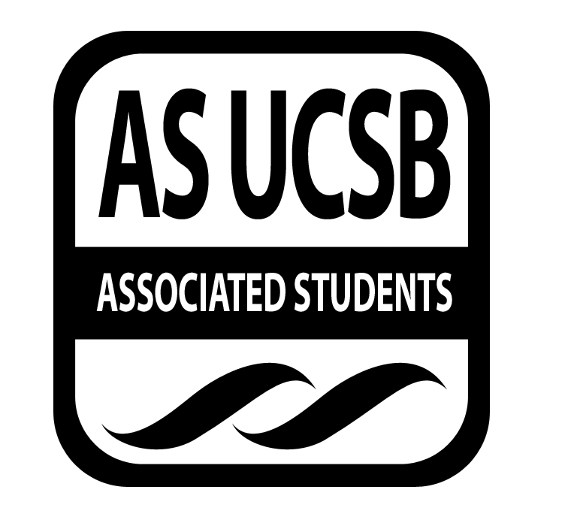**Committee on Committees Minutes/Action Summary**

Associated Students  
AS Main            Minutes Recorded by:  Priscilla Lee

March 29, 2016 6:00 PM

**CALL TO ORDER at 6:04 by Pedro Villalobos, External Chair**

**A. MEETING BUSINESS**

1. **Roll Call**

|  |  |  |  |
| --- | --- | --- | --- |
| **Name** | **Note:**  absent (excused/not excused)  arrived late (time)  departed early (time)  proxy (full name) | **Name** | **Note:**  absent (excused/not excused)  arrived late (time)  departed early (time)  proxy (full name) |
| **Oscar Zarate** | Late | **Sunny Chao** | Present |
| **Pedro Villalobos** | Present | **David Zhong** | Present |
| **Priscilla Lee** | Present | **Tony Aceves** | Present |
| **Megan Wong** | Present | **Theresa Tran** | Present |
| **Kelly Pearman** | Excused | **Tiffanie Vo** | Present |
| **Christina Pallone** | Present | **Maren Roberts** | Absent |

**C. DISCUSSION ITEMS**

**C-1: Meeting Time**

* Tuesday 8pm Pardall Center

**C-2: CommWeek**

* Hand out snacks at the Arbor, Monday April 4
  + Make goodie bags on Sunday at Pedro’s
  + 11-12pm: Priscilla, Theresa, Tony
  + 12-1pm: David, Christina, Sunny
  + 1-2pm: Oscar, Maren (?)
* Lemonade stand at UCEN, Tuesday April 5
  + Borrow water cooler from CAB; get ice, cups, lemonade mix
  + Question wheel
  + Giving out swag
  + 11-12pm: Megan, Theresa, Sunny
  + 12-1pm: Tony
  + 1-2pm: Christina, Tony
* Panel at SRB MPR or UCEN, Wednesday April 6
  + 5-6pm
  + AS Execs and Senators
  + Make a Facebook event and Digiknow
  + Pizza

**C-3: Recruitment Fair**

* Tiffanie and David sent out email to chairs directly
* Gave description of what the fair is, sign up form
* Thursday 1-3pm, set up at 12pm
* Still need to figure out how many tables we need
* Shirts will be coming in
* Rent out speakers from Media Services or borrow from Program Board?
* Costs (?) - Program Board first, but if not, then ask Media Services
* RHA - email equipment manager for tables ucsb.rha.com
* Flyers ready - print by late this week

***MOTION/SECOND: Lee/Tran***

***Motion to approve 122.08 dollars from Operations for Spring Recruitment Flyers***

***ACTION: Vote: passes by consent***

***Advisor/Staff recommendation/instruction/request: None***

***Responsible for Follow-through: David, Tiffanie, Priscilla***

***Additional approval required?  No***

**C-3: Shared Governance**

* Megan - send out email to schedule office hour with her; go over slideshow for new reps (1-2 weeks)
* 2 reps at each hour
* Banquet - week 4 or 5 evening

**C-4: Internal Climate Coordinators**

* Coordinate with Avery for candidate social event
* Put in order for the plaque, get Amazon giftcards for Kelly and Kimia ($10 each)
* LaDonte sent Theresa email - cultural assessment workshop
* IV elementary school - start getting confirmations that people are going to go
* Free food during office hours - compliment/motivational note to post up on AS Main walls
* Keep Oscar updated with cultural assessment

**C-4: Fellows Newsletter**

* Newsletter done by next Monday
* Talk to COSWB to make the newsletter to pop up right when you click the email open

**C-5: Fellows Newsletter**

* AS Assembly planning
* Theresa, Tony, Oscar - 9pm
* Workshops entire week and AS banquet at the end of the week
* Friday better than Sunday

**D. REMARKS**

* Sunny - start brochure

**ADJOURNMENT**

Meeting adjourned by Pedro at 7:13 PM