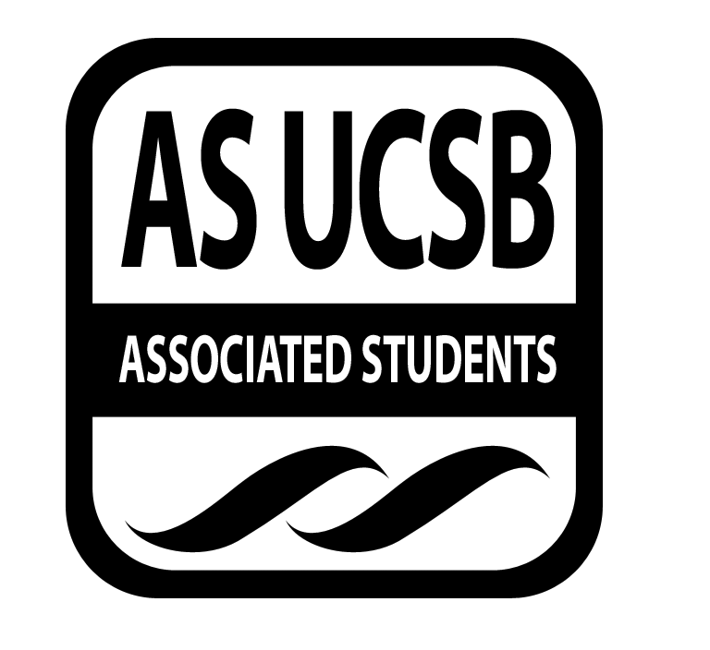
Committee on Committees Minutes/Action Summary

Associated Students
AS Main Minutes Recorded by: Priscilla Lee
March 29, 2016 6:00 PM

CALL TO ORDER at 6:04 by Pedro Villalobos, External Chair

A. MEETING BUSINESS
- Roll Call

Name | Note:  absent (excused/not excused)  arrived late (time)  departed early (time)  proxy (full name) | Name | Note:  absent (excused/not excused)  arrived late (time)  departed early (time)  proxy (full name)
Oscar Zarate | Late | Sunny Chao | Present
Pedro Villalobos | Present | David Zhong | Present
Priscilla Lee | Present | Tony Aceves | Present
Megan Wong | Present | Theresa Tran | Present
Kelly Pearman | Excused | Tiffanie Vo | Present
Christina Pallone | Present | Maren Roberts | Absent

C. DISCUSSION ITEMS

C-1: Meeting Time
- Tuesday 8pm Pardall Center

C-2: CommWeek
- Hand out snacks at the Arbor, Monday April 4
  - Make goodie bags on Sunday at Pedro’s
  - 11-12pm: Priscilla, Theresa, Tony
  - 12-1pm: David, Christina, Sunny
  - 1-2pm: Oscar, Maren (?)
- Lemonade stand at UCEN, Tuesday April 5
  - Borrow water cooler from CAB; get ice, cups, lemonade mix
  - Question wheel
  - Giving out swag
  - 11-12pm: Megan, Theresa, Sunny
  - 12-1pm: Tony
  - 1-2pm: Christina, Tony
- Panel at SRB MPR or UCEN, Wednesday April 6
  - 5-6pm
  - AS Execs and Senators
  - Make a Facebook event and Digiknow
  - Pizza

C-3: Recruitment Fair
- Tiffanie and David sent out email to chairs directly
- Gave description of what the fair is, sign up form
- Thursday 1-3pm, set up at 12pm
- Still need to figure out how many tables we need
- Shirts will be coming in
- Rent out speakers from Media Services or borrow from Program Board?
- Costs (?) - Program Board first, but if not, then ask Media Services
- RHA - email equipment manager for tables ucsb.rha.com
- Flyers ready - print by late this week

MOTION/SECOND: Lee/Tran
Motion to approve 122.08 dollars from Operations for Spring Recruitment Flyers
ACTION: Vote: passes by consent
Advisor/Staff recommendation/instruction/request: None
Responsible for Follow-through: David, Tiffanie, Priscilla
Additional approval required? No

C-3: Shared Governance
- Megan - send out email to schedule office hour with her; go over slideshow for new reps (1-2 weeks)
- 2 reps at each hour
- Banquet - week 4 or 5 evening

C-4: Internal Climate Coordinators
- Coordinate with Avery for candidate social event
- Put in order for the plaque, get Amazon giftcards for Kelly and Kimia ($10 each)
- LaDonte sent Theresa email - cultural assessment workshop
- IV elementary school - start getting confirmations that people are going to go
- Free food during office hours - compliment/motivational note to post up on AS Main walls
- Keep Oscar updated with cultural assessment

C-4: Fellows Newsletter
- Newsletter done by next Monday
- Talk to COSWB to make the newsletter to pop up right when you click the email open

C-5: Fellows Newsletter
- AS Assembly planning
- Theresa, Tony, Oscar - 9pm
- Workshops entire week and AS banquet at the end of the week
- Friday better than Sunday

D. REMARKS
- Sunny - start brochure

ADJOURNMENT

Meeting adjourned by Pedro at 7:13 PM

