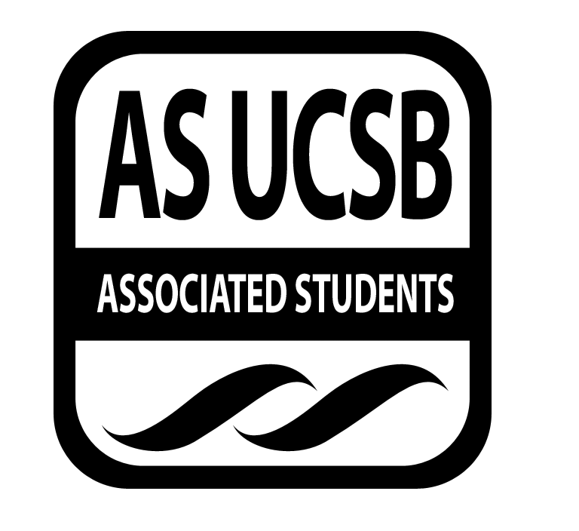

Committee on Committees Minutes/Action Summary

Associated Students
Pardall Center Minutes Recorded by: Priscilla Lee
February 18, 2015 9:30 PM

CALL TO ORDER at 9:34 PM by Sydney Bennet, Chair

A. MEETING BUSINESS
- Roll Call

Name | Note:  absent (excused/not excused)  arrived late (time)  departed early (time)  proxy (full name) | Name | Note:  absent (excused/not excused)  arrived late (time)  departed early (time)  proxy (full name)
Sydney Bennet | Present | Oscar Zarate | Present
Andrew Neiman | Present | Pedro Villalobos | Present
Eve Kopecky | Present | Priscilla Lee | Present
Izeah Garcia | Excused | Stacey Heo | Present
Kelly Pearman | Present | Theresa Tran | Present

B. ACCEPTANCE of ACTION SUMMARY/MINUTES
B-1. Approval of our Action Summary/Minutes from 02/09/15
MOTION/SECOND: Lee/Lee
Motion to approve minutes from 02/09/15
ACTION: Passes by consent

C. DISCUSSION ITEMS

C-1: Shared Governance Banquet
- Tomorrow 6:30-8PM, Lily’s Tacos
- Business casual

MOTION/SECOND: Pearman/Lee
Motion to approve 300 dollars for Shared Governance Banquet from Special Projects
ACTION: Vote: passes by consent
Advisor/Staff recommendation/instruction/request: None
Responsible for Follow-through: Eve
Additional approval required? No

C-2: Winter Recruitment Fair Debrief
- Cookies were a good idea
- Groups signed up and didn’t show up (also groups did not even sign up)
- Penalties to not show up
- Question in Honoraria application form for chairs
- EVPLA didn’t show up

C-3: Spring Recruitment Fair
- Casual in the Arbor usually
- Corwin Pavilion (outdoor) - put up a poll in the Facebook
- More traction b/c things are coming for next year
- Aim for fair on Week 2, Wednesday or Thursday
- Make Facebook event + flyer Week 1
- Look at budget for costs

C-4: Opening Positions
- Go through each position on Legal Code and make sure the positions are correct
- Copy and paste Legal Code descriptions
- Three options:
  - This weekend with movie
  - Monday individually 3:30-7 (make meeting as short as possible)
  - Independently - assigned
- Graphic design request sent

C-5: AS Assembly
- Date is tentative (Corwin) May 29th, 4-7PM Friday
- Transitional for new/old officers

C-6: Judicial Council
- Nawar - very educated, seems to go above and beyond, already in CBL, only thing: sounded more like SAG
- Matthew - CSO, experience with writing up people, state-wide soccer referee, already looked at the Legal Code before coming, enforcing AS Legal Code
- Gabriella - Sat in jury-type tribunal, did mock trials, didn’t have understanding of what Judicial Council actually is
- One more judicial council for Spring

C-7: Spring Climate Event
- Dodgeball tournament
- Signs in AS
- Rec Cen back courts
- Just get more balls
- Outdoor with two games + ice cream social

C-8: Bonding
- February 27th
- Talk about it Monday meeting

D. REMARKS
- Duties for the week:
- Stacey - organize a mixer for chairs (March 5 or first or second week of Spring Quarter)
  - Email Angela and see what they have done in the past
- Oscar + Theresa - contact all the chairs and see what their process for elections; if they’re doing it at a meeting, get the date to make sure candidates know
- Kelly and Pedro - open another Facebook event next week; look into tabling at dorms Week 1; get flyers approved (by Spring Week 1/2)
  - Maybe throw a program in Santa Rosa Formal Lounge, San Nic, FT (info sessions)
  - RHA can pay for the pizza
- Eve - keep working on which committees exist
- Andrew - Write a generic message about positions for University Announcement
- Find people who came in Fall
- Next Meeting @ 5PM Pardall Center, bring a computer for opening positions
- Sydney - trivia question

ADJOURNMENT

Meeting adjourned by Sydney Bennet at 10:08 pm

MOTION/SECOND: Lee/Kopecky
Motion to end meeting at 10:08 pm
ACTION: passes by consent

