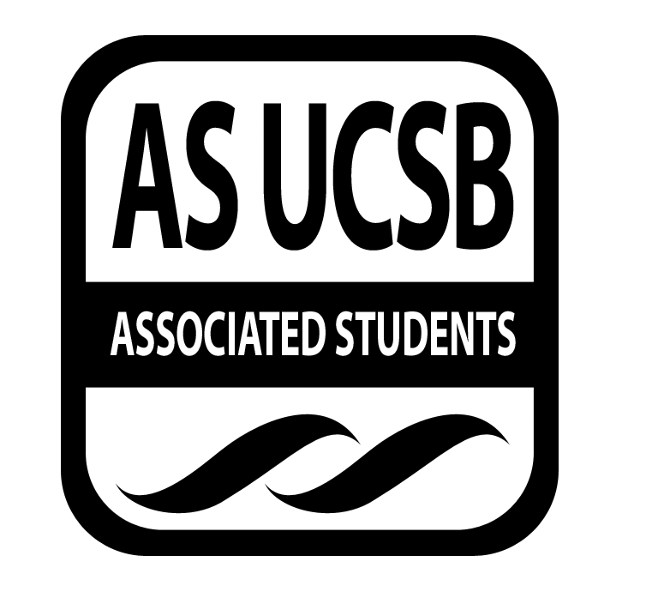
Committee on Committees Minutes/Action Summary

Associated Students
Pardall Center Minutes Recorded by: Priscilla Lee
February 2, 2015 5:00 PM

CALL TO ORDER at 5:05 PM by Sydney Bennet, Chair

A. MEETING BUSINESS
- Roll Call

Name | Note:  absent (excused/not excused)  arrived late (time)  departed early (time)  proxy (full name) | Name | Note:  absent (excused/not excused)  arrived late (time)  departed early (time)  proxy (full name)
Sydney Bennet | Present | Oscar Zarate | Present
Andrew Neiman | Present | Pedro Villalobos | Present
Eve Kopecky | Present | Priscilla Lee | Present
Izeah Garcia | Excused | Stacey Heo | Present
Kelly Pearman | Present | Theresa Tran | Present

B. ACCEPTANCE of ACTION SUMMARY/MINUTES
B-1. Approval of our Action Summary/Minutes from 01/26/15
MOTION/SECOND: Lee/Neiman
Motion to approve minutes from 01/26/15
ACTION: Passes by consent

C. DISCUSSION ITEMS

C-1: Intro Question
- How did you hear about AS/get involved?
  - Kelly - through Fellowship, heard of it on the Flush
  - Andrew - through Jonathan Abboud
  - Sydney - through Angela, EVPSA office
  - Stacey - through emails, and CoCtail party
  - Priscilla - roommate had a position in AS
  - Pedro - being a part of RHA last year; Erika Martinez had position last year for CoC
  - Eve - brother said to join AS
  - Theresa - through tabling in front of Arbor
  - Oscar - through Izeah

C-2: Recruitment Fair
- Set-up with 25 tables
- Still need to talk to UCEN about food
- Clarify if we can bring our own food with UCEN
- Maybe about prizes (ideas?)
  - Tickets or raffle
  - Ask around IV for donation prizes (Sweet Alley?)
  - Spending has to be approved by Senate
- Get people’s emails or sign-in to send a follow-up email
- Form to sign up for all of the emails
  - Add a question: Are you willing to share a table?
- Submitted request to have the flyer designed, approved to be advertised on the Flush
- Put on events calendar (everyone’s events)

C-3: Tabling/Helping Committees Recruit
- Email to ask about tabling at San Cat (Pedro)

C-4: Shared Governance
- Chairs are not available to AS and student reps - would not respond and instead had Senate Analyst respond
- Shared Governance banquet - Thursday, February 19 (7-9?)
- Invitations sent out by the end of this week (and University Announcement)
- Suggestions or questions for Eve

C-5: Proxy Bank
- Contact Senators directly to log who got training last week
- Send another email tomorrow to get people trained
- If anyone wants to be a proxy/wants to be a senator

C-6: AS Olympics
- Bought materials for games
- Any ideas for games with hula hoops, red cups, ping pong balls, etc.
- Talk to Exec about signing up
- Email out to those who RSVP’d: assign colors
- CoC wear CoC shirts
- Game ideas:
- 4 people - travel a particular distance with specific instructions
- Hula hoops - hold hands and get everyone through
- Dodgeball tournament for last two committees standing
- Winning each game earns points
- Flip cup tournament
- Water pong tournament (Civil War)
- Set up at 12PM
- Opening ceremony for Olympics - on Friday (Kelly in charge)
  - Send Kelly a list of people who RVSP’d

C-7: Spring Recruitment Strategies
- Open all positions for next year on Week 7 of Spring Quarter
- Positions that are not appointed by Week 7, not going to be appointed this year
- Right after recruitment fair, send out university announcements
- can’t start interviewing till week 5 of Spring Quarter
- Push committees to do their own interviews

ADJOURNMENT

Meeting adjourned by Sydney Bennet at 5:58 pm

MOTION/SECOND: Lee/Kopecky
Motion to end meeting at 5:58 pm
ACTION: passes by consent

