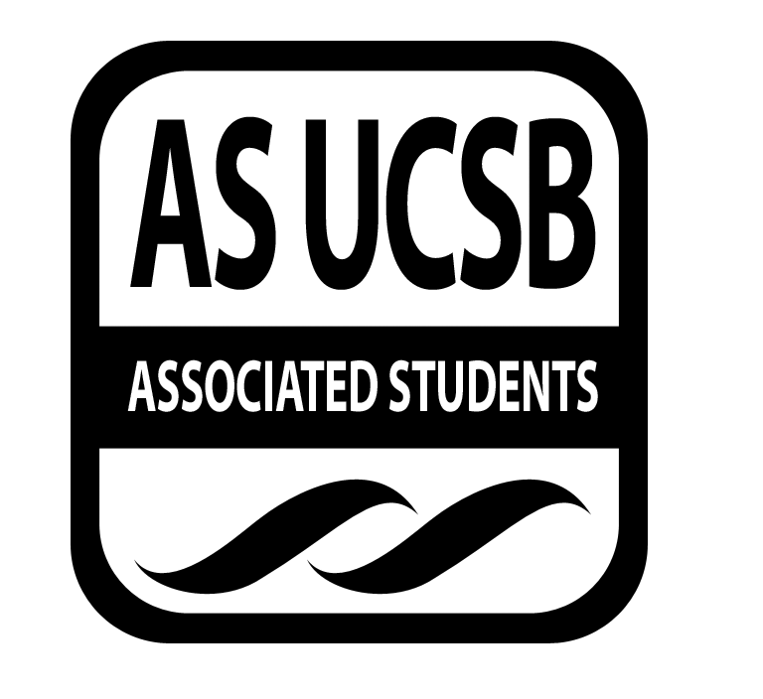
Committee on Committees Minutes/Action Summary

Associated Students
Pardall Center Minutes Recorded by: Priscilla Lee
January 26, 2015 5:00 PM

CALL TO ORDER at 5:04 PM by Sydney Bennet, Chair

A. MEETING BUSINESS
- Roll Call

Name | Note:  absent (excused/not excused)  arrived late (time)  departed early (time)  proxy (full name) | Name | Note:  absent (excused/not excused)  arrived late (time)  departed early (time)  proxy (full name)
Sydney Bennet | Present | Oscar Zarate | Present
Andrew Neiman | Present | Pedro Villalobos | Present
Eve Kopecky | Present | Priscilla Lee | Present
Izeah Garcia | Excused | Stacey Heo | Present
Kelly Pearman | Excused | Theresa Tran | Present

B. ACCEPTANCE of ACTION SUMMARY/MINUTES
B-1. Approval of our Action Summary/Minutes from 01/19/15
MOTION/SECOND: Villalobos/Kopecky
Motion to approve minutes from 01/19/15
ACTION: Passes by consent

C. DISCUSSION ITEMS

C-1: AS Assembly Debrief
- Very productive
- Sharing what each committee worked on was very valuable
- Very good amount of food (other than salad)
- Time period of lunch was good
- Workshops were very helpful
- SRB was a good location
- Improvements:
  - Fun activity or ice breaker
  - Slightly clique-y
  - More breakouts - 20-min breakout sessions
  - Work groups throughout the week - have them on the day of AS Assembly and then discuss after the same day
  - Transitional AS Assembly (5th week) - old and new chairs present
    - May have to change location because of occupancy
  - Consequences for people who RSVP’d and did not show up

C-2: Trivia
- Trivia starting next week - share it to groups on Facebook
- Priscilla - in charge of second Week trivia question (come up with by next meeting)
- Sydney - get flyers

C-3: AS Olympics
- Stacey - send out email to Thunderdome to give an agenda
- Give Stacey ideas for games if you want specific games for sure
- Post on Facebook groups for games
- Hullahooping competition
- Write up a message explaining what AS Olympics is and send to chairs
- Go to committee meetings and make an announcement

C-4: Proxy Bank
- Training started this week
- Two people per block
- Check on google doc if senators updated list when people have attended trainings

C-5: AS Orientation
- Going to update based on feedback given back
- Show up to your office hours since people will be there for orientation
- If you cannot come, make sure AS front desk knows so they can update
- Offer committees that we can come to meetings and do it at once

C-6: Recruitment Fair
- Date: Tuesday, February 17, 7:30-9:00PM
- Location: Corwin
- Think of theme
- E-mail notification: send out to all units to save the date
- Submit flyer to AS Graphic Designer
- Table in Arbor (Monday & Tuesday of that week)
- Go to big OSL meetings
- Poster making:
  - Banner/flyer on Pardall
  - CAB/ResHalls has paper/paints
- Advertise - get the Flush/The Bottom Line/The Nexus
- E-mail/call Career Services
- Finalize budget
- Make a poll - decide on food or no
- Make Facebook event
- Send University announcement
- Raffle off shirts

C-7: Helping Committees Recruit
- Advice for other committees:
  - Make Facebook event
  - Post in Facebook groups
  - Stand in front of dining commons
  - Send out on major list serves
  - Make university announcements
  - Go to Res Halls and flyer (leave a stack of flyers on front desk)
    - Get approval for RHA meeting to go door-to-door
    - Decide time frame
    - LPC Thursday, 6:30-9:30PM

D. REMARKS
- Make sure to get green stuff from the Annex, get compost waste bins
- Email zero waste chairs, ask how to get compost waste bins
- When working on project for CoC, good to go to Senate meeting and present to senators

ADJOURNMENT

Meeting adjourned by Sydney Bennet at 5:45 pm

MOTION/SECOND: Neiman/Kopecky
Motion to end meeting at 5:45 pm
ACTION: passes by consent

