## Coastal Fund Summary of Minutes

## ASsquare_logo.tifAssociated Students

5/19/2014

AS Conference Room Minutes/Actions recorded by: Sara Rosenblatt

\*The chair abstained from all votes.

**Major Funding**

**SPR 14-01: Ecological and Economic Feasibility for a Sustainable Coastal Development**

Sama Group is presently gaining traction with Santa Barbara County towards the adoption of a “Sustainable Living Research Ordinance” (SLRO) that would allow more sustainable types of development (not allowed in current building/zoning/health codes) that demonstrate positive ecological impacts with compelling community and economic benefits. The proposed project would hire 2 UCSB student interns and support from Sama Group staff to conduct an ecological and economic feasibility study of a sustainable (re)development of coastal property, such as the UCSB-owned Devereaux property, or private developer-owned Naples property(s).

Proposed Budget:

|  |  |  |
| --- | --- | --- |
| ITEM | COST | REQUEST |
| 2 UCSB grad interns for 1 quarter | $1,000 | $1,000 |
| Sama Group staff support for 1 quarter | $1,000 | $1,000 |
|  | Total | $2,000 |

The two graduate student internship stipends will be adjusted to $450 each per intern.

This project meets the mission in a new and unique way, and is a group that CF hasn’t worked with before. This project will provide students a unique opportunity and is a very localized that students will directly benefit from.

*MOTION/SECOND: Debevec/Bills*

*Motion to fund SPR 14-01 at $1,900 with the difference being the decreased graduate intern stipend.*

*ACTION: 6:0:1*

**SPR 14-02 Coal Oil Point Reserve: Internships and additional funding support for conservation, education, and restoration programs: Summer 2014/Fall 2014**

Coal Oil Point Reserve requests funds to provide UCSB students with paid internships for summer and fall quarters 2014. UCSB student interns will participate in the Snowy Plover Docent Program, the education program, and the habitat restoration program. The internships at the reserve will provide UCSB students with opportunities to acquire field experience necessary to enhance their professional development. The summer is the most sensitive time for the Western Snowy Plover (listed endangered species). The birds lay their eggs in the sand and raise their chicks on the public beach. Providing internships to UCSB students over the summer to assist with the conservation efforts of the snowy plover greatly improves the outreach and protection capabilities of the program.

Proposed Budget:

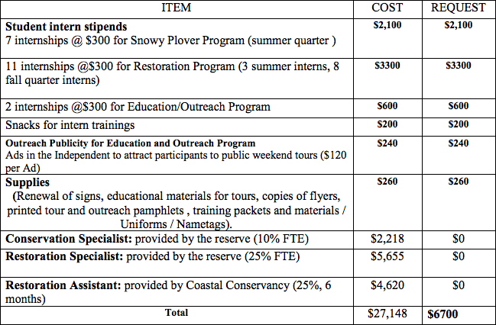

Testa and Bills make known a possible conflict of interest because they know the applicant and have enjoyed playing with her goats.

Tabled budget includes a revised stipend budget based on the recent increase in stipend funding.

This is a program that CF has funded in the past and provides many students with interesting and educational internships. Having a natural reserve on campus is very unique and a great opportunity for students to be involved with.

The Snowy Plover intern stipends will be increased from $2,100 to $2,362.50, the restoration intern stipend from 3300 to 3712.50, and education/outreach intern stipend from $600 to $675. This brings the project total to $7,450.

*MOTION/SECOND: Bills/Testa*

*Motion to fund at $7,450 with the difference being an increase to student stipends.*

*ACTION: 6:0:1*

**SPR 14-03: Kids in Nature Peer-to-Peer Environmental Education Program**

Four undergraduate students will be selected to serve as Kids in Nature (KIN) interns during fall quarter 2014. The interns will have successfully completed the Education Practicum course (EEMB 189/ES 191), which we have offered each quarter since 2008. The KIN interns will serve as mentors for the newly enrolled UCSB students and also for the over 90 5th grade students who are part of the KIN program. The interns will each lead one of the KIN groups of 4-5 students in classroom activities and on field trips.

Proposed Budget:

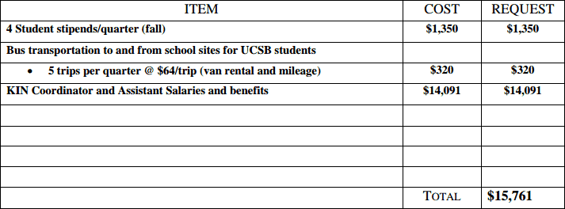

Testa makes known a possible conflict of interest as she took the KIN course during winter quarter 2014.

This project has had had many successful years and this time they are expanding their program, which the board is excited about especially having funded this project before. This program and helped raise science subject test scores. All of the interns seem to have a really great experience with the program. The program is actively adopting new science standards this summer.

*MOTION/SECOND: Testa/Bills*

*Motion to fund SPR 14-03 in full at $15,761.*

*ACTION: 6:0:1*

**SPR 14-04: MPA Watch Internship**

Santa Barbara Channelkeeper seeks a $5,500 grant to support two UCSB interns for the MPA Watch program. MPA Watch is a monitoring program that utilizes volunteers to record and track human activities in and around Santa Barbara's newly designated Marine Protected Areas (MPAs) by conducting onshore visual surveys. The data collected by MPA Watch volunteers is critical in detecting trends in human uses in the MPAs and how they correspond to biological changes resulting from the protected status of the MPAs. The program will also aid compliance and enforcement efforts to ensure that MPA regulations are followed.

Proposed Budget: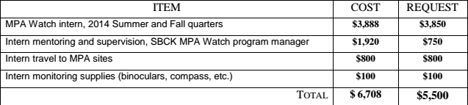

Testa, Bills, and Rosenblatt declare a potential conflict of interest, as they all work at the REEF, which is thinking of partnering with MPA Watch.

The board thinks this is a great program and was glad to hear that not many illegal fishing sittings have occurred. They believe this project fits the mission statement and supports UCSB students through the volunteer and intern program.

This is a new applicant that fits the mission statement well. The board would like to fund the interns at a decreased rate of $10.13 to keep consistent, which brings the new intern stipend total to $3282.12. The new project total is $4932.12. This project provides interns a unique opportunity and occurs right on campus. This project itemized their budget very well.

*MOTION/SECOND: Bills/Fulgham*

*Motion to SPR 14-04 fund at $4,932.12 with the difference being the decreased intern stipend.*

*ACTION: 6:0:1*

**SPR14-05: From Plankton to Particles: Predicting the Fate of Carbon in an Acidified Coastal Ecosystem**

This research project will bring an entirely new aspect of ocean acidification (OA) research to UCSB by examining a newly isolated, local phytoplankton species’ biogeochemical response to predicted climate conditions in the Santa Barbara Channel (SBC). Phytoplankton are an ecologically important group of marine autotrophs that contribute to carbon sequestration and food web structure in the SBC. Alterations to the physiology of these microscopic plants as a result of OA could result in dramatic changes to local water chemistry and marine aquaculture. To address this important issue, this project will not only focus on scientific discovery, it will also utilize modern video technology and the internet as a platform for community outreach and support the mentorship of an undergraduate student interested in contributing to their senior honors thesis in the aquatic sciences. This research project will enhance our current understanding of ocean acidification and seek to preserve and protect the UCSB shoreline for years to come by contributing research to the scientific community, raising environmental awareness in the online community, and fostering the education of an undergraduate student in the UCSB community.

Proposed Budget:

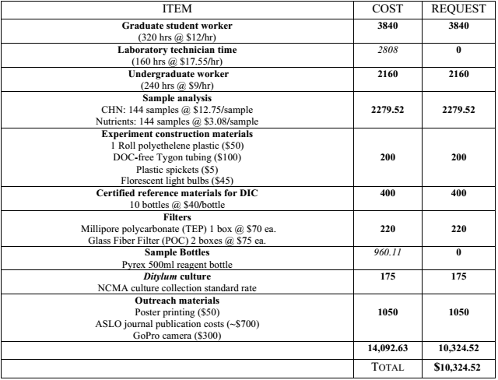

Bisson declares a conflict of interest and abstains from the vote, as she is a good friend of the applicant although she does not benefit from the project at all.

The board thinks this proposal is well thought out and applicable. They think this is also a great opportunity for the undergraduate who will be assisting with the project and writing up and senior thesis. This applicant received minor funding in Fall 2013.

The applicant has sent in a revised budget. The new budget reflects adding another element of realism to the project by using rolling containers to simulate turbulence. These containers could be continued to be used by the lab when the project is finished. The new total $14,587.40. The board would like to stipulate that the camera purchased stays in the lab for future projects to use. This project fits well with the CF mission statement and is very local.

Revised Budget:

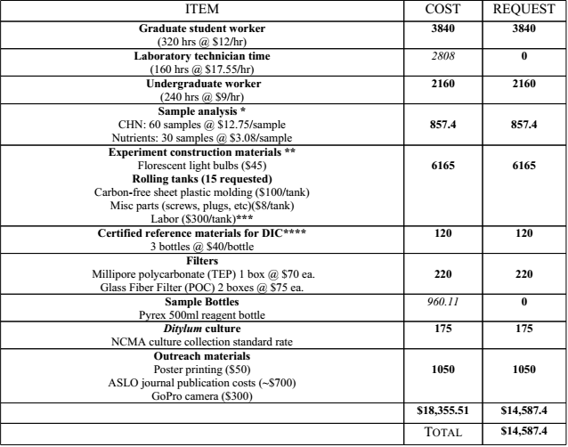

The new grad student stipend is increased to $4,320 from $3,840. Undergrad stipend is also increased from $2,160 to $2,431.20. The new total is $15,338.60.

*MOTION/SECOND: Debevec/Testa*

*Motion to fund SPR 14-05 at $15,338.60 with the difference being the increase in both student stipends.*

*ACTION: 5:0:2*

**SPR 14-06: Reef Check California**

Reef Check California (RCCA) is a community-based monitoring program dedicated to conserving California’s rocky reef ecosystem. At UCSB, RCCA trains students in reef monitoring protocols. Students then participate in RCCA’s annual surveys along the Santa Barbara coast and Channel Islands. The students’ data are used by the MPA Monitoring Enterprise to inform the monitoring of marine protected areas in southern California, by the Department of Fish and Wildlife and by leading marine scientists. Funds will support staff, training and surveys, providing UCSB with increased opportunities for immersion learning, field experience, and active engagement in marine management processes in California.

Proposed Budget:

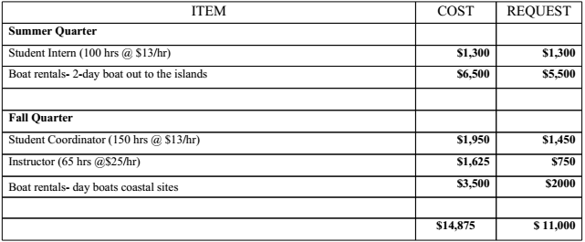

The board feels that this is a great experience for the student interns and the stipend is appropriate due to the amount of work that the interns would be completing.

The board thinks this is an amazing program, and provides and opportunity for students to be leaders in this field.

*MOTION/SECOND: Bills/Testa*

*Motion to fund SPR 14-06 in full at $11,000.*

*ACTION: 6:0:1*

**SPR 14-07: Nature Saturdays for North Campus Open Space**

CCBER is requesting funding to run four Nature Saturday events on North Campus Open Space to build on the 6 funded by the Outhwaite Foundation. Nature Saturday events are a capacity building program for CCBER to do outdoor education with Goleta and IV community members and their families about our local coastal resources. The goal is to build community as we move in to planning for and restoring the Ocean Meadows Golf Course and South Parcel in these people’s back yards. Their first event attracted more than 70 people and was much appreciated. They’ve been advertising this poster/flyer around town. Kids 6-12 can be dropped off by a parent. Kids 5 and under should be with a parent. There were 30 kids from the 6-12 range at their first event. Project is hopeful of being sustained after its over. Was reported about in the Independent and other outlets. CCBER is trying to target semi broad area from freeway to airport. CCBER would like to send out poster to coastal fund outreach to send out to our mailer.

Proposed Budget:

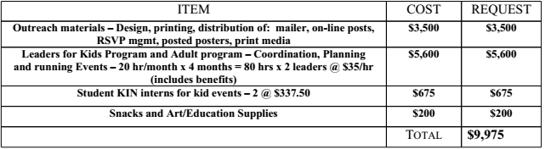

The board feels like this a really cool way to get the community involved with each other. They also like that it’s an outreach event targeted to children. Bisson thinks that it doesn’t seem like the internships are as technical as they should be. Fulgham thinks it would be a good idea to find high school student volunteers through the CSF program.

The board has concerns about funding the intern coordinator since this position does not seem to involve much more work than the internship. There is clarification that this coordinator also develops the program and runs the entire program. Since CF already has funded interns for this organization the board questions why this proposal has a separate intern stipend for these interns. After much discussion the board feels that since this is a separate proposal that it should be treated as entirely separate from the KIN interns funded last quarter. It seems as though the interns are only present the day of the event and not planning the event as well. Bisson questions if CF should be cutting internships since this is something CF is usually very excited about. Bills is concerned that if the intern for this project is already a funded KIN intern are they now being paid two stipends. Bisson feels like this could be volunteer work for the interns since this is supplementary to the KIN internship. Testa feels that the board should view funding these interns separate than funding the KIN interns because it is an entirely different project but the same interns are possibly being used because they are already trained. The discussion is focused on how much time the interns are going to be working as this is something that is usually included with the application. The board would like to change the stipend to an hourly wage instead of a quarterly stipend. The board will fund at $10.13 per hour for interns with a cap of $675 for intern stipends. Since the project has already run this program the board feels that their budget should be fairly accurate. Jones will contact Lisa Stratton and explain the proposed plan and ask her how many hours interns will be working.

*MOTION/SECOND: Fulgham/Debevec*

*Motion to table SPR 14-07 in full until further information from Lisa Stratton can be provided about how the adjusted intern stipend will affect the project.*

*ACTION: 6:0:1*

**SPR 14-08: Wilderness, Wildlife, and Watersheds**

Bills declares that there might be a conflict of interest, but there is no way that she benefits from this project. The board decides that it is okay for her to vote.

The Wilderness, Wildlife & Watersheds Program is a volunteer effort designed to remove trash from ten areas in the Los Padres National Forest and restore six areas by removing invasive tamarisk plants from forest watersheds. By doing so, they can prevent water pollution, promote watershed function, remove visual blights on the landscape, and increase everyone’s enjoyment of the great outdoors. Through this program ForestWatch has taken an active hands-on role in protecting and restoring these special places with the help of hundreds of community volunteers. The work makes a direct impact addressing projects that simply would not get done were it not for their efforts. Federal agency budgets preclude their completing these labor-intensive but wholly necessary projects, and that is where volunteers step in and get the work done. As a result of these efforts and the engagement and education in the community, they protect clean water, open space, and wildlife habitat that are so important to environmental health and quality of life.

Proposed Budget:

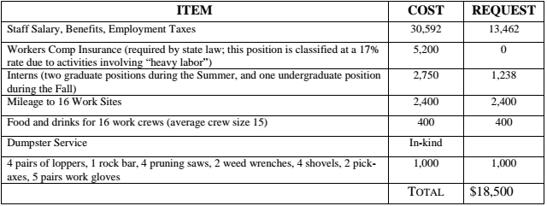

The updated budget is $18,638.74 with an increase in the itemized budget, which included actual prices that had been further researched.

The board thinks this is a very cool organization and the project is applicable to CF’s mission statement.

The board feels uncomfortable funding the staff time with the line item being so ambiguous and not including hours of work, which is something that is usually included in applications that request funds for staff time. The board feels comfortable leaving the stipend for GIS intern (originally noted at “grad intern”) at $450 whether this is an undergrad or grad because it requires a specialized skill. The board feels comfortable assuming that they have calculated the hours that their staff person would be working and that the budget reflects this. This project targets the watershed portion of the CF mission statement, offers a new opportunity for students, and is not something that CF has seen before. This project specifically addresses problem of micro trash, which is very important. They also have an expansive study site so the project will be far reaching.

*MOTION/SECOND: Bills/Testa*

*Motion to fund SPR 14-08 at $18,638.74, which includes the amended supply budget.*

*ACTION: 6:0:1*

*MOTION/SECOND: Testa/Bills*

*Motion to reopen SPR 14-08 to discussion and complete and email vote contingent upon receiving the breakdown of all requested funds.*

*ACTION: 6:0:1*

The board would like to request that applicants itemize out their staff time. Jones will contact the applicant for this.

**SPR 14-09: Freshman Water Bottle Giveaway**

Testa, Bills, and Rosenblatt declare a conflict of interest, as they work with applicant at the reef.

Plastic Solutions is a campus organization here at UCSB that aims to reduce the amount of single-use plastics on campus. One of their goals is to eliminate the sale of single-use plastic water bottles on campus. In doing so, Plastic Solutions would like to promote awareness of the impact of single-use plastic water bottles by having a Freshmen Water Bottle Giveaway next fall. The idea behind this is that the water bottles would be given to students who sign a pledge to stop purchasing and using single-use plastic water bottles.

Proposed Budget:

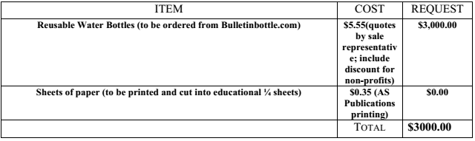

There is an update to this budget because cheaper bottles were found. The new price is $7.50 a bottle from the company Pura but the applicant did not send in a revised budget. The board feels like this is a good way to get the CF name out and plans on asking to table along with this group when they give away bottles. The board also notes that this applicant was very cooperative and took the boards recommendations into considerations and is planning on using the environmentally friendly company that CF recommended. The board likes that this project targets freshmen and encourages them to be more environmentally friendly when they arrive at UCSB. It moves the campus in a good direction away from plastic use and the project is going to collect usable data about plastic use. The board would like to fund 500 Pura bottles at $7.50 per bottle.

*MOTION/SECOND: Debevec/Fulgham*

*Motion to fund SPR 14-09 $3,750 with the stipulations that this applicant conducts a follow up survey during the year and when they initially distribute the bottles CF tables with them.*

*ACTION: 4:0:2*

**SPR 14-10: Cleaning and Enhancing Goleta’s Vital Watersheds**

EDC will plan and implement seven creek and watershed clean-ups to protect water quality in the Goleta Valley in 2014. Beyond straight clean-up, they will identify and abate pollution sources and train and empower creek stewards to carry the work forward. Working with a student intern lead, they will conduct site reconnaissance, schedule the clean-ups, obtain City of Goleta and Santa Barbara County permits, prepare maps and waiver forms for participants, and provide supplies (e.g., bags and gloves). Their work will include but not be limited to securing volunteers, engaging local media, supervising volunteers and managing the clean-ups.

Proposed Budget:

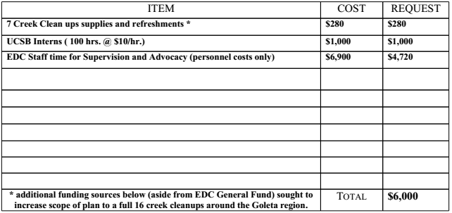

Intern stipend is increased from $10 per hour to $10.13 for a new total of $6,013. This project provides a unique opportunity and reaches out to neighbors of the creeks to educate them. They also get the media there by releasing PSAs and news presses.

*MOTION/SECOND: Bills/Testa*

*Motion to fund SPR 14-10 at $6,013 with the difference being the increased student stipend rate.*

*ACTION: 6:0:1*

**SPR 14-11 Adopt-A-Block**

Adopt-A-Block is requesting the funding to retain a part-time staff member to continue to expand their community outreach and special events portion of their existing program. This person would reach out to student groups to create awareness and solicit their participation in keeping our streets and beach accesses clear of waste that would have otherwise reached our beaches and ultimately pollute our oceans. They are also looking to improve the quality and efficiency of their clean-up events by obtaining funding for a portable PA system and an AAB EZ-UP canopy.

Proposed Budget:

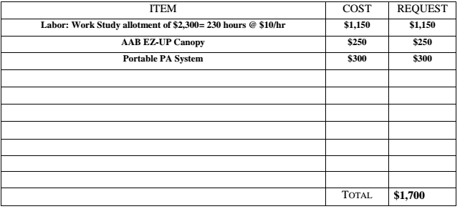

The board thinks the canopy will make for a good meeting place at the events and will help the events run smoother, especially since this is the second time they have requested the canopy. The board really likes the work Adopt-A-Block does especially the clean up after Deltopia. The student intern seems to be working out very well and the board was happy to hear this.

It is great to have a returning student as the intern. This project has had great success with the number of volunteers they see at their events. Both requested items will help with the efficiency and growth of the program.

The board would like to increase the student stipend to $10.13 for a new total of $1,164,95. Work-study will not match this increase. The student intern will be paid at the rate specified through CF and then at the allotted amount through work-study. The new total is increased from $17,00 to $1,714.95.

*MOTION/SECOND: Debevec/Testa*

*Motion to fund SPR 14-11 $1,714.95 with the change being the increased student stipend.*

*ACTION: 6:0:1*

**SPR 14-12: Coastal Cleanup Day and Watershed Resource Center Management Internship**

This grant will fund UCSB student interns to assist Explore Ecology (EE) staff at the Watershed Resource Center (WRC). The objective is to raise public awareness about Santa Barbara’s unique watersheds and ocean environment and impart the importance of practicing pollution prevention to maintain clean water quality. UCSB interns will be instrumental in the development and management of community programming and will work as liaisons with UCSB students and faculty, involving them in WRC activities, and in administering the Santa Barbara County Coastal Cleanup Day event and Creek Week activities.

Proposed Budget:

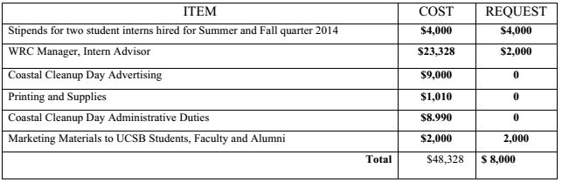

The board feels that this project lines up with the CF mission statement, especially the access and research components. It sounds like the interns will be a great help because it’s a big undertaking to coordinate for an entire area as well as a great experience for the interns. However, there seemed to be no concrete details about what the requested $2,000 for advertising will be used for. Possibly the interns will figure this out. This event occurs before fall quarter begins so not many students will be around to partake and it should be taken into consideration that UCSB may not have a large impact on the clean up.

Since many UCSB students will not be here for the event the board feels like the marketing budget should be cut because they specified their marketing budget to be UCSB specific marketing. Jones clarifies that about 8,000 students take classes over the summer. Poure clarifies that the price for an ad in the Daily Nexus is $350. The budget includes an intern rate at $10 /hour. The new increased intern total is $4,052 with the rate increased by $0.13 per hour. The board feels like the marketing line item should be decreased from $2,000 to $500. The board feels that the project is really great because it is solely focused on cleaning up beaches and aligns with the mission statement.

*MOTION/SECOND: Debevec/Testa*

*Motion to and to fund SPR 14-12 $6,552 with the difference being the increased student stipend rate and the decreased funding for marketing.*

*ACTION: 6:0:1*

**SPR 14-13 Developing New Tools for Assessing the Vulnerability of Sandy Beach Ecosystems to Climate Change**

Coastal ecosystems are not adequately considered in climate change adaptation planning, particularly at local scales. Sandy beaches make up most of Santa Barbara’s coastline providing vital economic, recreational and ecological benefits. A critical impediment to assessing vulnerability of beach ecosystems to climate change is the lack of information on the elevations of key ecological zones relative to standard elevational metrics (mean sea level, mean high tide) used in modeling coastal hazards. To fill this critical gap, this project will collect elevation data for key ecological features of beaches that can be integrated with standard elevational metrics used in coastal models.

Proposed Budget:

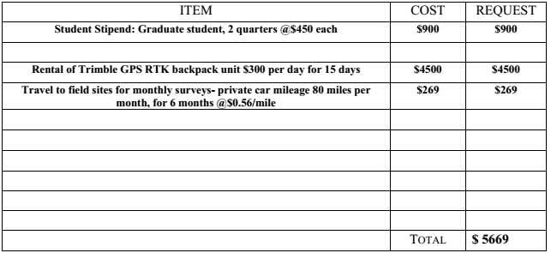

The proposed budget in section two of the application is incorrect but is correct in section four.

The board questioned the value of buying the backpack proposed in the budget and it was determined to be easier to rent it. Dugan stated that she believes she will be able to rent it for $100 cheaper than listed on the application.

The board has concerns about whether her last final report was turned in. Other than that they feel it is a good project and that Dugan did a great job of making it clear how important this information is as well as clarifying the specifics of her project.

A final report for this applicants last funded project has not been found. The board would like to make any motion under the condition that a final report is received.

This project is a unique, very local, timely and important project not only for SB but can be applicable to other beach locations as well. This work is highly relevant in the face of climate change.

*MOTION/SECOND: Bills/Debevec*

*Motion to fund SPR 14-13 in full at $5,669 on the condition that a final report for this applicant’s last project is received.*

*ACTION: 6:0:1*

**Minor Funding**

**SPR 14-14:Watershed Restoration Assistant Fall 2014**

South Coast Habitat Restoration is a local non-profit that is dedicated to environmental stewardship and habitat restoration. They focus their efforts on preserving and restoring habitat for the endangered southern steelhead trout. This proposal seeks funding for compensation for two UCSB student assistant positions. The assistants will assist with the implementation of a variety of watershed restoration projects including: fish passage improvements, bank stabilization projects, non native removal, and maintenance and monitoring of project sites, under the guidance and supervision of SCHR staff. Additionally assistants will be involved in community outreach and education at local festivals and volunteer events with SCHR. This work will focus on projects that restore stream habitat for the endangered southern steelhead trout throughout Santa Barbara County’s coastal streams. The student assistants will learn about native flora and fauna and be introduced to the process of project implementation including: planning, permitting, construction, native re-vegetation etc. Assistants will complete roughly 8 hours of work a week for 10 weeks over Fall 2014 Quarter.

Proposed Budget:

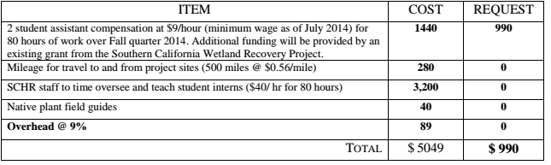

Increasing the intern stipend for this project would make this application a major instead of a minor. $1620 will be the total cost of the stipend instead of the $1440 that they had calculated only $990 of which they had requested. Jones will be contacting this project and inquiring about how they would like to proceed with the intern stipend. Even if the funding request is over $1000 CF will treat it as a minor.

*MOTION/SECOND: Fulgham/Testa*

*Motion to table and inquire about what their new intern budget will be with the increase. A vote will take place by email.*

*ACTION: Consent*

**SPR 14-15: Exploring the UCSB Coast with kite aerial photography**

Using kite aerial photography (KAP) and image processing software, undergraduate interns will create a time series of photographic maps of the coastal zone between Campus Point (CP) and Coal Oil Point (COP) during Summer Quarter of 2014. The resulting maps and photographs will be featured in a lesson, designed by the interns, to teach 3rd-6th student about the ecology and geomorphology of the Santa Barbara coast while introducing principles of environmental monitoring through remote sensing. The lesson will be delivered to one or more local elementary school classes during Fall Quarter of 2014, in conjunction with the Department of Geography’s annual community outreach event during Geography Awareness Week (November 16–22). The project will run through Summer and Fall quarters, 2014, and will require two UCSB undergraduate interns who will receive 3 units of Geog 199RA credit for their participation of approximately 6 hours per week. Funding is sought to purchase equipment that will enable the project.

Proposed Budget:

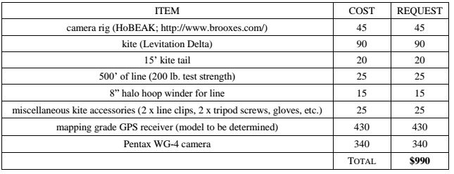

The board feels that this project’s budget looks very reasonable and the project sounds interesting. The board is excited that this is a different application than ones they have previously seen. The board also feels that bringing in student interns will help them to develop skills as leaders and researchers, while also providing the graduate student a mentorship opportunity.

*MOTION/SECOND: Debevec/Testa*

*Motion to fund SPR 14-15 for $990.*

*ACTION: Consent*