Coastal fund Agenda

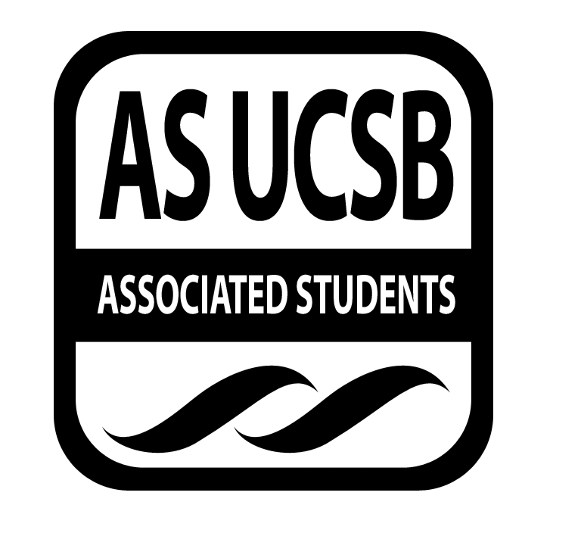
Associated Students
05/17/2016, Tuesday 6:33 PM
Nati Conference

CALL TO ORDER

A. MEETING BUSINESS
- Roll Call (Pre-entered Names)

Name | Note:  absent (excused/not excused)  arrived late (time)  departed early (time)  proxy (full name) | Name | Note:  absent (excused/not excused)  arrived late (time)  departed early (time)  proxy (full name)
John Morrow | present | Maximilian Stiefel | present
Lauren Croshaw | present | Stephen Fetterly | present
Delaney Archer | present | Emily Rogers | present
Madeline Dahm | present | Sarah Siedschlag | present
Isabella Marill | present | John Liedle | present
Maya Normandi | excused absence | Alejandra Posada | present

- Acceptance of Excused Absences
MOTION/SECOND: Marill/Consent
Motion to accept the attendence for May 17, 2016.
ACTION: Consent

B. PUBLIC FORUM
  - Announcements/Information/Introductions
  - Appreciations/Concerns
  - Request to have item added to today’s agenda: Budget Re-allocation

- ACCEPTANCE of ACTION SUMMARY/MINUTES FROM PREVIOUS WEEK
MOTION/SECOND: Archer/Croshaw
Motion to accept last week’s minutes 5/10/15
ACTION: Consent

- REPORTS
- Advisor’s Report: Siedschlag
-Overall requested $126,000

- Chair Report: Morrow
-Senate tomorrow night
-

- Coastal Service Program: Fetterly
-Working on presentation for the gala
-2015-2016 CSP reports 901 hrs of volunteer service, 338 lbs of trash, over $7,000 awarded

- Outreach and Education
-Gearing up for Gala

- Sub-Committee Reports
-Project Visitations
-KIN May 19th
-Meet at stadium
-Your Children’s Trees
-Saturday

- ACCEPTANCE of AGENDA/CHANGES to AGENDA FOR THIS WEEK
MOTION/SECOND: Marill/Leidle
Motion to accept this week’s agenda 5/17
ACTION: Consent

- ACTION ITEMS

New Business
F-1 Fall 15-11 Extension Request: Kids in Nature
-Through December 9th, need to extend to the 20th to be able to pay interns
MOTION/SECOND: Leidle/Croshaw
Motion to approve extension request for FALL 15-11.
ACTION: Consent

F-2 Gala Entertainment: Andrew Manos
-Discussed expectations, $200 pay
MOTION/SECOND: Marill/Liedle
Motion to approve $200 for gala musician
ACTION: Consent

F-3 Co-Sponsorship: Ojai Wild
-Sunday June 5th, $1000
MOTION/SECOND: Dahm/Marill
Motion to fund Ojai Wild co-sponsorship event for $1000.
ACTION: Consent

- DISCUSSION ITEMS

G-1 Coastal Fund Retreat 2016
- Responsible for Follow-through: NAME of PERSON/GROUP/N/A

- Project Review

SPR: 16-09: Dune Swale Pond Buffer Fire Recovery Program
Applicant: Aaron Kreisberg, Audubon Society

Summary:

The funding request ($3550) is primarily ($3150) to support eight student intern positions (six undergraduate and two graduate students) during fall quarter 2016 and winter quarter 2017, with a small amount ($400) to support snacks and tool maintenance. On a week by week basis the project will be overseen by Audubon’s Restoration Coordinator, Aaron Kreisberg. His time and supervision, along with other elements of the project, are funded by a grant from the Southern California Wetlands Recovery Project (secured in May 2015). Santa Barbara Audubon Society’s Dune Swale Pond Buffer Fire Recovery Project aids the recovery of the most sensitive habitats within the almost 20 acres of Coal Oil Point Reserve that burned in the Tank Fire in June 2014. The 8 acres of buffer around the freshwater pond and adjacent seasonal wetlands support breeding birds, an endangered plant and Southwest Pond Turtle. Native vegetation has re-sprouted, along with invasive weeds. It is crucial to remove the weeds that have germinated in order to aid the recovery of native fauna. Native plantings will be installed where natural regeneration is limited.

Presentation:
-Wild fire 2014 burned 20 acres of reserve at Coal Oil Point
-restore around season wetland to native state
-Help prevent against invasive plant species
-⅔ mark of restoration
-$3,350 to fund undergrad and grad intern and $400 for supplies

Board Q & A:

Q: Can you tell us about restoring this wetland is essential to the Audobon society?
A: Goleta and Dexerou slough prone to salinity and water levels, dune stays fresh for birds, western plam turtles, evaporating wetlands. Golf course being restored will link up with these wetlands.
Q: What kind of plants occupied the plants before the burn?
A: Invasive plants had the best return, improving habitat quality with planting of native plants.
Q: There are grad and undergrad interns, is the reason behind this to spread out the opportunity or to create different programs?
A: I look to graduate students to be leaders in the project because of their experience. Enjoy it because there is a physical experience to help out in nature. Availability skews towards undergrads.
Q: Where would you cut if you had to?
A: Probably interns most important and then snacks. Through Coastal Fund we only fund current students. Rest of supplies is less critical or interns.

Board Discussion:
-Great project, very close to our campus, important buffer between Goleta and beach

MOTION/SECOND: Marrill /Dahm
Motion to table discussion for SPR 16-09 with potential cuts to internships.
ACTION: Consent

SPR: 16-16: Reef Check Foundation

Applicant: Jan Freiwald, Reef Check California
Summary:
Reef Check California (RCCA) is a community-based monitoring program dedicated to conserving California’s rocky reef ecosystem. At UCSB, RCCA trains students in reef monitoring protocols. Students then participate in RCCA’s annual surveys along the Santa Barbara coast and Channel Islands. The students’ data are used by the Ocean Sciences Trust (OST) to inform the monitoring of marine protected areas in southern California, by the Department of Fish and Wildlife and by leading marine scientists. Funds will support staff, training and surveys, providing UCSB with increased opportunities for immersion learning, field experience, and active engagement in marine management processes in California.

Presentation:
-Non-profit reef monitering in over 90 different countries, teach volunteer divers who do surveys for us
-CA rocky reef program for SoCal
-20 sites in Santa Barbara: 3 shore sites IV, Naples, Refugio beaches
-Last year did 90 surveys and trained more volunteers than ever before
-Intro to reef check protocol, in SB and Channel Islands
-Funded by Coastal Fund since 2008
-Diving for a purpose
-Provide 3 potential internships: SB dive trainer, training, data input assistant providing opportunites for active engagement, management
-Two scientific dive programs: 40 students total checked by reef protocal
-Were able to do a three day Channel Islands reef check-took 20 divers surveying 11 spots in 3 days

Board Q & A:
Q: What is the minimum diving standards for your certifcation process?
A: At least 16 yrs old and 16 dives and 12 in cold waters, 6 dives in the past years
Q: Do you have trouble getting divers?
A: For SoCal classes are filled up.
Q: How do you deal with sargasm?
A: Sargasm suckers, use it in products, our data helps research.
Q: Summer intern, student intern in fall, boat for both--students able to go?
A: In summer the students would come, intern would help run surveys.
Q: What would intern do to teach RC protocol?
A: Two scientific dive classes, intern would teach reef check protocol.
Q: What could we cut?
A: Boats are most expensive part, interns are key.
Q: You don’t have an office in SB though?
A: No.
Q: How is your data available?
A: Database inputed in NED and intern will help doing data entry.

Board Discussion:
- Potential question is does it help Santa Barbara, it does for sites here and helps make sure SB reefs get checked
MOTION/SECOND: Dahm/Liedle
Motion to table discussion on SPR 16-16 with intent to fund in full.
ACTION: Consent

ADJOURNMENT

MOTION/SECOND: Dahm/Marill
Motion to adjourn meeting at 8:09
ACTION: Consent

