Coastal Fund Minutes

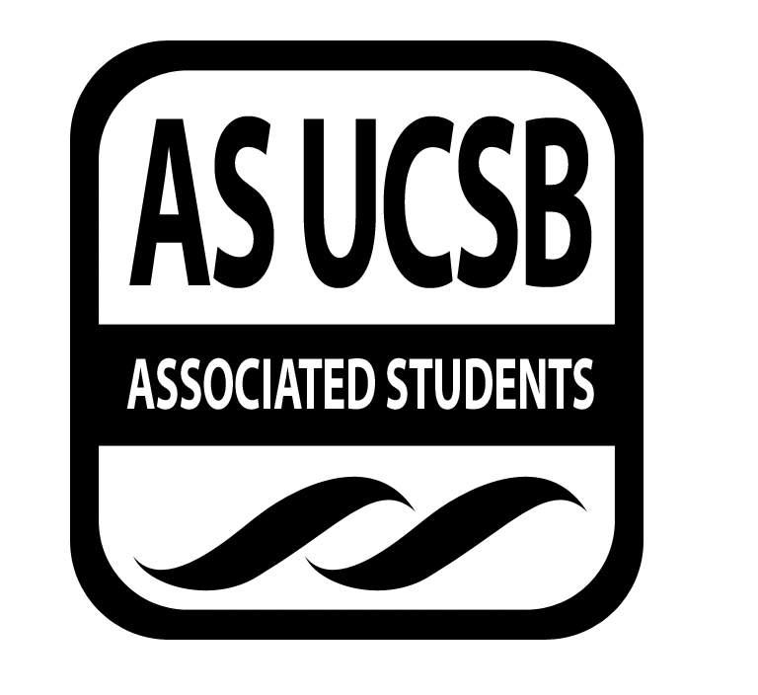
Associated Students
02/24/14, 6:00 PM
AS Conference Room Minutes/Actions recorded by: Sara Rosenblatt

CALL TO ORDER AT 6:18 PM

A. MEETING BUSINESS
- Roll Call

Name | Note:  absent (excused/not excused)  arrived late (time)  departed early (time)  proxy (full name) | Name | Note:  absent (excused/not excused)  arrived late (time)  departed early (time)  proxy (full name)
Natalie Testa | Present | Miranda Walker | Absent (excused)
Marissa Bills | Present | Sara Rosenblatt | Present
Taylor Debevec | Present | Marcee Davis | Absent (excused)
Gad Girling | Present | Megan Roy | Present
Bjorn Kallerud | Present | Andre Taylor | Tardy
Kelsey Bisson | Absent (excused) | Omead Poure | Present
Samantha Fulgham | Present
Aaron Jones | Present

- Acceptance of Excused Absences & Acceptance of Proxies

MOTION/SECOND: Girling/Bills
Motion to approve absences and proxies.
ACTION: Consent
B. Announcements
- None

- ACCEPTANCE of ACTION SUMMARY/MINUTES

C-1. Approval of our Action Summary/Minutes from 02/10/14

MOTION/SECOND: Girling/Bills
Motion to approve minutes from 02/10/14.
ACTION: Consent

- ACCEPTANCE of AGENDA

MOTION/SECOND: Fulgham/Debevec
Motion to approve agenda 02/24/2014.
ACTION: Consent

- Budget Announcement
None.

E-1. Outreach Budget
Outreach has spent $160.00 for Earth day.

- REPORTS
Announcements in this section are informational. Do not include any requests for financial allocations.

- Advisor’s Report
  - Technical Assistance Workshop
    - The technical assistance workshop was successful both dates last week. All winter applicants participated and it took no longer than 20 minutes. The following was discussed at the workshop: reasons for implementing the workshop, how Coastal Fund began, how money spent is reported to auditors, what is needed when submitting receipts (for the exception of university affiliated organizations), grant disbursements, 990s, the change in internship rates, the importance of finals reports, and how to request a budget reallocation or project extension. Jones has received good feedback and was able to answer many of the applicants’ important questions.
  - Philanthropic Giving Personnel and Administrative Assistant
    - Poure will be joining Coastal Fund to help administer over all philanthropic giving entities on campus. In addition he will temporarily fill Walker’s position. Walker and Poure have met this week to briefly discuss the position
- Chair Report: Testa
  - Philanthropic Awards Dinner
    - Testa attended the philanthropic awards dinner, which was hosted in part of the alumni association. They hoped to involve more undergraduates in the future. Everyone was requested to submit a statement that declared why they should be recognized for their philanthropic work. Four awards were given, musical instruments were donated and the children’s toy drive was the recipients. Testa expressed that our participation and presence was not particularly helpful or necessary.
- Senate
None.
- IV Surfrider
  - Surfrider is going on a camping trip this weekend, but may be changed if the weather does not permit it. On another note, campaigns are continuing strong.
- EAB
  - Events and weekly meetings continue in the GSA Wednesdays at 7PM. Events include hiking, gardening, and farmers market bike rides. The newsletter has done well to feature other organization’s events.
- EVPLA
None.
- Administrative Report
None.
- Coastal Service Program
  - Weekly group update
    - Groups have been paid. If the weather does not permit groups to attend their beach clean-up or restoration, they will have first priority for next quarter.
- Outreach and Education
  - Plastic Paradise Screening
    - The price of screening the film is $300.00 each time, regardless of having rented or purchased the film. Roy recommends a single rental, because outreach does not have the intention on showing it again.

MOTION/SECOND: Bills/Fulgham
Motion to approve $300.00 for a single rental with the contingency that money will not be spent until a venue is secured.
ACTION: Consent

  - Channelkeeper’s Blue Water Ball, April 5th
    - The board has voted via email to fund $3,000.00 for six participants to attend the ball.
  - Big Fish Apparel advertising
    - Big Fish Apparel contacted outreach asking if we would like to be advertised on their website, but would like Coastal Fund to make a video to feature. Testa suggested that Coastal Fund be sure the company falls in line with the mission statement. Coastal Fund should also ensure that Big Fish Apparel are a credible and responsible company. Debevec concurred and suggested waiting until their company launches and assessing what they have to offer. It is also important to know how they plan to use the Coastal Fund logo.
  - Merchandise
    - Coordinators are working on designing and ordering new t-shirts for the next year and the logo has been presented to the board. Girling suggested including the shoreline preservation fund logo, however Roy does not want individuals confused with who the Coastal Fund is now. The board has made suggestions for altering the logo and Roy will send out the design later this week. Any other comments or suggestions should be emailed directly to outreach. To date, $5,000.00 was allocated to merchandise. The options made available are to order 100 shirts for $850.00 or 150 for $1275.00. Once the logo and t-shirt design has been made official, shirts will be ordered.
  - Co-sponsorships
    - Roy suggests that the webpage and application be updated. Testa, Jones, Roy and Davis will meet this week to come up with a working definition of “Co-Sponsorship.”
  - Interns
    - Both interns have been working on preparing/advertising for the beach cleanup and photo contest. The theme for the photo contest will be Keeping it Green and it must include individuals doing environmentally friendly things.
  - Prize Wheel for Tabling

MOTION/SECOND: Debevec/Fulgham
Motion to approve up to $55.00 for a prize wheel.
ACTION: Consent

- Sub-Committee Reports
  - Bylaw Review
    - The committee met this week and each member has been assigned a specific task.
  - Project Visitation
    - The committee will be meeting this week and diving organizations into groups and assigning different members to contact the groups.
  - Intern Follow Up
    - All interns previously funded by Coastal Fund will be given merchandise already on hand and specific tasks have been divvied up. These will be distributed beginning next quarter. The committee also plans to add a question to the intern evaluations to gauge how much of Coastal Fund they are familiar with.
  - Special Events
    - The committee has met twice in the last few weeks and will be proposing a hike for all of Coastal Fund board and staff to attend. In addition, they plan to feature a BBQ for all of Coastal Fund during the first weekend of spring quarter. In addition, the committee plans to attend and represent Coastal Fund at the Extravaganza.
  - Green Bill
    - The committee met last week with Paces to determine the green bill qualifications. A questionnaire has been sent to all board and staff members and they are waiting for the responses before moving further.

- ACTION ITEMS

G-1. Old Business
  - Retreat Food Bill
    - The expenses for food at the Winter 2014 quarterly retreat were $158.51.

MOTION/SECOND: Bills/Girling
Motion to approve up to $160.00 for the Winter 2014 retreat food expenses.
ACTION: Consent

G-2. New Business
- Snacks
    - It is important that all food purchased for the purpose of snacking in the office be kept in airtight food canisters.

MOTION/SECOND: Bills/Girling
Motion to approve up to $20.00 for officer Tupperware.
ACTION: Consent

G-3. Project Update
  - FALL13-18 In Situ pH Monitoring at Stearn’s Wharf: Establishing Reliability with Point Sampling
    - The applicant requests that funding be reallocated, such that of the remaining $64.10 of unspent funds for the Pyrex 500 mL Narrow Mouth Reagent Storage Bottles be used to buy safety clips in the amount of $32.00.

MOTION/SECOND: Bills/Kallerud
Motion to approve the budget reallocation for FALL13-18.
ACTION: Consent

G-4. Project Review

- WIN14-09 Ticks and Tick-Borne Disease

The purpose of this research is to understand the level of risk and increase awareness about ticks and tick-borne diseases such as Lyme disease in the natural areas surrounding UCSB. I will address the following objectives: How abundant is the competent tick vector and what is the infection prevalence with the Lyme bacteria in Coal Oil Point Natural Reserve? What level of Lyme disease risks does various habitat types and recreation areas in and around Santa Barbara pose?
It is to be noted that the applicant has requested funds in a previous quarter was denied by the board. The board has concerns regarding the mission of the project and how it relates to the mission of Coastal Fund. The uniqueness of the project in relation to the Santa Barbara coast has also been questioned. Furthermore, the board is concerned as to whether or not the project will have any significant implication for the entire ecosystem. The board has decided that this project does not meet our mission statement because it is not specific to the coast. Though it is a national problem, it is not specific to the Santa Barbara. The board would like to redirect the organization to other funding sources, as provided on the Coastal Fund website.

MOTION/SECOND: Bills/Fulgham
Motion to deny on the basis that this project does not meet our missions statement.
ACTION: Consent

- WIN14-11 Goleta Beach Preservation and Restoration Project

The most critical decision affecting the future of Goleta Beach will occur in mid-2014 when the County Board of Supervisors votes to pursue permits for (1) coastal armoring which negatively impacts beaches, or (2) a Park Reconfiguration and Beach Restoration Alternative. A UCSB intern will educate students, faculty, and the greater community about the environmental implications of the Project, and will facilitate public involvement to assure the best decision about Goleta Beach Park’s future. The objective of the project is to use science and education to preserve and enhance the ecological integrity of Goleta Beach’s coastal habitats and the recreational values of Goleta Beach Park.

The board has agreed that the project fits the Coastal Fund mission statement and agrees that the project will be influential in preserving and restoring the coast for both the ecosystem and Santa Barbara community. The board feels that all of the current science supports the work that EDC is trying to implement and that Coastal Fund has been supporting this project since 2009 and would like to continue the support.

MOTION/SECOND: Bills/Girling
Motion to table WIN14-11 in the full amount of $9,120.00 with the stipulation of receiving a line item detailing staff salaries.
ACTION: Consent

- WIN14-14 Tracking Springs and Irrigation Water Sources Using Stable Isotopes
The Cheadler Center for Biodiversity and Ecological Restoration have two main goals for this project. The first is to understand if the persistent water found in the SW arm of the golf course and at the top of South Parcel is artisanal/spring water being pushed to the surface at tectonic faults. It is important because persistent fresh water is key to local wildlife and it will be important to understand these freshwater sources in the design of the North Campus Open Space restoration project. The restoration project will connect the golf course to saline ocean water so integrating the two water sources will be a key component of the design. We can use naturally occurring stable isotopes of Hydrogen and Oxygen to track the water source. If the creek water and the potential spring water have different signals then we know that their sources are different and important to further study and understand.
The second goal is to understand local coastal bluff erosion. The Manzanita Village bluffs contain well irrigated lawns adjacent to the housing area and un-irrigated, rain-water fed vernal pools further out on the bluff. There is water seeping out of the bluffs that is visible from the beach. CCBER wants to use stable isotopes (deuterium and Oxygen 18) to track these water sources to see if the moisture on the bluff can be sourced to reclaimed or rain water. This will help to understand the underground movement of water in this important coastal area.
The board is particularly fond of the project’s intention to hire a graduate student intern and values the implications that the project will give to students living on and near the bluffs. The board has supported this project in the past and would like to continue to do so.

MOTION/SECOND: Bills/Girling
Motion to table WIN14-14 in full, with the stipulation that the graduate student stipend by increased.
ACTION: Consent

- REMARKS

ADJOURNMENT at 08:40 PM

MOTION/SECOND to ADJOURN: Girling/Bills
ACTION: Consent

