Coastal fund Agenda

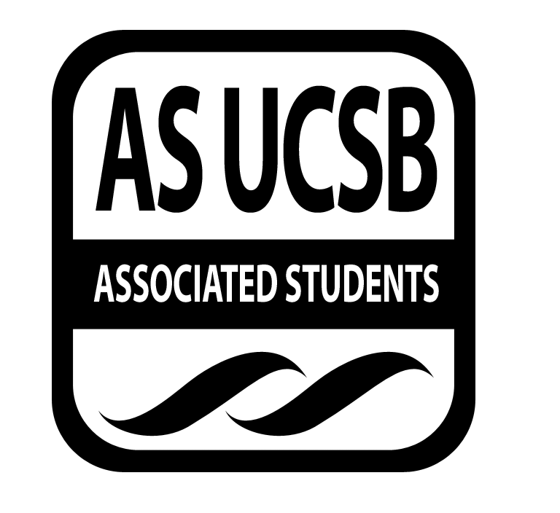
Associated Students
02/16/2016, Tuesday 6:07 PM
Nati Conference

CALL TO ORDER

A. MEETING BUSINESS
- Roll Call (Pre-entered Names)

Name | Note:  absent (excused/not excused)  arrived late (time)  departed early (time)  proxy (full name) | Name | Note:  absent (excused/not excused)  arrived late (time)  departed early (time)  proxy (full name)
John Morrow | present | Maximilian Stiefel | present
Lauren Croshaw | present | Stephen Fetterly | departed early (excused)
Delaney Archer | present | Emily Rogers | present
Madeline Dahm | present | Sarah Siedschlag | present
Daniel Ellis | present | John Liedle | present
Maya Normandi | present | Alejandra Posada | present

- Acceptance of Excused Absences
MOTION/SECOND: Dahm/Leidle
Motion to accept attendance for 2/16/16.
ACTION: Consent

B. PUBLIC FORUM
  - Announcements/Information/Introductions: Project visitation this weekend. Ellis talks about Coastal Commission Director Lester being fired
  - Appreciations/Concerns
  - Request to have item added to today’s agenda: Accept deposit for gala venue

- ACCEPTANCE of ACTION SUMMARY/MINUTES FROM PREVIOUS WEEK
MOTION/SECOND: Archer/Ellis
Motion to approve minutes from February 9th.
ACTION: Consent

- REPORTS
- Advisor’s Report: Siedschlag
    - Minor grants due this Friday
    - Grant review Tuesday, week after will be final decision making
    - Some final reports have come in, board to go over liaison reports to be discussed next week
    - Grad student recruitment tomorrow for board

- Chair Report: Morrow
    - AS recruitment
    - Honoraria due Sunday

- Coastal Service Program: Fetterly
    - Surfrider beach clean-up

- Outreach and Education: Rogers
    - Location has been confirmed for the Gala - Maritime Museum

- Sub-Committee Reports
    - Visiting Your Children's Trees this Saturday and have two project visitations next week
    - Discuss outline for emergency funding application next week

- ACCEPTANCE of AGENDA/CHANGES to AGENDA FOR THIS WEEK
MOTION/SECOND: Ellis/Liedle
Motion to approve the agenda for February 16 with changes.
ACTION: Consent

- ACTION ITEMS

New Business
- Budget Re-alloction: Fall 15-07
- Not taking any money away from students, line items have improved less money towards travel
MOTION/SECOND: Steifel/Last Name
Motion to approve budget reallocation for Fall 15-07.
ACTION: Consent

F-2 Gala Venue
- Securing same location as last year with discount at Santa Barbara Maritime Muesuem
MOTION/SECOND: Dahm/Steifel
Motion to pass $2,200 dollars and $500 deposit for the Coastal Fund Gala in May.
ACTION: Consent

- DISCUSSION ITEMS
- Intern Stipend Question
  - Responsible for Follow-through: NAME of PERSON/GROUP/N/A

- Project Review

WIN 16-01: The Impact of Sea-Level Rise on Coastal Erosion at UCSB
Applicant: Paul Alessio, UCSB Earth Science & Geography

Summary:

We are requesting funding for the support of two graduate students and eight undergraduate students from the Earth Science, Geography, and Environmental Science departments. Funding will be used for travel expenses, support for students, and saftey equipment. Undergraduate students will be working closely with and assisting graduate students in a 194E research class setup in the Earth Science department. By involving students in two disciplines, including undergraduates, in the measurements and analyses we will be providing valuable experience for STEM students, including those from underrepresented groups.
Presentation:
- Sea level rise is 8in
- High level resolution scans that track sea level over time
- Started in November to track El Nino impacts
- Look at swell data and see what different are causing erosion patterns
- Look at the ecological changes in local beaches at UCSB
- What we want to money for is we have a class of undergrads teaching about terrestrial lidar and how to use it and create maps with point cloud data

Board Q & A:

Q: How much time will the interns be spending?
A: Depends on the units that the student chooses.
Q: What is the class number?
A: 194 independent research class Processing of Terrestrial Lidar data.
Q: Will you expect students to have any experience?
A: Not really, it is a hands on class.
Q: Which number is correct 12 or 3 thousand and what will the money go towards?
A: Two graduate students and 8 undergrads to be in class and compensated.
Q: What is the goal for the data to go towards?
A: Measuring the coastal impacts of cliff erosion, develop awareness about erosion.
Q: Are you just talking about physical resistance of cliff and beaches?
A: Sea cliff resistance and resilience however we will not be measuring resilience.
Q: What is supplementary funding from Sea Grant and NOA going towards?
A: Equipment and supplies for machine: battery, cords, and NOA go towards salary for teachers and specialized software for campus.
Q: Going back and forth between weather reports before/ after El Nino storms, why is that?
A: First serves as base level and after storms to see response to look at both with large storms and not.
Q: Minimum hour requirements in order to pay them?
A: Have not made minimum requirements but I would want at least 2 hours a week.
Q: Time period in January is to raise awareness, how so?
A: Put up signs, talks, emails.

Possible conflict of interest Jack Morrow might take class next quarter but wouldn’t be getting paid.

Board Discussion:
- Not sure whether or not someone can get paid as well as get units for taking the class
- Class and paid interns might be separate
- Recruitment strategy a bit narrow since he only takes students from the class
- Supplemental strategy or TA payment
- Not sure if we think he is accountable--missed meetings and many errors in proposal

MOTION/SECOND: Last Name/Last Name
Motion to send send Paul Alessio an email
ACTION: Vote: X-X to APPROVE/DENY.

WIN 16-10: Protecting California’s Central Coast from the Risks and Impacts of Oil Development
Applicant: Kristen Hislop, Environmental Defense Center

Summary:
"Protecting California's Central Coast from the Risks and Impacts of Oil Development" will have a two-pronged approach, with one component focused on avoiding the risks of new oil development and the other on restoring our coastal environment in response to the Refugio Oil Spill. During the first prong of our project, we will conduct research and develop information to help stop an expanded oil drilling project from Platform Holly, directly off the coast from UCSB. The second portion of our effort will focus on researching other oil spill incidents governed by the Natural Resource Damage Assessment (NRDA) law to ensure that the Refugio Oil Spill assessment of harm is robust and regional restoration planning is effective.
Presentation:
- Kristen 7:02pm
- Project focusing on getting intern to help
- Project will focus on avoiding risk and also
- Intern will research science behind claims that oil drilling can be beneficial for the environment to determine risk
- Also do research on the impacts of the recent Refugio oil spill
- Research other oil spill impacts in guidance on how best to restore the coast

Board Q & A:

Q: When the intern is doing the research are there any resources that you will be guiding them?
A: Yes Linda (EDC) and I will be guiding them with literature, contacts.
Q: What are the specifics on how the restoration works?
A: Restoration progress is often slow and multi-faceted.
Q: It is currently leased out to the public
A: We will look at their environmental impact report and
Q: Is it possible that access will be determined
A: Access will not be open during time of internship.
Q: What is your recruitment program?
A: We will send out email blast to UCSB students and solicit applications.
Q: Intern for research will look at impact for a new oil drill or risks of potential drilling?
A: That will be included in their environmental impact report.
Q: If we had to cut something , for example staff time how would that affect your project?
A: We have to have staff time funding to have an intern.
Q: Will the supervision be solely to
A: In order to work on project with research, supervising but also checking research.

Board Discussion:
- In the past we didn’t fund staff time and they had to turn down the grant because they couldn’t actually support it
- Couldn’t imagine a better internship program to help stop and restore impacts of oil spills on our coast

MOTION/SECOND: Liedle/Archer
Motion to table discussion for Win 16-10 until our final decision date with intention to fund in full.
ACTION: Vote: Consent

ADJOURNMENT

MOTION/SECOND: Morrow/Ellis
Motion to adjourn the meeting at 8:29pm.
ACTION: Vote: Consent

