Coastal Fund Minutes

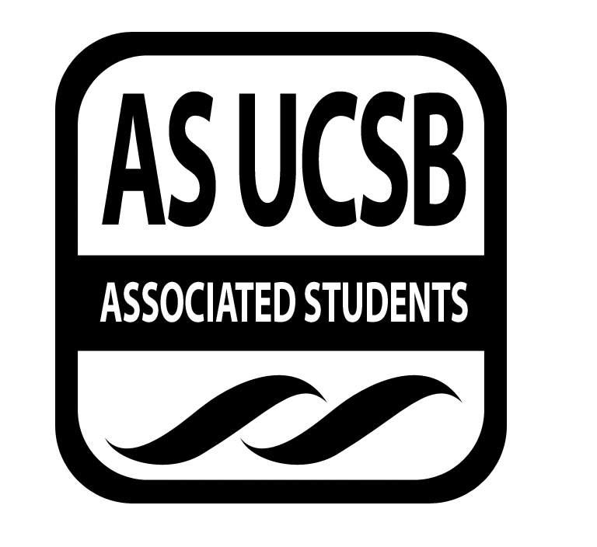
Associated Students
11/3/14, 6:00 PM
AS Conference Room Minutes by Omead Poure

Call to Order: Gad Girling at 6:07

A. MEETING BUSINESS
- Roll Call

Name | Note:  absent (excused/not excused)  arrived late (time)  departed early (time)  proxy (full name) | Name | Note:  absent (excused/not excused)  arrived late (time)  departed early (time)  proxy (full name)
Gad Girling | Present | Kevin Lu | Present
Kelsey Bisson | Excused Tardy | Sara Rosenblatt | Present
Omead Poure | Present | Kylie Taylor | Present
Hilary Walecka | Present | Megan Roy | Present
Ryan Fass | Present | Jonathan Rothschild | Present
Evan Perlman | Present | Matthew Mills | Present
Samantha Fulgham | Present
Aaron Jones | Excused tardy

- Acceptance of Excused Absences & Acceptance of Proxies

MOTION/SECOND: Perl/Fass
Motion to excused the tardies of Bisson and Jones
ACTION: Vote: Consent

A-3.
MOTION/SECOND: Fulgham/Rosenblatt
Motion to approve minutes 10/27/14
ACTION: Vote: Consent

B. Announcements

B-1 Food Bill Update
- Girling: Food Bill for coastal fund wont pass for fall 2014
B-2 Retreat Updates
- Girling: Doodle poll us. It’s kind of scattered so were going to work on figure out the best day.
B-3 Chicken Next Tuesday 11/11
B-4 Sign Up for Office Hours
- Sign up for your hours and make sure you’re there

- ACCEPTANCE of AGENDA 11-3-14

MOTION/SECOND: Fulgham/Perlman
Motion to approve agenda 11-3-14
ACTION: Vote: Consent

- Budget Announcement
None
E. Outreach Budget
None
F. REPORTS
- Advisor’s Report: Jones: I will be late this quarter because IVTU meets on Monday. There is also a special elections going on right now for two executive office positions. Folks can vote on gold. The elections committee needs at least a 20% voter turnout. Halloween was very calm this year. There were roughly 20 citations and 20 arrests this year.

- Chair Report: Girling/Bisson
- Girling: Grant funding is week 9.
- Bisson: Dr. Horny sent us an email regarding clarification of their project. Go through it and make notes of it.

- Senate: Rothschild
- Rothschild: Please make sure to vote

- IV Surfrider
- Rosenblatt: I went to the meeting last week.

- EVPLA - None

- Administrative Report: Poure
- Poure: Jessica Myers from bestcolleges.com would like to review here website and see we could use it as a resource and potentially setup a link on the coastal fund web page.

- Coastal Service Program: Mills

- Outreach and Education: Roy/Taylor/Lu
- Lu: Still working on events. Specially a kayaking event
- Taylor: Working on an art walk event. We are also working on an inventory of merchandise event. Beth is working on a new more professional coastal fund poster.

- Sub-Committee Reports

  - Film Sub-Committee (Bisson/Fulgham/Walecka et al)
    - None
  - Intern Check in Sub-Committee (Fulgham/Mills/Girling)
    - Fulgham:
  - Merch Sub-Committee (Girling/Bisson/Perlman)
    - Griling: We are looking into getting a discount with Patagonia clothing line.
  - Special Events Sub-Committee (Fass/Rosenblatt/Taylor)
    - Rosenblatt: Would like to have a potluck or bbq for team bonding. We will be sending out a new doodle pool.
    - At 12 to 1:30 on Wednesday there will be a sustainability tour. Meet at the benches overlooking the lagoon.
  - Project Visitation Sub-Committee (Perlman/Lu/Roy)
    - Bisson: We definitely want to meet with KIN.
    - Perlman: Would like to see the Gaviota coast movie project from last year.

G. ACTION ITEMS

G-1. Old Business: None

G-2. New Business
- Outreach Art Walk:
MOTION/SECOND: Perlman/Fulgham
Motion to allocated $140 to print out pictures for an art walk
ACTION: Vote: Consent

- Snack Allocation (150$)
MOTION/SECOND: Fulgham/Fass
Motion to approve $150 for snacks
ACTION: Vote: Consent

c. 2012-2013 Annual Report
MOTION/SECOND: Fulgham/Rosenblatt
Motion to table 2012-2013 annual report to a later date
ACTION: Vote: Consent

G-3. Project Update

G-4. Project Review
- FALL14-06: UCSB Campus Lagoon – Continuting multifaceted restoration eforts
Seeking CCBER’s goal is to build on the successful restoration efforts of the last few years by continuing to expand the conversion of weed-dominated monocultures to diverse native habitats at several sites of the Campus Lagoon natural area. We plan to continue using innovative techniques such as solarization and experimental salt-water application along with standard manual efforts to achieve our restoration goals. We are requesting partial support for the project manager and support for student workers during winter and spring quarters. These projects are part of CCBER’s effort to incrementally and sustainably implement the Coastal Commission approved Lagoon Restoration Plan.

The board believes they cover the CF mission statement
MOTION/SECOND: Pearlman/Fulgham
Motion to table FALL14-06 with cuts to budget to a later date
ACTION: Vote: Consent

- FALL14-07: Restoration Intern Training Program Winter & Spring 2015
Provide a brief stand-alone description of proposal, including objectives (100-word maximum).
CCBER seeks funding for student interns to participate in CCBER restoration work in multiple sites and habitats from the Campus Lagoon Dune and Bluff restoration to Storke Wetland. Eligible students have generally participated in CCBER’s Restoration Ecology Field Skills Class (ES95) in which CCBER Staff provide three or four sections for three-hour training sessions per week focused on a range of relevant restoration skills. We seek Coastal Fund support for 6 paid student interns for Winter & Spring 2015 quarters. Students can follow-up their training with an opportunity to gain in-depth experience working with a project manager and helping with important ecological restoration projects. Funding request: 6 students x $375/quarter x 2 quarters = $4,500

MOTION/SECOND: Perlman/Rosenblatt
Motion to table project FALL14-07 with cuts to budget with stipulation to contact Lisa Stratton asking for clarification on errors and funding interns at $337.50.
ACTION: Vote: Consent
Follow up: Fulgham will follow up with Stratton

- FALL14-08: Physiological drivers of toxicity in the harmful diatom, Pseudo-Nitzschia in response to silicon and iron limitation.
Harmful Algal Blooms (HABs) formed by diatoms from the genus Pseudo-nitzschia, threaten the local coastal health and economy. Although the natural conditions that cause Pseudo-nitzschia to produce domoic acid are not completely understood, stress caused by low nutrient availability appears to play a crucial role. This project proposes to examine how physiological stress changes the toxcity in Pseudo-nitzschia in response to the availability of the essential nutrients, silicon and iron. This project will promote undergraduate research by employing an intern and enhance our current understanding of drivers of HAB formation and potentially help refine forecasting models that predict HAB events.

MOTION/SECOND:
Motion to table project FALL 14-08 with cuts to budget and to a later date with stipulation to contact applicant regarding number of microscope hours.
ACTION: Vote: Consent
Follow up: Bisson will follow up with applicant via email.

Board thinks she would be a good mentor for an undergraduate student.
ADJOURNMENT

MOTION/SECOND: Fass/Pearlman
Motion to adjournment
ACTION: Vote: Consent

8:22 PM

