Coastal Fund Minutes

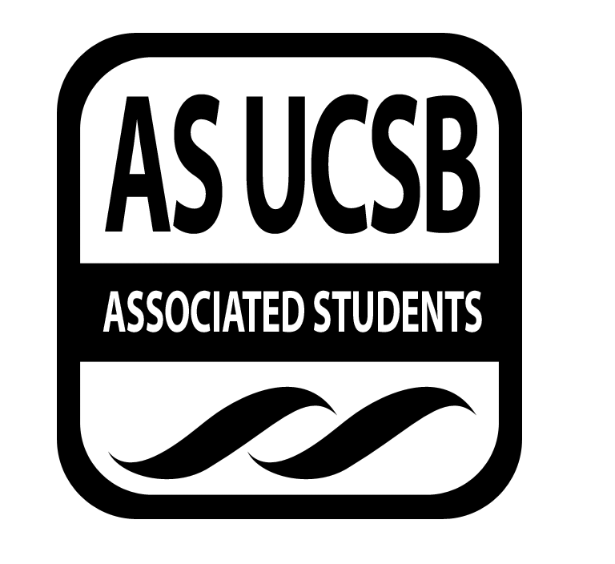
Associated Students
10/28/13, 6:00 PM
AS Conference Room Minutes/Actions recorded by: Miranda Walker

CALL TO ORDER AT 6:06 PM

A. MEETING BUSINESS
- Roll Call

Name | Note:  absent (excused/not excused)  arrived late (time)  departed early (time)  proxy (full name) | Name | Note:  absent (excused/not excused)  arrived late (time)  departed early (time)  proxy (full name)
Natalie Testa | Present | Miranda Walker | Present
Marissa Bills | Present | Sara Rosenblatt | Present
Taylor Debevec | Present | Marcee Davis | Present
Gad Girling | Present | Megan Roy | Present
Bjorn Kallerud | Present | Andre Taylor | Absent
Kelsey Bisson | Excused Absence
Samantha Fulgham | Present
Aaron Jones | Present

- Acceptance of Excused Absences & Acceptance of Proxies

MOTION/SECOND: Girling/Debevec
Motion to approve absences and proxies.
ACTION: Consent
B. Announcements
None.

- ACCEPTANCE of ACTION SUMMARY/MINUTES

C-1. Approval of our Action Summary/Minutes from 10/21/13

MOTION/SECOND: Fulgham/Debevec
Motion to approve action summary/minutes from 10/21/2013
ACTION: Consent

- ACCEPTANCE of AGENDA

MOTION/SECOND: Girling/Debevec
Motion to approve agenda 10/28/13.
ACTION: Consent

- Budget Announcement
- The board must decide what they would like their annual and quarterly budget to be. This will be discussed at the next meeting.

E-1. Outreach Budget
- None.

- REPORTS
Announcements in this section are informational. Do not include any requests for financial allocations.

- Advisor’s Report
  - CSP 990 Requests
    - Marisella has called attention to the 990’s that must be provided by any non-profit projects receiving free labor through the Coastal Service Program, not just funded projects by the board. All funds must be included because they are all funded using the lock-in fee. It demonstrates that these organizations are verifying they are a rightfully chartered non-profit.
- Chair Report: Bills
  - Coastal Fund Processes
    - Jones and Bills will meet later this week to further discuss the logistics and implementation of future processes changes which includes the following:
      - Instituting a Technical Assistance Workshop, accountability of their Award
2-A. Incremental Funds
2-B. 990 IRS Statements
2-C. Final Reports
      - Denial of Future Awards Based on Non Compliance with the Board’s Expectations
- Senate

- IV Surfrider
  - All applications have been received and will be reviewed this week, at which time interviews will be scheduled.
- EAB
  - Events are continuing weekly, including hikes, gardening, and bike trips to farmers market. This week they will be meeting in the Storke courtyard, encouraging members to dress in their costumes.
- EVPLA
  - Preparations for Halloween
    - Hydration-station will be placed at the lower end of the loop 7PM-2AM Thursday-Saturday with two volunteers to help. Take Back the Night and Women’s Center along with other campus organizations will be staffing a crisis center.
    - Alex Moore of EVPLA is attempting to implement fencing along all parks to protect the community during the Halloween weekend. Potentially launching a campaign to encourage residents to amend and be mindful to make the cliffs safer.
- Administrative Report
  - Missing Final Reports WIN08-FALL12 update
    - Jones and Walker have agreed to meet together to discuss how to go about contacting these individuals. They plan to contact the applicants personally and request the reports.
  - MINOR Fall13-16
    - A new minor funding project has been received and will be reviewed on the Nov. 18th meeting.
  - Minutes and Agenda
    - Only budget items that are approved in minutes are time sensitive. The board has agreed to delay sending final minutes until they have been approved at the next meeting. In the mean time, draft minutes may be sent to the senate for budget approvals. This allows the board time to review and edit the minutes.
    - Agenda items must be emailed to Walker before 2PM Mondays.
- Coastal Service Program
  - Rollover amount has been finalized; the exact amount is $1,435.94.
  - Weekly group update – two groups are going out this weekend.
  - Coastal Fund CSP project with Growing Solutions
    - Potential dates: Nov. 2nd and Nov. 16th
  - Awards may be made for groups who have the most attendees, pick up the most trash, etc. This is tentative and will be discussed further at a later date.
- Outreach and Education
  - Sweatshirts or Jackets for Coastal Fund for board and staff
    - Everyone has agreed to pay out-of-pocket for custom board and staff jackets. These will not be distributed to the public. The design layout will be drafted in the coming weeks and will be presented to the board at a later date.
  - 15th anniversary merchandise
    - Tide-calendars and logo design drafts will be showcased next week.
  - Photo contest
    - A new photo contest will be opening in the coming weeks, in which case contestants will take photos of themselves wearing their Coastal Fund shirt in the local Santa Barbara area – the most outstanding photos will be featured on CF’s Facebook and newsletter.
  - Budget: there is no rollover amount available.
  - Mutt-Mitts Co-sponsorship will be reviewed at the next meeting after more information has been provided by the organization.
- Sub-Committee Reports
Subcommittees will be formed at a later date.

- ACTION ITEMS

G-1. Old Business

G-2. New Business
- Food Cash-Advance
    - A cash advance will be given to a particular individual to allow Coastal Fund to make food orders for the remaining of the quarter without requiring board or staff to pay out-of-pocket. Receipts will be submitted at the end of the quarter and any remaining funds will be returned.

MOTION/SECOND: Debevec/Girling
Motion to allocate a $300 cash advance to Aaron Jones to place food orders for the following two meetings.
ACTION: Consent

  - Reconsidering Incremental Funds Recommendation as requested by Marisella Marquez
    - As explained by Jones, having funds paid in increments will not be out of the organizations norms and expectations. The amount of funds will be distributed as purchases are made and receipts are submitted.
    - Opined by Roy: this change will affect all co-sponsorships. They will not be able to happen, given all co-sponsorships are fiscally and time sensitive. Most co-sponsorships are given to support one-time events. The events themselves will not directly apply to the CF mission, as they are distinct from grants, and they will not have the funds already available, thus affecting the opportunity for events to be featured.
    - Rosenblatt would like to know how this would affect the Coastal Service Program.
    - Other considerations made by the board include increasing the percentage of the total grant distributed at the beginning of each project and increments of cash-advances.
    - Concerns by the board and staff: an applicant may not be able to begin their project due to front-loaded money requests for equipment necessary to begin the project and setting a standard and evaluating each project on a case-by-case basis would become difficult to monitor. Past experiences have demonstrated that many internships, graduate student endeavors, and local projects have had difficulty in paying these expenses in the beginning without their grant in full.
    - Jones opined: There are currently projects not using funds at the beginning of their project nor are all applicants using all of the funds awarded to them, therefore not all applicants will be affected in any significant way.
  - Coastal Service Program Requiring 990s
MOTION/SECOND: Debevec/Girling
Motion to require 990s from all non-profit organizations that receive free-labor from the Coastal Service Program.
ACTION: Consent

G-3. Project Update
None available.

G-4. Project Review
- FALL 13-08 The End of Southern California
Over the course of twelve months this movie will unfold the astonishing ecological circle that takes place on the Gaviota Coast. Watch as the flora and fauna from the mountains to the coastline ebb and flow throughout the summer, fall, winter, and spring. From this production, an archive is being created for the use of the non-profit organizations charged with protecting the coast, as well as the educational institutions of the Santa Barbara Community. Depending on where the interest lies, a copy may be provided to UCSB, SBCC, and any other local organization. As a side note the temp score used for the film is original. The hope is to involve the SB Symphony to write an original score that would also be available in the archive. The producer also hopes to premier the film at the Granada while the SB Symphony play the score live.

The Gaviota Coast Conservancy applied for $20,000 in 2011. We required that they find a matching grant in order to ensure the success of the film. In two quarters they were able to find other sponsoring organizations and recieve the grant. They have had a full year cycle to work on the film. They are in the final stages and will need further funding to complete the project.

In the meeting technology clarifications were made regarding the camera package, go pro kit and motorized pan. All such equipment will assist the current technology equipment being used, the gopro more specifically being used for harsher conditions and is more versatile. Note that all equipment and the archive will be donated to the university. Further clarifications include the internship coordinator duties. The intern coordinator helps to arrange exit interviews and oversee the activity of the production, ensuring that the internship program is not neglected. The board agrees that the project is in full support for the Coastal Fund mission. The project gives back to the community, provides phenomenal equipment to the school, and educates both our local community and public at large of the Gaviota Coast.

MOTION/SECOND: Girling/Debevec
Motion to table the project in the full amount of $16,600.00
ACTION: Consent

Kallerud declares a conflict of interest, as his friend is a part of the filming project. Jones declares a conflict on interest, as he has known Shaw for an estimated 11 years, worked with him at Trader Joes for several years, and has been in constant conversation in the recent months with both Shaw and Wolf regarding an investigation separate from the whistle blower report.

- FALL 13-10 Oceans-to-Classrooms (O2C)

The effects of Climate Change will significantly affect our relationship with, and understanding of Nature for generations. Our education system is in the midst of change as well. Therefore, it has never been more critical to our health-physically, mentally, economically, and environmentally, that people understand how the world, as a living system, functions. Baba Dioum said, “In the end we will conserve only what we love; we will love only what we understand; and we will understand only what we have been taught.” A River Runs To It teaches people how local ecological relationships are tied to global environmental issues using local streams in the Goleta Slough Watershed that run into Goleta Bay-the front yard of UCSB! Increasing their science literacy. Inspiring them to be better stewards of the environment. The board has agreed that the project is in support of Coastal Fund’s mission to educate the UCSB and local community of the importance of our local habitat. The board agrees to fund the project given that the applicant provide a more detailed outline of his budget. Should funds be limited, the number of workers will be reduced.

MOTION/SECOND: Debevec/Fulgham
Motion to table the project in the full amount of $45,000.00, pending he provide a detailed description of the budget.
ACTION: 3-0-3

Conflict of interest declared by Testa, Girling, and Bills. The three have excused themselves from the discussion as they each work for the project.

- MINOR FALL 13-02 Kids in Nature Peer to Peer Environmental Education Program

Five undergraduate students will be selected to serve as Kids in Nature (KIN) interns during winter quarter 2013. The interns will have successfully completed the Education Practicum course (EEMB 189/ES 191), which we have offered each quarter since 2008. The KIN interns will serve as mentors for the newly enrolled UCSB students and also for the over 85 5th grade students who are part of the KIN program. The interns will each lead one of the KIN groups of 4-5 students in classroom activities and on field trips.
MOTION/SECOND: Girling/Kallerud
Motion to table the project in the full amount of $13,602.00
ACTION: 5-0-1

Natalie abstains, as she is enrolled in the class.

- REMARKS

ADJOURNMENT at 9:30 PM

MOTION/SECOND to ADJOURN: Girling/Debevec
ACTION: Consent

