Coastal fund Agenda

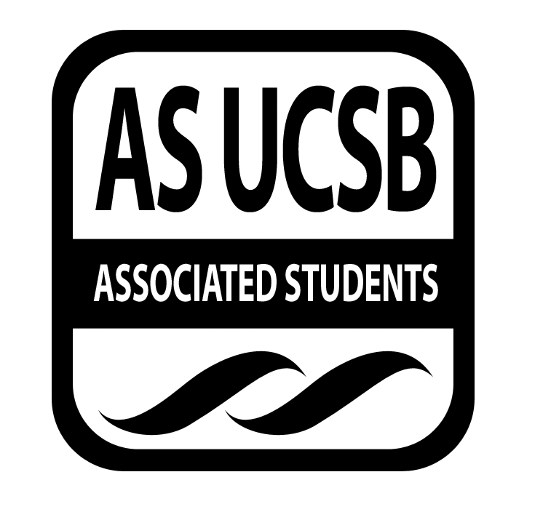
Associated Students
03/29/2016, Tuesday 6:47 PM
Nati Conference

CALL TO ORDER

A. MEETING BUSINESS
- Roll Call (Pre-entered Names)

Name | Note:  absent (excused/not excused)  arrived late (time)  departed early (time)  proxy (full name) | Name | Note:  absent (excused/not excused)  arrived late (time)  departed early (time)  proxy (full name)
John Morrow | Present | Maximilian Stiefel | Absent
Lauren Croshaw | Present | Stephen Fetterly | Present
Delaney Archer | Present | Emily Rogers | Present
Madeline Dahm | Present | Sarah Siedschlag | Present
Isabella Marill | Present | John Liedle | Present
Maya Normandi | Present | Alejandra Posada | Present

- Acceptance of Excused Absences
MOTION/SECOND: Archer/Croshaw
Motion to accept this week’s attendance.
ACTION: Consent.

B. PUBLIC FORUM
  - Announcements/Information/Introductions: Ice breakers/ intro Isabella, table option of starting meeting at 6:30
  - Appreciations/Concerns
  - Request to have item added to today’s agenda

- REPORTS
- Advisor’s Report: Siedschlag
- All grant paperwork compiled, checks going out as soon as ED signs

- Chair Report: Morrow
- Food adjustment
- Senate liaison Austin Hetchler
- Honoraria will be available

- Coastal Service Program: Fetterly
- Spring quarter calendar is up
- fliers made
- clubs or sports friends? would like to connect

- Outreach and Education
- Gala menu update
- Newsletter going to be sent out next week
- Earth day doodle going to be sent out

- Sub-Committee Reports
-Project Visitations

- ACTION ITEMS

New Business

F-1 Rain Supreme Co-Sponsorship
- Event hosted by the Program board, event to soon to fund and we have further questions
MOTION/SECOND: Croshaw/Archer
Motion to back the Rain Supreme tour on social media.
ACTION: Consent

F-2 Blue Water Ball Co-Sponsorship
- Discussion of amount to fund $5,000-1,500, due to budget restrictions we will fund in lowest amount for 2 tickets and ¼ pg ad
MOTION/SECOND: Dahm/Marill
Motion to co-sponsor the Blue Water Ball for an amount of $1,500.
ACTION: Consent

F-3 Environmental Defense Center Sign-On Letter
- Expanding the definition of chaparral and making it a protected habitat
MOTION/SECOND: Liedle/Dahm
Motion to sign off on EDC’s sign on letter.
ACTION: Vote 5-0-1 to APPROVE

Isabella declares conflict of interest as current intern for EDC. Board does a hand vote.

F-4 Fall 15-07 Budget Reallocation
- Moving funds towards travel away from internship, however, this would help cover costs for students
MOTION/SECOND: Liedle/Marill
Motion to table discussion on budget reallocation for Fall 15-07 until next week’s meeting.
ACTION: Consent

F-5 Winter 16-14 Budget Reallocation
- Didn’t realize that she could not be reimbursed retroactively, so is reallocating budget
MOTION/SECOND: Last Name/Last Name
Motion to approve budget reallocation for Win 16-14.
ACTION: Consent

F-6 Fall 15-06 Extension Request
- Looking to further research to implement into research design
MOTION/SECOND: Croshaw/Dahm
Motion to grant Fall 15-06 extension request
ACTION: Consent

F-7 Fall 15-07 Extension Request
- Project expected to be done sooner, however, actual deadline is in Sept
- No action needed deadline is already within range of expected end date

- DISCUSSION ITEMS

G-1 Spring 2016 Meeting Schedule
- Meeting time will be at 6:30
a. Responsible for Follow-through: Morrow

G-2 Coastal Fund Board 2016-2017 Interviews
  - Responsible for Follow-through: Morrow

G-3 Tabling Shifts at SB Earth Day
- Will send out Doodle on Thursday
a. Responsible for Follow-through: Rogers

ADJOURNMENT

MOTION/SECOND: Liedle/Marill
Motion to adjourn meeting at 8:04pm
ACTION: Consent

