Coastal Fund Minutes

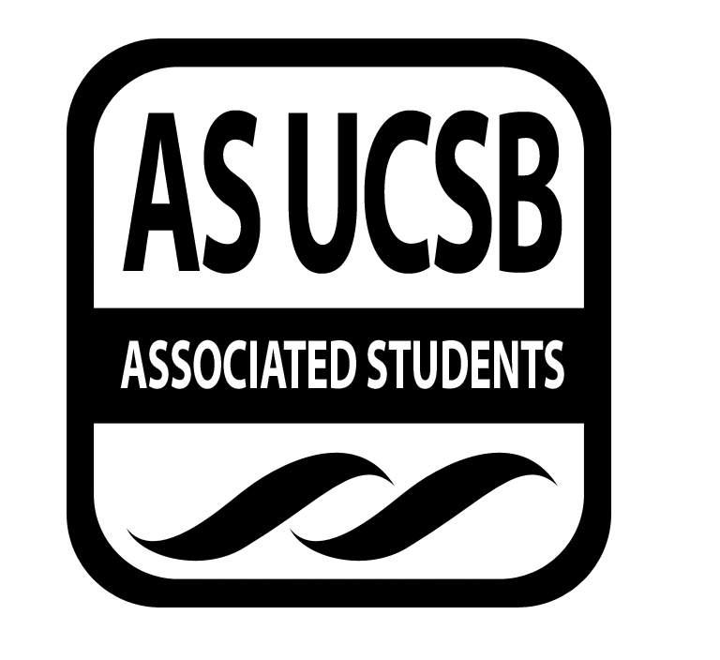
Associated Students
11/18/13, 6:00 PM
AS Conference Room Minutes/Actions recorded by: Miranda Walker

CALL TO ORDER AT 6:10 PM

A. MEETING BUSINESS
- Roll Call

Name | Note:  absent (excused/not excused)  arrived late (time)  departed early (time)  proxy (full name) | Name | Note:  absent (excused/not excused)  arrived late (time)  departed early (time)  proxy (full name)
Natalie Testa | Present | Miranda Walker | Present
Marissa Bills | Present | Sara Rosenblatt | Present
Taylor Debevec | Present | Marcee Davis | Present
Gad Girling | Present | Megan Roy | Present
Bjorn Kallerud | Present | Andre Taylor | Present
Kelsey Bisson | Present
Samantha Fulgham | Present
Aaron Jones | Present

- Acceptance of Excused Absences & Acceptance of Proxies

MOTION/SECOND: Bills/Kallerud
Motion to approve absences and proxies.
ACTION: Consent
B. Announcements
- None

- ACCEPTANCE of ACTION SUMMARY/MINUTES

C-1. Approval of our Action Summary/Minutes from 01/13/2014

MOTION/SECOND: Kallerud/Bills
Motion to approve minutes from 01/13/2014.
ACTION: Consent

- ACCEPTANCE of AGENDA

MOTION/SECOND: Kallerud/Bills
Motion to approve agenda 01/27/2014.
ACTION: Consent

- Budget Announcement
None.

E-1. Outreach Budget
Tide calendar cost… remaining amount of money is…

- REPORTS
Announcements in this section are informational. Do not include any requests for financial allocations.

- Advisor’s Report
  - Office Space
    - It is important that the office space be respected and that the computers belonging to staff are always available. It is also important to be mindful of the use of office supplies for things that are not specific to Coastal Fund. Furthermore, if office supplies needs to be ordered please contact Walker. Additionally, Jones requests that any food and trash be composted or discarded in the trash bins outside the office. There is a compost bin available in the CAB office and composting guidelines are posted above the bin.
  - Intern stipends and pay rates
    - After reviewing the data composed by Walker regarding intern stipends and pay rates, Jones recommends that stipends and pay rates be codified. Also noted is the state’s upcoming increase for minimum wage by 12.5%.
  - Fair Political Practices
    - Jones, Testa and Kallerud will be drafting a response to FPP regarding Coastal Fund’s specific practices and procedures.
- Chair Report: Testa
  - Intern stipends and pay rates
    - Testa suggests that the board set a base pay for student interns. This will be further discussed in new business.
- Senate
  - Schedule conflict
    - Unfortunately Taylor has been scheduled by AS to attend two BCC meetings that both begin at 6PM on Mondays. He may attend each BCC’s meeting on alternating week.
  - Current AS objectives
    - Current objectives include the restructuring of BCCs. In addition, the food bill was passed last week. The bill will be posted with AS minutes within the coming week.
- IV Surfrider
  - The next general meeting will be this Wednesday at Woodstocks. Beginning this week will be campaign planning.
- EAB
  - Events and weekly meetings continue in the GSA Wednesdays at 7PM.
- EVPLA
  - Alex Moore, EVPLA External Vice President of External Affairs, gave a short presentation regarding local political news including, but not limited to, the reopening of oil extraction off the Goleta Beach, the review of the environmental impact report by the Goleta City Council and the oil extraction tax that has been tabled indefinitely by the county.
- Administrative Report
  - Final reports WIN08-FALL12 Update
    - Since contacting the 24 applicants who were missing a final report, 15 have submitted their report. Several others are working to complete their report.
    - FALL10-01 Tour Programs at Coal Oil Point Reserve
      - Christina Sandoval, an applicant who received funding for Fall 2013 has not yet submitted her final report for a previous project, FALL10-01. Walker will continue to contact Christina.
  - Upcoming Final Reports Update
    - An excel spreadsheet has been created that note upcoming final report due dates. Of the nine applicants with a January 31st deadline two have submitted their reports and three have requested an extension.
  - SPR13-07 The Peregrine Story
    - Gabriele Drozdoqski has requested that the start and end dates be changed. They have only recently received the other 50% of funds needed to begin and filled the internship positions.
MOTION/SECOND: Fulgham/Debevec
Motion to approve the change in start and end dates for SPR13-07 from 06/01/2013-10/31/2013 to 10/01/2013-02/31/2014.
ACTION: Consent

  - Camino Majorca Funds
    - Jill Van Wie responded to our request for the unspent funds of $104.00 and declared that the fiscal information provided in their final report was not truly accurate. After further explaining the budget and expenses, it was reported that all Coastal Fund funds were spent as allocated. The line items in their requested budget at the time of application were not specific and therefore should not be attested. The project was completed successfully and the board agrees that pursuing the matter further is not necessary.

MOTION/SECOND: Girling/Fulgham
Motion to approve the revised final report with its adjusted fiscal information provided by Jill Van Wie for projects SPR11-20, WIN12-10 and SUM12-06.
ACTION: Consent

  - West Storke Wetland CCBER Letter
    - Lisa Stratton has requested that the board consider signing a letter in which the Coastal Service Program will commit to establishing two dates during Spring quarter in which volunteer groups will participate in the restoration of the West Storke Wetland. Rosenblatt has agreed to make this commitment. She will contact Lisa directly and coordinate the signing of the letter.
  - Girl Scouts Presentation
    - The leader of a local girl scouts troop, Elizabeth Ross, has requested that a Coastal Fund representative attend one of their meetings to present on issues of water conservation, especially considering the state’s decision to declare a drought emergency. Davis and Debevec have agreed to attend their meeting on Monday, February 24th from 3-430PM at La Patera Elementary.
- Coastal Service Program
  - Weekly group update
    - As of last week all dates have been filled. Rosenblatt explained that by requiring reoccurring applicants to be waitlisted several new groups have had the opportunity to sign-up.
  - Rosenblatt will report next week regarding recent payments made to volunteer groups.
  - Copy account
    - Because of a delay in withdrawing funds for the copy-account, $200 was only recently processed.
- Outreach and Education
  - Co-Sponsorships:
    - Valeria Olson with the More Mesa Symposium project from last quarter has reached out to the outreach and education coordinators to request the funds as part of a co-sponsorship, as was recommended by the board. In the past Coastal Fund has given funds for the symposium and handbook. Roy and Davis have requested that the board approve the funding to co-sponsorship the More Mesa Symposium, which will take place March 15th.

MOTION/SECOND: Girling/Bills
Motion to approve the co-sponsorship request of $420 for the More Mesa Symposium, which is to be used to print fliers and posters.
ACTION: Consent

    - IV Surfrider has contacted Davis and Roy to co-sponsor the Concert for the Coast event which will be held Spring of 2014. They have requested $1,250.00. Note: Kallerud, Bills and Testa declared conflict of interest.

MOTION/SECOND: Girling/Bisson
Motion to approve the co-sponsorship for Isla Vista Surfrider’s event “Concert for the Coast” in the amount of $1,250.00.
ACTION: 4:0:3

  - Internship Applicants
    - Applications for the internships have been received and filed. Interviews will begin in the coming two weeks.
- Sub-Committee Reports
Board members and staff will be assigned to a sub-committee this week. If anyone has a time concern it is important to email Testa.

- ACTION ITEMS

G-1. Old Business
  - Green Bill
    - Kallerud reported back regarding his meeting with the advisor of the Green Bill Initiative. He explained that there are ranks within the green bill, to which a group can be moderately green, very green, etc. Kallerud will post an outline of guidelines, the ranks and other important information on the Coastal Fund google drive. The largest impact will include food, in which case all food orders must be from local and sustainable sources, e.g. South Coast Deli. Furthermore, meals should include less meat and more vegetarian options. Each board member is required to sign the pledge, as is provided. Lastly, it is suggested that these same guidelines be applied to future grants. The Green Bill sub-committee will be the ones to help implement the changes needed and make the necessary adjustments in the office.
  - Ecoalition
    - At the Ecoalition meeting over 200 groups met to show support for one another. The groups discussed ways to improve communication between environmental organizations and what they would like to see future meetings look like. At the meeting Kallerud met a member from another group who is taking action to make the annual Extravaganza event waste-free. Meetings will continue on a monthly basis with at least one representative from each group. Bjorn has volunteered to be Coastal Fund’s representative at the Extravaganza.
G-2. New Business
- Internships and Stipends
    - Based on the state’s increase in minimum wage of 12.5% and the trend found amongst previous applicant intern funding requests in the previous years undergraduate student stipends will begin at $10 hourly and $337 quarterly.

MOTION/SECOND: Girling/Bills
Motion to approve an increase in undergraduate student intern pay rates, beginning at $10 hourly and $337 quarterly.
ACTION: Consent

- Final reports
    - Each quarter the chair and vice-chair will provide summaries of final reports that have been submitted.

G-3. Project Update
- Extension requests
  - FALL12-10 Santa Barbara Restoration Project Data Base I
    - Lisa Stratton has requested that the end date be changed from 07/31/2013 to 03/31/2014. Stratton plans to use this time to further improve the SB Restoration Data Base including an interactive map. Stratton has also requested that the $312 of unspent funds be used to pay the expert in the program.

MOTION/SECOND: Bills/Debevec
Motion to approve the extension request for FALL12-10 from 07/31/2013 to 03/31/2014 and reallocate $312 of unspent funds for the expert in the program.
ACTION: Consent

  - SPR13-08 Santa Barbara Restoration Project Data Base II
    - For the same reasons that Lisa Stratton provided in her earlier project FALL12-10, she has requested to extend the deadline.

MOTION/SECOND: Bills/Girling
Motion to approve the extension request for SPR13-08 from 12/31/2013 to 03/31/2014.
ACTION: Consent

  - SPR13-12 Protecting Local Marine Habitats from the Invasive Asian Kelp, Undaria pinnatifida, through integrated pest management
    - Carrie Culver and Marissa Bills have requested an extension in order to complete their survey analysis. In addition, the time spent collecting the studied organism was more extensive than anticipated. Given that some progress has been completed, the board would like to ensure that the project is followed through to its end.
Note: Marissa declared conflict of interest. Bisson/Fulgham 6:0:1

MOTION/SECOND: Bisson/Fulgham
Motion to approve an extension request for SPR13-12 from 12/15/2013 to 06/13/2014.
ACTION: 6:0:1

G-4. Project Review

  - WIN14-01 Fun in the Sun – Summer of Service
FITS is a national award-winning summer learning program designed to: 1) improve academic, behavioral, and social skills in financially and academically struggling children (ages 7-18), and 2) address the long-term effects of summer learning loss and the achievement gap on participants, their families, and the community. To do so, FITS incorporates service-learning curriculum into its comprehensive programming by offering participants hands-on educational activities that focus on environmental/disaster preparedness issues. Held at six south Santa Barbara County sites, FITS promotes literacy, science/math, character development, and civic engagement, while inspiring students to pursue higher education and potential careers in environmental/disaster preparedness fields.
Though the board supports the mission of service learning, the connection between the project and the coast is weak. The focus of Coastal Fund is to fund projects that will positively and directly impact the environment and coastal, but this project does not meet this objective. The board is interested in funding the project’s service learning as such funds will go directly to the students who will create their own projects to positively impact the coast.

MOTION/SECOND: Bisson/Fulgham
Motion to table FALL14-01 in the full amount of $6,500.00.
ACTION: Consent

- WIN14-02 Kids in Nature, Environmental Education Program
Ten undergraduate students will be selected to serve as Kids in Nature (KIN) interns during spring quarter 2014. The interns will have successfully completed the Education Practicum course (EEMB 189/ES 191), which they have offered each quarter since 2008. The KIN interns will serve as mentors for the over 90 5th grade students who are part of the KIN program. The UCSB students have already worked with the same KIN students for 2 quarters, which gives a wonderful continuity and builds on the already established relationships. The interns will each lead one of the KIN groups of 4-5 students in classroom activities and on field trips. During spring quarter, the interns will also be responsible for serving as leaders for the development of the final Power Point presentations. Each KIN group presents on the final Celebration Day at UCSB in June 2014.
The board agrees that this project fully supports the mission of Coastal Fund. The project is fully supported and dependent on UCSB students and positively impacts the local coast.

MOTION/SECOND: Girling/Bisson
Motion to table WIN14-02 in the full amount of $12,576.37, with the stipulation that the intern stipends be increased to $337/quarter.
ACTION: 6:0:1

- REMARKS

ADJOURNMENT at 08:30 PM

MOTION/SECOND to ADJOURN: Girling/Debevec
ACTION: Consent

