Coastal fund Agenda

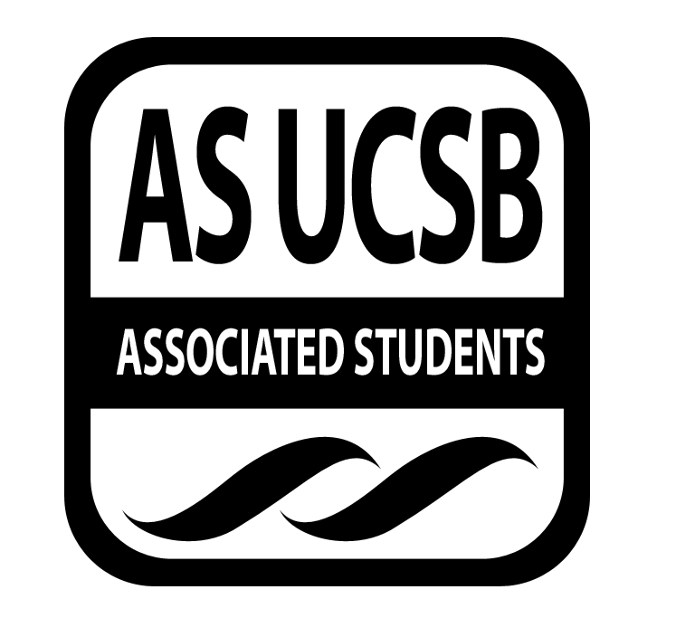
Associated Students
04/12/2016, Tuesday 6:30 PM
Nati Conference

CALL TO ORDER

A. MEETING BUSINESS
- Roll Call (Pre-entered Names)

Name | Note:  absent (excused/not excused)  arrived late (time)  departed early (time)  proxy (full name) | Name | Note:  absent (excused/not excused)  arrived late (time)  departed early (time)  proxy (full name)
John Morrow | present | Maximilian Stiefel | present
Lauren Croshaw | arrived late | Stephen Fetterly | present
Delaney Archer | present | Emily Rogers | present
Madeline Dahm | absent (proxy) | Sarah Siedschlag | present
Isabella Marill | present | John Liedle | present
Maya Normandi | present | Alejandra Posada | present

- Acceptance of Excused Absences
MOTION/SECOND: Archer/Stiefel
Motion to accept excused absences.
ACTION: Consent

B. PUBLIC FORUM
  - Announcements/Information/Introductions
  - Appreciations/Concerns
  - Request to have item added to today’s agenda

- ACCEPTANCE of ACTION SUMMARY/MINUTES FROM PREVIOUS WEEK
MOTION/SECOND: Leidle/Marill
Motion to accept minutes from previous week.
ACTION: Consent

- REPORTS
- Advisor’s Report: Siedschlag
-checks have been mailed

- Chair Report: Morrow
-liason pushed until March 29th and did not pass

- Coastal Service Program: Fetterly
-send contacts for sports and groups

- Outreach and Education
-Earth Day schedule and game set

- Sub-Committee Reports
-Project Visitations

- ACCEPTANCE of AGENDA/CHANGES to AGENDA FOR THIS WEEK
MOTION/SECOND: Leidle/Croshaw
Motion to accept today’s agenda.
ACTION: Consent

- ACTION ITEMS

Old Business
F-1 Fall 15-11 Budget Reallocation Update: Croshaw
-Extension request submited, aware that she will not be able to retroactively recieve funding

New Business
F-2 Coastal Fund Outreach Gala Expenses
-Rental for location $1500 including 3 more cocktail tables, stools, plates
MOTION/SECOND: Croshaw/Archer
Motion to approve $1500 Coastal Fund gala rentals.
ACTION: Consent

- DISCUSSION ITEMS

G-1 Winter 2016 Project Liaison
-Applications due on Sunday
a. Responsible for Follow-through: Jack

G-2 Coastal Fund Board 2016-2017 Interviews: Doodle
-Going to narrow down applications
  - Responsible for Follow-through: Sarah

- Project Review

SPR: 16-03: MPA Watch Internship Program

Applicant: Penny Owens, Santa Barbara Channelkeeper

Summary:

Santa Barbara Channelkeeper seeks a $5,252.30 grant to support two UCSB interns for our MPA Watch Program. MPA Watch is a citizen monitoring program that trains and engages volunteers to record and track human activities in and around Santa Barbara's coastal Marine Protected Areas (MPAs) by conducting onshore visual surveys. The data collected by MPA Watch volunteers is critical in tracking trends in human activities in our MPAs and providing context for the interpretation of biological monitoring data to measure changes in fish populations in response to the protection offered by MPAs. MPA Watch data also aids compliance and enforcement efforts to ensure that MPA regulations are followed.

Presentation:
-MPA Watch Internship program is now a part of a larger statewide Marine Protected Areas internship program
-No one doing human uses, started MPA through Channel Keeper and Heal the Bay
-Volunteer base has been grown within the student body, creating regular surveys, data, and training workshops
-Intern has learned more about the MPA and how the nonprofit works in terms of professional development
-Would like to pay interns
-Almost 2,000 surveys conducted

Board Q & A:

Q: Is the undergrad work on honor system?
A: Have to complete a certain amount every month.
Q: Funding for supervisor, how much does the supervisor add to the internship?
A: Checking in a couple times a month, checking data, how to run outreach, MPA event, fundraiser.
Q: Being able to do boat based surveys?
A: Twice a month there are boat based surveys because of limited access.
Q: What has been your most common job in terms of reporting human use?
A: Biggest one is beach recreation and surfers.
Q: Led workshops, more interaction with interns?
A: Interns are more hands on with workshops.

Board Discussion:
-one of the only ways that illegal fishing is tracked
-fits mission with helping students get experience, observe public access, research, conservation

MOTION/SECOND: Leidle/Archer
Motion to table discussion of SPR 16-03 with intent to fund in full.
ACTION: Consent

SPR: 16-04: Internships and additional funding support for conservation, education, and restoration programs for Summer and Fall 2016
Applicant: Tara Longwell, Coal Oil Point Reserve (COPR)
Summary:

Coal Oil Point Reserve requests funds to provide UCSB students with paid internships
for summer and fall quarters of 2016. UCSB student interns will participate in the
Snowy Plover Docent Program, Habitat Restoration Program, and subtidal monitoring
program. The internships at the Reserve will provide UCSB students with opportunities
to acquire field experience to enhance their professional development.

Presentation:

-Asking for funding for student internship for Coal Oil Point with snowy plover docents
-Learn about conservation and restoration
-Subtitle monitoring, having certified diver

Board Q & A:

Q: Specialized requirement contribute to cost?
A: Yes, rewarding member for diving specialty.
Q: Do you expect sand to recover?
A: Erosion from front dunes will probably be back but lost sand from storms.
Q: Have you noticed trends in awareness for Coal Oil Point and snowy plovers?
A: The more we go into classes and give public tours the more we bring people in.
Q: What do you think is the most challenging part?
A: Dealing with people on the beach who are not compliant.
Q: What do you look for in terms of conservation?
A: Base monitoring off kelp forest, point contact for species.
Q: What is the schedule like?
A: Docents work most during spring and summer during nesting.

Board Discussion:
-none of the non intern costs are too excessive
-fits great with mission

MOTION/SECOND: Liedle/Croshaw
Motion to table discussion for SPR 16-04 with intent to fund in full.
ACTION: Consent

SPR: 16-05: Farming and Farm Education Internships
Applicant: Kelly Campbell, Fairview Gardens
Summary:

Fairview Gardens is a non-profit educational farm nestled in Goleta’s urban center, making it an
invaluable resource for our community. With the help of interns from UCSB, the Farm has been able to expand its educational programs to serve more youth in the greater Goleta and Santa Barbara area. We are seeking funding to continue providing opportunities for UCSB undergraduate students to be involved with our farm Summer and Fall quarters of 2016 in two capacities: as Farm Education Interns and Farming Interns.

Farm Education interns will assist with various educational programs on the farm, depending on the quarter of involvement and their availability. These programs include SPROUTS! Food Connection for Infants and Toddlers, Homeschoolers on the Farm, After School Farm Days, Farm Tours, and Farm Camp. The farming aspect seeks to continue and expand our compost tea system through the assistance of two stipend interns and necessary equipment.

Presentation:
-Fairview is one of the oldest certified farm in CA, 12.5 acres, non-profit educational farm under Santa Barbara land trust
-After school program, apprenticeships, children’s education, volunteers, school tours
-started having interns about a year ago for education
-3-10 hrs a week for volunteers
-2 interns who received a stipend
-looking for funding now for microscope for understanding soils

Board Q & A:

Q: Huge movement for urban farming, any experience they can carry over to other farms?
A: Hands on small scale growing of food and food stand.
Q: Sell most of yield at farm stand?
A: Past we have been at many farmer's markets but we give our food to food bank, interns.
Q: Ever partnered with elementary or high schoolers to provide food?
A: Yes, we have those connections set for when our harvest is set.
Q: How do you think Fairview Farms meets our pillar mission?
A: Soil restoration is an important step in being sustainable, what it looks like to be responsible for the environment and watershed, education, compost tea will have research aspects, not using synthetic pesticides to watershed.

Board Discussion:
-Fits mission, great for the community and students

MOTION/SECOND: Liedle/Archer
Motion to table discussion on SPR 16-05 with intent fund in full.
ACTION: Consent

ADJOURNMENT

MOTION/SECOND: Croshaw/Marill
Motion to adjourn meeting at 8:27pm on April 12th 2016.
ACTION: Consent

