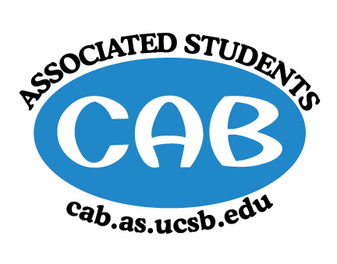
AS Community Affairs Board Minutes
Monday, May 22th, 2017, 7:34PM
University of California, Santa Barbara
AS Community Affairs Board Office, University Center 2523

Roll Call and Attendees:
Name | Status | Name | Status
Michelle Leonard (Co-Chair) | Absent - Excused | Tanios Boudames | Present
Jacqueline Vierra (Co-Chair) | Present | Renee O’Donnell | Present
Jacob Morales | Absent - Unexcused | Jordan Freedlander | Present
Michelle Vu | Late | Monica Luna | Present
Elizabeth Mendez | Present | Eric Wang | Present
Joi Duncan | Absent - Unexcused | Daniel Flores | Present
Matt Garnica | Present | Felipe Recinos Quant (Senate Liaison) | Absent
Jasmin Gutierrez | Present | Bianca Fernandez (Senate Liaison) | Absent
Morgan Lee | Present | Allina Mojarro (Advisor) | Absent
Stephanie Nguyen | Present | Ruth  Garcia-Guevara (Advisor) | Absent
Gabe Tienda | Absent | Aaron Jones (Advisor) | Absent
Nancy Huang | Present | Tiffany Vuong | Present
Ileana Navarro Hernandez | Present

- Acceptance of Agenda
  - Acceptance of Excused Absences
  - MOTION/SECOND: Boudames/Gutierrez
  - ACTION: Passed by consent

- Public Forum/ Announcements

- Funding Requests

- Action Items
- Ileana & Tiffany -- Retroactive-request $6000* approved by advisor (vouchers for IV Elementary Afterschool Program, IVYP Children’s Center, Non-trad Student Resource Center, FLP Kids, etc.)
  - Motion to fully fund ($6000)
    - Motion/Second: Boudames/Nguyen
    - Action: Passed by consent
- Matt- Request $350 for snowcone machine for Cab banquet
  - Motion to fully fund ($350)
    - Motion/Second: Boudames/Wang
    - Action: Passed by consent

- Advisor Updates
  - Ruth Garcia
  - Allina Mojarro
  - Aaron Jones

- Co-Chair Updates (Michelle Leonard & Jac Vierra)

- Set up/ Clean up (eric morgan stephanie -danny jasmin eli)
- Pancake Study Jam (stephanie-eli-jac→ cleanup-danny, jasmin, monica, tanios)
- Superlatives
- RSVP Banquet
- Board Updates
  - Nancy - Secretary/Webmaster
    - pass
  - Tiffany & Ileana-FLP Co-Coordinator
    - Hosted bookfair today and was great!
  - Jasmin & Morgan - Alternative Breaks Co-Coordinator
    - Currently finishing up planning the weekend trip, finished interviews
  - Eric - Animal Coordinator
    - BUNS until week 10
  - Joi - Childcare Director
    - pass
  - Renee - Community Outreach Coordinator
    - pass
  - Jacob - Environmental coordinator
    - pass
  - Elizabeth - Historian
    - Ordering pictures soon
  - Daniel & Gabe- Hunger/Houseless Co-Coordinator
    - pass
  - Monica & Jordan - Public Relations Co-Coordinator
    - Advertising cab banquet
  - Michelle - Senior Citizen Coordinator
    - The fling dance was fun
  - Matt - Social Chair
    - Got decorations for the banquet
  - - Special Projects Coordinator
    - Having you matter week 10
  - Stephanie - Youth Outreach Coordinator
    - pass
  - Michael - CAB Student Staff
    - pass
  - Tanios - Treasurer
    - June 2nd last day for req forms reminder

- Motion to Adjourned Meeting at 7:55pm
  - MOTION/SECOND: Nguyen/Boudames
  - ACTION: Passed by consent

