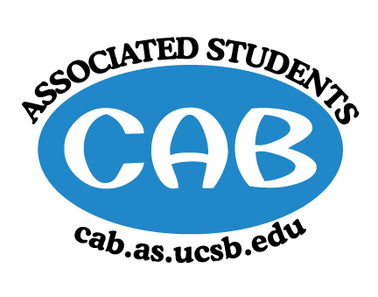
AS Community Affairs Board Minutes
Monday, May 6 , 2019, 7:32PM
University of California, Santa Barbara
AS Community Affairs Board Office, University Center 2523

Roll Call and Attendees:
Name | Status | Name | Status
Christian Larson (Co-Chair) | Present | John Balbuena | Excused
Stephen King (Co-Chair) | Present | Katie Lydon | Present
Ambar Gonzalez | Present | Kellie McManamon | Present
Andrea Nonato | Present | Siena Matsumoto | Excused
Claire Bolton | Present | Megan Lee | Present
Claudia Okuniewski | Present | Oscar Ramos | Excused
Colin Wu | Present | Raphael King | Present
Ricky Nguyen | Present | Shivani Shah | Excused
Katarina Petritsch | Excused | Kyla Gelev | Present
Edwin Ballesteros | Present | Allina Mojarro  (Advisor) | Absent
Joanna Kim | Present | Lea Toubian  (Senate Liaison) | Present

Ruth Guevarra-Garcia (advisor) | excused | Yara Khamis (Senate Liaison) | Absent

- Acceptance of Agenda
  - Acceptance of Excused Absences
  - MOTION/SECOND: Kim/King
  - ACTION: motion passes by consent

- Public Forum/ Announcements

- Funding Requests

  - Muslim Student Association
Funding Request
      - Budget
      - Requesting: $
        - Motion to
        - Motion/Second:
        - Action:

  - Pre-Physician Assistant X Health Guardians of America Crossover Event Spectacular for Diabetes
    - Funding Request
      - Budget
      - Requesting: $250 for advertising, and food
        - Motion to fully fund Pre-Physician Assistant X Health Guardians of America Crossover Event Spectacular for Diabetes $250 for advertising and food
        - Motion/Second: Lee/Wu
        - Action: Motion passed by consent

  - American Red Cross UCSB
    - Funding Request
      - Budget
      - Requesting: $
        - Motion to
        - Motion/Second:
        - Action:

- Action Items (Internal Funding)

2. Advisor Updates
  - Allina M.:
  - Ruth G.:

1. Co-Chair Updates (Steven King & Christian Larson)

2. Board Updates
  - Secretary/Webmaster: John Balbuena

  - FLP Co-Coordinator: Johanna Najera/Colin Wu

  - Alternative Breaks Co-Coordinator: Ambar Gonzalez/Shivani Shah

  - Animal Coordinator: Katarina Petrisch

  - Childcare Director: Claudia Okuniewski

  - Community Outreach Coordinator: Kellie Mcmanamon

  - Environmental coordinator: Oscar Ramos

  - Historian: Siena Matsumoto

  - Hunger/Houseless Co-Coordinator: Katie Lydon/Andrea Nonato

  - Public Relations Co-Coordinator: Ricky Nguyen/Claire Bolton

  - Senior Citizen Coordinator: Raphael King

  - Social Chair: Kyla Gelev

  - Special Projects Coordinator: Joanna Kim

  - Treasurer: Edwin Ballesteros

  - Youth Outreach: Megan Lee

  - CAB Student Staff

- Motion to Adjourn the Meeting at 9:18PM
  - MOTION/SECOND: Kim/Ballesteros
  - ACTION: motion passes by consent

