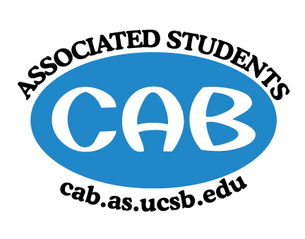
AS Community Affairs Board Minutes
Monday, February 4, 2019, 7:33PM
University of California, Santa Barbara
AS Community Affairs Board Office, University Center 2523

Roll Call and Attendees:
Name | Status | Name | Status
Christian Larson (Co-Chair) | present | John Balbuena | present
Steven King (Co-Chair) | present | Katie Lydon | present
Ambar Gonzalez | present | Kellie McManamon | late
Andrea Nonato | present | Siena Matsumoto | present
Claire Bolton | present | Megan Lee | present
Claudia Okuniewski | present | Oscar Ramos | absent
Colin Wu | late | Raphael King | present
Edwin Ballesteros | present | Shivani Shah | late
Katarina Petritsch | present | Kyla Gelev | present
Ricky Nguyen | present | Allina Mojarro  (Advisor) | absent
Joanna Kim | present | Lea Toubian  (Senate Liaison) | present

Ruth Guevarra-Garcia (advisor) | present | Yara Khamis (Senate Liaison) | present

- Acceptance of Agenda
  - Acceptance of Excused Absences
  - MOTION/SECOND: King/ Kim
  - ACTION: motion passes by consent

- Public Forum/ Announcements

- Funding Requests
Floating Doctors, Dental Edition - RESCHEDULED MEETING
  - Funding Request
      - Budget
      - Requesting: $5200.00
      - $5200 funding will go towards Accommodations (a place to stay, paying locals for their services, boat and bus transportation, food)
        - Motion to fully fund $5200 for accommodations and program fees
        - Motion/Second: King/Kim
        - Action: motion passes by consent

  - Dance Company, RE-request
    - Funding Request
      - Budget:
      - Requesting: $1500-$1700
      - All funds will go to ACDA Registration
        - Motion to fully fund $1650 for hotel and gas
        - Motion/Second: Kim/Lee
        - Action: Motion passes by consent

  - UCSB PINK
    - Funding Request
      - Budget
      - Requesting: $550.00
      - All $550 will go towards media and technology (microphone, media rental, technology set up)
        - Motion to fully fund $550
        - Motion/Second: Kim/King
        - Action: motion passes by consent

  - Phi Lambda Rho and Lambda Theta Alpha
    - Funding Request
      - Budget
      - Requesting: $1320.00
      - $1320 of funds would go towards speaker fees and transportation (plane tickets, gas reimbursement, car rental, housing, etc.)
        - Motion to fully fund $1320
        - Motion/Second: Shah/King
        - Action: motion passes by consent

- Action Items (Internal Funding)
  - Social Chair- $100 for Tie dye and snacks
    - Motion to fully fund $100 for tie dye and snacks
      - Motion/Second: Kim/King
      - Action: motion passes by consent
  - Childcare Director- $2700 for Moxy Passes
    - Motion to fully fund $2700 for Moxy Passes
      - Motion/Second: Kim/McManamon
      - Action: motion passes by consent

2. Advisor Updates
  - Allina M.:
  - Ruth G.: Anyone interested in elections, sign up for AS Position; Elections next quarter!

1. Co-Chair Updates (Steven King & Christian Larson)
- Corwin has been booked for Volunteer week!
- Hopefully you are all in communication with groups you have been assigned to
- If you did not do 1 on 1, please schedule them for this week

2. Board Updates
  - Secretary/Webmaster: John Balbuena
    - Send Care-Mail via email by Tuesday 8pm
  - FLP Co-Coordinator: Johanna Najera/Colin Wu
    - -
  - Alternative Breaks Co-Coordinator: Ambar Gonzalez/Shivani Shah
    - -
  - Animal Coordinator: Katarina Petrisch
    - -
  - Childcare Director: Claudia Okuniewski
    - -
  - Community Outreach Coordinator: Kellie McManamon
    - -
  - Environmental coordinator: Oscar Ramos
    - -
  - Historian: Siena Matsumoto
    - -
  - Hunger/Houseless Co-Coordinator: Katie Lydon/Andrea Nonato
    - -
  - Public Relations Co-Coordinator: Ricky Nguyen/Claire Bolton
    - -
  - Senior Citizen Coordinator: Raphael King
    - -
  - Social Chair: Kyla Gelev
    - -
  - Special Projects Coordinator: Joanna Kim
    - -
  - Treasurer: Edwin Ballesteros
    - -
  - Youth Outreach: Megan Lee
    - -
  - CAB Student Staff
    - -
- Motion to Adjourn the Meeting at 8:45PM
  - MOTION/SECOND: King/Nonato
  - ACTION: motion passes by consent

