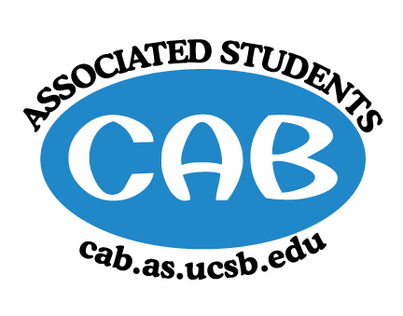
AS Community Affairs Board Minutes
Monday, February 11, 2019, 7:32PM
University of California, Santa Barbara
AS Community Affairs Board Office, University Center 2523

Roll Call and Attendees:
Name | Status | Name | Status
Christian Larson (Co-Chair) | present | John Balbuena | present
Steven King (Co-Chair) | present | Katie Lydon | absent
Ambar Gonzalez | present | Kellie McManamon | present
Andrea Nonato | absent | Siena Matsumoto | absent
Claire Bolton | present | Megan Lee | present
Claudia Okuniewski | present | Oscar Ramos | present
Colin Wu | present | Raphael King | present
Edwin Ballesteros | present | Shivani Shah | absent
Katarina Petritsch | present | Kyla Gelev | present
Ricky Nguyen | present | Allina Mojarro  (Advisor) | absent
Joanna Kim | late | Lea Toubian  (Senate Liaison) | late

Ruth Guevarra-Garcia (advisor) | absent | Yara Khamis (Senate Liaison) | absent

- Acceptance of Agenda
  - Acceptance of Excused Absences
  - MOTION/SECOND: King/Gonzalez
  - ACTION: Motion passes by consent

- Public Forum/ Announcements

- Funding Requests
Muslim Student Association
  - Funding Request
      - Budget
      - Requesting: $900- ($500 for Honoraria and $400 for Food)
        - Motion to partially fund $500 for Honoraria
        - Motion/Second: Matsumoto/Ramos
        - Action: motion passes by consent

  - Southeast Asian Union
    - Funding Request
      - Budget:
      - Requesting: $1030 for workshops materials ($360), chaperone accommodations ($510), and snacks ($160)
        - Motion to fully fund $1030 for workshop materials, chaperone accommodations, and snacks
        - Motion/Second: King/Ramos
        - Action: Motion passes by consent

  - College Link Outreach Program
    - Funding Request
      - Budget
      - Goes to Hermanos Unidos’ account
      - Requesting: $2000 for transportation costs
        - Motion to not fund C.L.O.P
        - Motion/Second: King/Ramos
        - Action: Motion passes by hand vote
          - 15-0-0

  - Brothas From Othas Mothas
    - Funding Request
      - Budget
      - Requesting: $3500 for sound equipment
        - Motion to fully fund $3500 for sound equipment
        - Motion/Second: Kim/Balbuena
        - Action: Motion passes by consent

  - Students for Sensible Drug Policy
    - Funding Request
      - Budget
      - Requesting: $1,162 for Conference tickets($580), hotel rooms($212), and plane tickets ($370)
        - Motion to not fund until they expand outreach
        - Motion/Second: Ramos/Kim
        - Action: Motion passes by consent
  - Naked Voices
      - Requesting: $2005.50 for sound equipment fees
        - Motion to fully fund $2006.00 for Sound equipment
        - Motion/Second: Kim/Nguyen
        - Action: motion passes by consent

- Action Items (Internal Funding)

    - Motion to
      - Motion/Second:
      - Action:

    - Motion to
      - Motion/Second:
      - Action:

2. Advisor Updates
  - Allina M.:
  - Ruth G.:

1. Co-Chair Updates (Steven King & Christian Larson)
- General Meeting:
  - Set-Up:
  - Clean-Up:
  - Guest Speaker:
- Meet with groups for Volunteer Week Event Planning

2. Board Updates
  - Secretary/Webmaster: John Balbuena
    - -
  - FLP Co-Coordinator: Johanna Najera/Colin Wu
    - -
  - Alternative Breaks Co-Coordinator: Ambar Gonzalez/Shivani Shah
    - -
  - Animal Coordinator: Katarina Petrisch
    - -
  - Childcare Director: Claudia Okuniewski
    - -
  - Community Outreach Coordinator: Kellie Mcmanamon
    - -
  - Environmental coordinator: Oscar Ramos
    - -
  - Historian: Siena Matsumoto
    - -
  - Hunger/Houseless Co-Coordinator: Katie Lydon/Andrea Nonato
    - -
  - Public Relations Co-Coordinator: Ricky Nguyen/Claire Bolton
    - -
  - Senior Citizen Coordinator: Raphael King
    - -
  - Social Chair: Kyla Gelev
    - -
  - Special Projects Coordinator: Joanna Kim
    - -
  - Treasurer: Edwin Ballesteros
    - Campus Democrats
  - Youth Outreach: Megan Lee
    - -
  - CAB Student Staff
    - -
- Motion to Adjourn the Meeting at 9:21PM
  - MOTION/SECOND: Kim/Gonzalez
  - ACTION: Motion passes by consent

