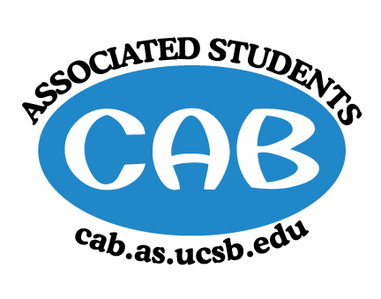
AS Community Affairs Board Minutes
Monday, October 15, 2018, 7:32PM
University of California, Santa Barbara
AS Community Affairs Board Office, University Center 2523

Roll Call and Attendees:
Name | Status | Name | Status
Christian Larson (Co-Chair) | present | John Balbuena | present
Steven King(Co-Chair) | present | Katie Lydon | present
Ambar Gonzalez | present | Kellie McManamon | Late (unexcused)
Andrea Nonato | present | Emma Wiley | present
Claire Bolton | present | Megan Lee | present
Claudia Okuniewski | present | Oscar Ramos | present
Collin Wu | present | Raphael King | present
Edwin Ballesteros | present | Shivani Shah | present
Glynnis Foley | Present | Allina Mojarro  (Advisor) | present
Ricky Nguyen | present | (Senate Liaison) | absent
Joanna Kim | present | (Senate Liaison) | absent
Johanna Najera | present

- Acceptance of Agenda
  - Acceptance of Excused Absences
  - MOTION/SECOND: Shah/Foley
  - ACTION: Motion passed by consent

- Public Forum/ Announcements

- Funding Requests
  - Armenian Student Association - Tabled on October 8, 2018
  - Update: FBC funding for $2370 of $2500 estimated staff costs
  - Request from CAB: $300
    - Funding Request
    - Budget
      - Motion/Second: Shah/Foley
      - Action: Passed by consent

- Action Items (Internal Funding)
- $500 for ‘You Matter’ event to buy scantron, blue books, and snacks- Special Projects Coordinator
  - Motion/Second: Foley/Ramos
  - Action: Motion passed by consent
- $600 for CARE Mail Subscription for the Year- Advisor Allina M.
  - Motion/Second: Foley/Ballesteros
  - Action: Motion passed by consent
Advisor Updates
  - Ruth Garcia
  - Allina Mojarro - SLACK app update. Centralizing communication to one platform association wide. Important legally, specifically and not limited to the Freedom of Information Act. Useful for easy access to answers, and communication with groups and individuals in AS.
    - Login on your phone or computers in CAB using only your AS email @as.ucsb.edu
    - Expectation you are using your assigned email and SLACK for all AS communication.

- Co-Chair Updates (Steven King & Christian Larson)
  - 40 Moxi Applications -- Will we be able to cover that? Let’s establish this connection (Claudia and Ricky -- Reach out to Brenda and Paulina)
  - Sign up for your One on Ones if you haven’t already
  - General Meeting:
    - Set Up: Ricky, Katie, Glynnis
    - Clean-up: Steven, Christian, Raphael
    - Guest Speaker: Possible Surfrider

- Board Updates
  - Secretary/Webmaster: John Balbuena
    - Send me your events for CARE Mail No Later Than Tuesday 10PM
    - If you have not sent me your bio’s, picture, or O.H, please send it my way ASAP
  - FLP Co-Coordinator: Johanna Najera/Collin Wu
    - Pass
  - Alternative Breaks Co-Coordinator: Ambar Gonzalez/Shivani Shah
    - Pass
  - Animal Coordinator: Glynnis Foley
    - Pass
  - Childcare Director: Claudia Okuniewski
    - Pass
  - Community Outreach Coordinator: Kellie Mcmanamon
    - Pass
  - Environmental coordinator: Oscar Ramos
    - pass
  - Historian: Emma Wiley
    - pass
  - Hunger/Houseless Co-Coordinator: Katie Lydon/Andrea Nonato
    - Emailed path for a date to set up for event
    - Meeting with hillel tomorrow after meeting to finalize details
  - Public Relations Co-Coordinator: Ricky Nguyen/Claire Bolton
    - Leaderboard member of the week is Steven
    - Give 2-3 Business days notice before if you want announcements to be sent to University Announcements
    - Received message from pre-law org to collaborate on Halloween event
  - Senior Citizen Coordinator: Raphael King
    - Halloween party scheduled at Friendship Manor
  - Social Chair:
    - -
  - Special Projects Coordinator: Joanna Kim
    - Yerba Mate collaboration for ‘You Matter’ event- send contact info for Yerba representative to Joanna
  - Youth Outreach Coordinator: Megan Lee
    - pass
  - Treasurer: Edwin Ballesteros
    - We are funding Laughology $3,010 instead of aforementioned $3,440. On the budget where we initially voted on their funding request, we accidentally funded an extra show. While this does not affect the orgs use of the money, we wanted to make clear exactly what the money is going towards
  - CAB Student Staff

- Motion to Adjourn Meeting at 8:18pm
  - MOTION/SECOND: Wiley/Shah
  - ACTION: Motion passed by consent

