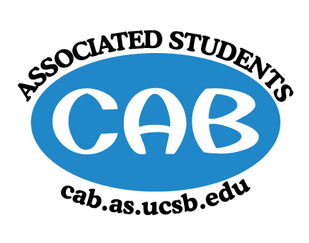
AS Community Affairs Board Minutes
Monday, January 7, 2019, 7:31PM
University of California, Santa Barbara
AS Community Affairs Board Office, University Center 2523

Roll Call and Attendees:
Name | Status | Name | Status
Christian Larson (Co-Chair) | present | John Balbuena | present
Steven King (Co-Chair) | present | Katie Lydon | present
Ambar Gonzalez | present | Kellie McManamon | late
Andrea Nonato | Late | Sienna Matsumoto | present
Claire Bolton | present | Megan Lee | present
Claudia Okuniewski | present | Oscar Ramos | absent
Colin Wu | present | Raphael King | present
Edwin Ballesteros | present | Shivani Shah | late
Katarina Petritsch | present | Kyla Gelev | present
Ricky Nguyen | present | Allina Mojarro  (Advisor) | absent
Joanna Kim | present | Lea Toubian  (Senate Liaison) | present

Ruth Guevarra-Garcia (advisor) | absent | Yara Khamis (Senate Liaison) | present

- Acceptance of Agenda
  - Acceptance of Excused Absences
  - MOTION/SECOND: Kim/King
  - ACTION: Motion passes by consent

- Public Forum/ Announcements

- Funding Requests
Naked Voices
  - Funding Request
    - Budget
    - Requesting: $1475
      - $950 for sound engineering fee and $525 for microphone rental
      - Requested funding from other organizations as well
      - Free to the entire public!
        - Motion to fully fund ‘Naked Voices’ $950 for the sound engineering fee and $525 for the microphone rental for a total of $1475
          - Motion/Second: Khamis/King
          - Action: Motion passes by consent

- Action Items (Internal Funding)
  - FLP: requesting $150 for Food (Pizza) for Tutor orientation
    - Motion to fully fund FLP $150 for Pizza for the tutor orientation
      - Motion/Second: Kim/King
      - Action: Motion passes by consent
  - FLP: requesting $500 for snacks
    - Motion to fully fund FLP $500 for snacks
      - Motion/Second: Kim/King
      - Action: Motion passes by consent
  - Co-chair- $300 for Pizza for first meeting this Wednesday
    - Motion to fully fund Co-Chairs $300 for Pizza for the first meeting
      - Motion/Second: King/Kim
      - Action: Motion passes by consent
  - Co-Chair: Motion to accept Sienna to replace Emma Wiley as Historian
    - Motion to accept Sienna Matsumoto as Emma’s replacement as Historian
      - Motion/Second: Lee/Najera
      - Action: Motion passes by consent

2. Advisor Updates
  - -

1. Co-Chair Updates (Steven King & Christian Larson)

- Retreat this Saturday
  - Stay tuned for an exact itinerary
  - LET US KNOW IF YOU WILL NOT BE THERE ASAP
  - We will be asking for drivers soon too, are there any volunteers?
  - Be at the CAB office at 8am for breakfast/ departing at 9am
    - Retreat will be held in Los Angeles this weekend; plan/pack accordingly
- Sienna will be filling in as Historian in place of Emma
2. Board Updates
  - Secretary/Webmaster: John Balbuena

  - FLP Co-Coordinator: Johanna Najera/Colin Wu

  - Alternative Breaks Co-Coordinator: Ambar Gonzalez/Shivani Shah

  - Animal Coordinator: Glynnis Foley

  - Childcare Director: Claudia Okuniewski

  - Community Outreach Coordinator: Kellie Mcmanamon

  - Environmental coordinator: Oscar Ramos

  - Historian: Sienna Matsumoto

  - Hunger/Houseless Co-Coordinator: Katie Lydon/Andrea Nonato

  - Public Relations Co-Coordinator: Ricky Nguyen/Claire Bolton

  - Senior Citizen Coordinator: Raphael King

  - Social Chair: Kyla Gelev

  - Special Projects Coordinator: Joanna Kim

  - Treasurer: Edwin Ballesteros

  - Youth Outreach: Megan Lee

  - CAB Student Staff

- Motion to Adjourn Meeting at 7:48PM
  - MOTION/SECOND: King/Kim
  - ACTION: motion passes by consent

