

**AS Community Affairs Board Minutes**

**Monday, January 9th, 2017, 7:30PM**

**University of California, Santa Barbara**

**AS Community Affairs Board Office, University Center 2523**

**Roll Call and Attendees:**

|  |  |  |  |
| --- | --- | --- | --- |
| **Name** | **Status** | **Name** | **Status** |
| **Michelle Leonard (Co-Chair)** | **Present** | **Gary Van Huynh** | **Present** |
| **Jacqueline Vierra (Co-Chair)** | **Present** | **Renee O’Donnell** | **Present** |
| **Jacob Morales** | **Present** | **Jordan Freedlander** | **Present** |
| **Michelle Vu** | **Present** | **Monica Luna** | **Present** |
| **Elizabeth Mendez** | **Present** | **Tanios Boudames** | **Present** |
| **Joi Duncan** | **Present** | **Eric Wang** | **Present** |
| **Connie Lin** | **Absent** | **Mauricio Baltrons** | **Present** |
| **Jasmin Gutierrez** | **Present** | **Allina Mojarro (Advisor)** | **Absent** |
| **Morgan Lee** | **Present** | **Ruth**  **Garcia-Guevara (Advisor)** | **Present** |
| **Stephanie Nguyen** | **Present** | **Aaron Jones (Advisor)** | **Absent** |
| **Nancy Huang** | **Present** | **Ileana Navarro Hernandez** | **Present** |
| **Tiffany Vuong** | **Present** | **Bianca Fernandez**  **(Senate Liaison)** | **Present** |
| **Gabe Tienda** | **Present** | **Felipe Recinos Quant (Senate Liaison)** | **Present** |

1. **Acceptance of Agenda**
   1. **Acceptance of Excused Absences**
   2. *MOTION/SECOND: Nguyen/Gutierrez*
   3. *ACTION:* Passed by Consent
2. **Public Forum/ Announcements**
3. **Funding Requests**
   1. Isla Vista Surfrider
      1. [Funding request](https://docs.google.com/document/d/1cGD5-WG5c9esihfnbZAKDSTTqAM9JHEVQ2NQ4hz-dXE/edit?usp=sharing)
      2. [Budget](https://drive.google.com/file/d/0B6KnVI08xBzYQUgwaFBMTzRDdmhzT3FzNTdDTktkSkV3dUI0/view?usp=sharing)
      3. Request $2000 for fencing needed for park rental; surf contest is open to public-money goes to recycling project
      4. Motion to partially fund ($1000) to Isla Vista Surfrider
         1. MOTION/SECOND: Morales/Tienda
         2. ACTION: Passed by Consent
         3. Vote: 16-0-5
   2. Improvability
      1. [funding request](https://docs.google.com/document/d/1hnk6kQ5kJ4qJ3L4ImiUHqKlPFPZZfd7nUIOpNxNNH5k/edit?usp=sharing)
      2. [Budget](https://docs.google.com/spreadsheets/d/1EgfcLAJrEk0TOR3offPhs_Cuf-nEqaVXbj9kRjzk-o4/edit?usp=sharing)
      3. Request $972 for equipment usage, cover all winter quarter shows
      4. Motion to fully fund ($972) to Improvability
         1. MOTION/SECOND: ODonnell/Duncan
         2. ACTION: Passed by Consent
         3. Vote: 20-0-0
4. **Action Items**
   1. Tanios and Gabe Dinner Club
      1. Requesting funding ($600) for dinner Club’s 1st & 3rd Mondays Winter Quarter.
      2. Motion to fully fund ($600) to Tanios and Gabe
         1. MOTION/SECOND: Morales/Nguyen
         2. ACTION: Passed by consent
   2. Michelle and Jac Wed Meeting Pizza
      1. Woodstocks 4 pepperoni 4 cheese 1 Gluten Free 1 Vegan
      2. Requesting $210 (overestimation just in case)
      3. Motion to fully fund ($210) to Michelle and Jac
         1. MOTION/SECOND: Baltrons/ODonnell
         2. ACTION: Passed by consent
   3. Stephanie
      1. Requesting $25 for toys for dental buddies program
      2. Motion to fully fund ($25) to Stephanie
         1. MOTION/SECOND: ODonnell/Wang
         2. ACTION: Passed by consent

D. Michelle and Jac (Email request passed 1/6/16)

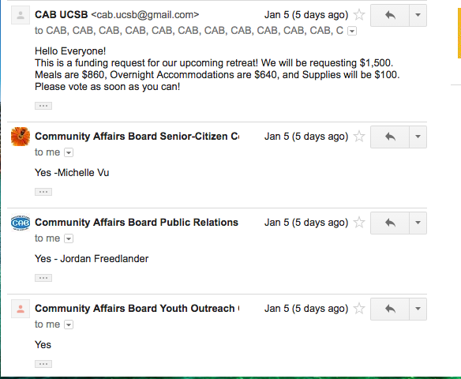

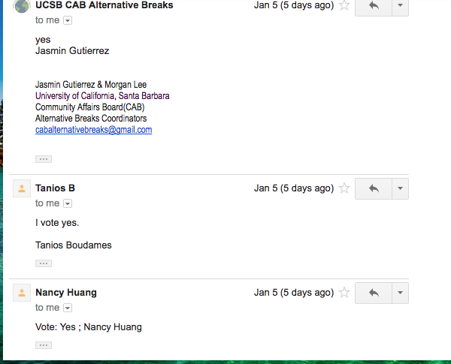

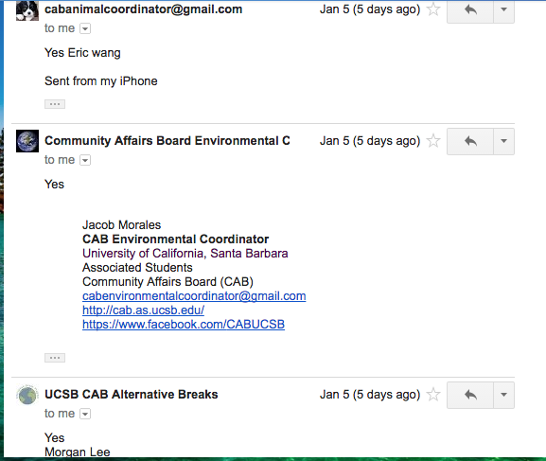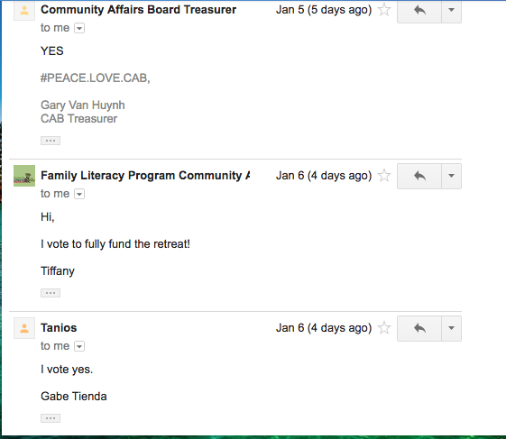

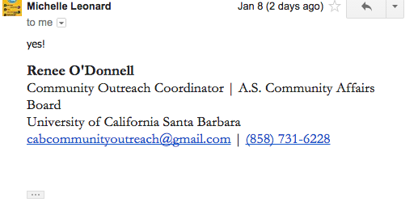

1. **Advisor Updates**
   1. Ruth Garcia-general update
   2. Allina Mojarro
   3. Aaron Jones
2. **Co-Chair Updates (Michelle Leonard & Jac Vierra)**

* Clean-up/ set-up [Jacob/Renee/Jasmin--Stephanie/Jordan/Ileana]
  + New sheet posted and sign-in
* Volunteer Activity/ Speaker Sign-Ups for Wed Meetings
  + https://docs.google.com/spreadsheets/d/1vnWNkLqMER7wRi5G4IdSZDoFLhdNOeVyqNC7EAeoz94/edit?usp=sharing
* Retreat
* Sign Documents
* Packing List <https://docs.google.com/document/d/1TOFb_pF3DhW11kZaQ7CDRqwYiFb4Tn1t2G1eBT2C-pI/edit?usp=sharing>
* Meet in CAB office at 8am Saturday Jan 21st
* Looking for another social chair
* Post Slides on ppt!
* Send Nancy office hours

1. **Board Updates**
   1. Nancy - Secretary/Webmaster
      1. Spoke with Ruth about MyEmma/she submitted requisition for payment
      2. Collecting winter office hours
   2. Ileana & Tiffany-FLP Co-Coordinator
      1. Contacted Juan at IV elementary school-waiting for room information
      2. Volunteer tutors needed
   3. Jasmin & Morgan - Alternative Breaks Co-Coordinator
      1. Went on Alternative Breaks (went really well!)
   4. Eric - Animal Coordinator
      1. B.U.N.S friday (not doing Sat. this week), normal schedule begins next week
      2. A.S. assembly Jan 28th
   5. Joi - Childcare Director
      1. End of Fall quarter event went well; bi-monthly event starting this quarter
   6. Renee - Community Outreach Coordinator
      1. City of Hope is coming next Fri.-helping host bone marrow drive
      2. Will talk to career center this week
   7. Jacob - Environmental coordinator
      1. Contacted a Frat for a cleanup project
      2. Trying to make an event partnering with MCC
   8. Elizabeth - Historian
      1. Pass
   9. Tanios & Gabe - Hunger/Houseless Co-Coordinator
      1. Weekly Dinner Clubs starting next week
      2. Going to meet with Swipe out Hunger
   10. Monica & Jordan - Public Relations Co-Coordinator
       1. Will post CAB gear example soon
   11. Michelle - Senior Citizen Coordinator
       1. Meal serving resumed
   12. Mauricio - Special Projects Coordinator
       1. Create Tabling Wed.
   13. Stephanie - Youth Outreach Coordinator
       1. Juguemos and Dental Buddies
   14. Michael - CAB Student Staff
       1. Pass
   15. Gary - Treasurer
       1. Pick up honorary checks
2. **Motion to Adjourned Meeting at 8:30pm**
   1. *MOTION/SECOND: Wang/Gutierrez*
   2. *ACTION: Passed by Consent*