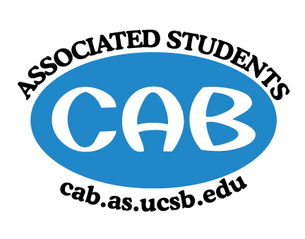
AS Community Affairs Board Minutes
Monday, April 22, 2019, x:xxPM
University of California, Santa Barbara
AS Community Affairs Board Office, University Center 2523

Roll Call and Attendees:
Name | Status | Name | Status
Christian Larson (Co-Chair) |  | John Balbuena
Stephen King (Co-Chair) |  | Katie Lydon
Ambar Gonzalez |  | Kellie McManamon
Andrea Nonato |  | Siena Matsumoto
Claire Bolton |  | Megan Lee
Claudia Okuniewski |  | Oscar Ramos
Colin Wu |  | Raphael King
Ricky Nguyen |  | Shivani Shah
Katarina Petritsch |  | Kyla Gelev
Edwin Ballesteros |  | Allina Mojarro  (Advisor)
Joanna Kim |  | Lea Toubian  (Senate Liaison)

Ruth Guevarra-Garcia (advisor) |  | Yara Khamis (Senate Liaison)

- Acceptance of Agenda
  - Acceptance of Excused Absences
  - MOTION/SECOND:
  - ACTION:

- Public Forum/ Announcements

- Funding Requests
  - Mental Health Conference-
    - Funding Request
      - Budget
      - Requesting: $4914.2 for snacks tech and speaker
        - Motion to
        - Motion/Second:
        - Action:

  - Freedom 4 Youth-
    - Funding Request
      - Budget
      - Requesting: $5000, $3000 for food and event space, $2000 for speaker, with the stipulation that they are granted a one time exception
        - Motion to
        - Motion/Second:
        - Action:

  - Sigma Lambda Beta
    - Funding Request
      - Budget
      - Requesting: $2760 for CPR workshop and snacks
        - Motion to
        - Motion/Second:
        - Action:

  - Sikh Student Association
    - Funding Request
      - Budget
      - Requesting: $500 for food
      - Motion to
        - Motion/Second:
        - Action:

  - GauchoThon Bingo
    - Funding Request
      - Budget
      - Requesting: $1098 for bingo supplies and food, with the stipulation that they get a one time exception
      - Motion to
        - Motion/Second:
        - Action:
  - Alpha Chi Omega
    - Funding Request
      - Budget
      - Requesting: $4381.37
      - Motion to
        - Motion/Second:
        - Action:

- Action Items (Internal Funding)
  - Social Chair $200 for painting materials and snacks
    - Motion to
      - Motion/Second:
      - Action:

    - Motion to
      - Motion/Second:
      - Action:

    - Motion to
      - Motion/Second:
      - Action:

    - Motion to
      - Motion/Second:
      - Action:

2. Advisor Updates
  - Allina M.:
    - For confidentiality purposes related to AS elections, the CAB office and entire 2nd floor of AS will be closed off to everyone this Thursday starting at 4pm. Please complete any business you have before then.
    - Vote on Gold!

  - Ruth G.:

1. Co-Chair Updates (Steven King & Christian Larson)

2. Board Updates
  - Secretary/Webmaster: John Balbuena

  - FLP Co-Coordinator: Johanna Najera/Colin Wu

  - Alternative Breaks Co-Coordinator: Ambar Gonzalez/Shivani Shah

  - Animal Coordinator: Katarina Petrisch

  - Childcare Director: Claudia Okuniewski

  - Community Outreach Coordinator: Kellie Mcmanamon

  - Environmental coordinator: Oscar Ramos

  - Historian: Siena Matsumoto

  - Hunger/Houseless Co-Coordinator: Katie Lydon/Andrea Nonato

  - Public Relations Co-Coordinator: Ricky Nguyen/Claire Bolton

  - Senior Citizen Coordinator: Raphael King

  - Social Chair: Kyla Gelev

  - Special Projects Coordinator: Joanna Kim

  - Treasurer: Edwin Ballesteros

  - Youth Outreach: Megan Lee

  - CAB Student Staff

- Motion to Adjourn the Meeting at x:xxPM
  - MOTION/SECOND:
  - ACTION:

