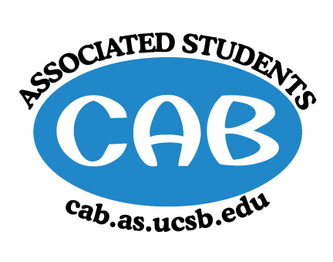
AS Community Affairs Board Minutes
Monday, October 1st 2018, 7:30PM
University of California, Santa Barbara
AS Community Affairs Board Office, University Center 2523

Roll Call and Attendees:
Name | Status | Name | Status
Christian Larson (Co-Chair) | Present | John Balbuena | Present
Steven King(Co-Chair) | Present | Katie Lydon | Present
Ambar Gonzalez | Present | Kellie McManamon | Absent
Andrea Nonato | Present | Emma Wiley | Late
Claire Bolton | Present | Megan Lee | Absent (excused)
Claudia Okuniewski | Present | Oscar Ramos | Present
Collin Wu | Present | Raphael King | Present
Edwin Ballesteros | Present | Shivani Shah | Absent (Excused)
Glynnis Foley | Present | Allina Mojarro  (Advisor) | Present
Ricky Nguyen | Present | (Senate Liaison)
Joanna Kim | Present | (Senate Liaison)
Johanna Najera | Present

- Acceptance of Agenda
  - Acceptance of Excused Absences
  - MOTION/SECOND: Wiley/Ballesteros
  - ACTION: Motion passed to excuse absence

- Public Forum/ Announcements
Expectations for CAB board members from Co-Chairs Steven and Christian

- Funding Requests
  - Laughology
    - Funding Request: Laughology ($5,000)
      - Laughology requesting fund to continue funding program, that allows all UCSB students to come out and interact, observe performances.
    - Budget
      - Also requested $6000 from AS, $1000 from After Dark, $200 from the AS Start Up Fund
      - Requesting: *bolded are funds they are requesting from CAB*
        - $800(8) for Headliner
        - $150(8) for Featured MC
        - $200(8) for Featured Act
        - $220(8) for Venue
        - $20(8) for CSOs
        - $30(8) for Marketing
      - Amount requested: $5,000
    - Motion to partially fund ($3,440) for Featured MC, Featured Act, CSOs, and Marketing
      - Motion/Second: King/Larson
      - Action: Passed by consent

- Action Items (Internal Funding)
- Christian -- $500 -- General meeting food
  - Motion to Fully fund $500 for general meeting food
    - Motion: Gonzalez/Ramos
    - Action: Passed by consent
- Steven -- $300 -- General meeting pizza
  - Motion to fully fund $300 for Pizza
    - Motion: Ballesteros/Bolton
    - Action: passed by consent

- Advisor Updates
  - Ruth Garcia
    - Possible CAB’s tabling at Pardall Center Carnival on 10/13
    - Attend organization retreat organized by AS on 10/6
  - Allina Mojarro

- Co-Chair Updates (Steven King & Christian Larson)
  - Feedback on Retreat
    - Reimbursement: For anyone that has receipts from retreat, please turn them in to be fully reimbursed
  - Starting up events
  - General Meeting
    - At 6pm in the GSA; Food will be provided
    - Slides will be posted either tonight or tomorrow morning
  - Glynnis to fill in as Animal Coordinator

- Board Updates
  - Secretary/Webmaster: John Balbuena
    - Send me fall quarter office hours
    - Send me events for Care mail
    - Bio’s of each member; a few sentences and a picture by next Monday
  - FLP Co-Coordinator: Johanna Najera/Collin Wu

  - Alternative Breaks Co-Coordinator: Ambar Gonzalez/Shivani Shah

  - Animal Coordinator: Glynnis Foley

  - Childcare Director: Claudia Okuniewski

  - Community Outreach Coordinator: Kellie Mcmanamon

  - Environmental coordinator: Oscar Ramos

  - Historian: Emma Wiley

  - Hunger/Houseless Co-Coordinator: Katie/Andrea Nonato

  - Public Relations Co-Coordinator: Ricky Nguyen/Claire Bolton

  - Senior Citizen Coordinator: Raphael King

  - Social Chair:

  - Special Projects Coordinator: Joanna Kim

  - Youth Outreach Coordinator: Megan Lee

  - CAB Student Staff

  - Treasurer: Edwin Ballesteros

- Motion to Adjourn Meeting at 8:43pm
  - MOTION/SECOND: Wiley/Najera
  - ACTION: passed by consent

