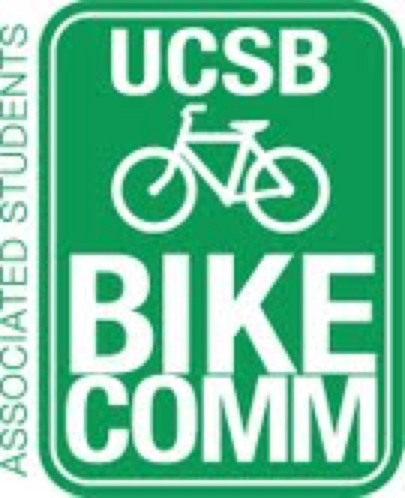

Bike Committee Minutes
Associated Students
04/25/14@ 3:00 PM
A.S. Conference Room

CALL TO ORDER

- Meeting Business
  - Attendance
Name | Present/Absent | Name | Present/Absent
Emily Littleworth | Present | Mac Kennedy | Present
Richard Lo | Absent | Reida Khan | Present
Chris Bustos | Present | Alex Kim | Absent
Zac Armour | Present | Aaron Jones | Absent
Dennis Whelan | Absent | Steve Conner | Absent
Jamey Wagner | Present | Ralph Fertig | Absent
Thomas Bell | Present | Adam Jahnke | Present
Ava Cheng | Absent | Alisa Rangwala | Absent

- Public Forum
  - General Announcements
    - Matt Stern- possible Bike Committee project to name all the bike paths
      - Would helpo clarify projects, maintenance, accidents, etc.
  - Appreciations/Concerns
  - Requests to have items added to the agenda
- Committee Member Reports
  - Treasurer Report
    - A.S. Account has $671.84
    - Facilities has $133,441.55
    - State Account has $58,756
  - Bike System Analyst Report
    - Psychology Lot (97.7%)
    - LSB (83%)
    - IV Theater (?)
  - Social Media Report
  - (Ava’s Ecoalition Report)
- Action Items
  - Approval of Funds
    - New heads for Dero Airkits ($275.80)
      - Needs $320 for parts plus spares for the most breakable hoses (so the essential parts and 13 spare gaskets)
        - Emily motions to approve up to $320 for the new generation pump heads and spare parts/Chris seconds/Mac calls to question
- Campus Improvement
  - Projects Completed
  - Projects Underway
    - SAASB Intersection
        - Cheadle Hall Meeting
    - Library Intersection
  - Primary Prospective Projects
    - Other racking projects
      - HSSB
      - South Hall
      - Campbell
      - Broida
  - Maintenance
    - Underway
      - Dero Airkits
        - How to do signage
    - Prospective
      - University Center Root
      - El Colegio signage
      - Bike Path near San Ynez
        - Being taken care of over summer
      - Building 429 Racks
        - Jamey to see if possible
- Outreach, Business, and Events
  - Bike Traffic Safety Education
  - Bike Rental Program
- Closing Remarks
  - Possible vending machine for bike tire tubes
  - Contact the DSP if ever pedestrian crossing changes
ADJOURNMENT

