Bike Committee Minutes

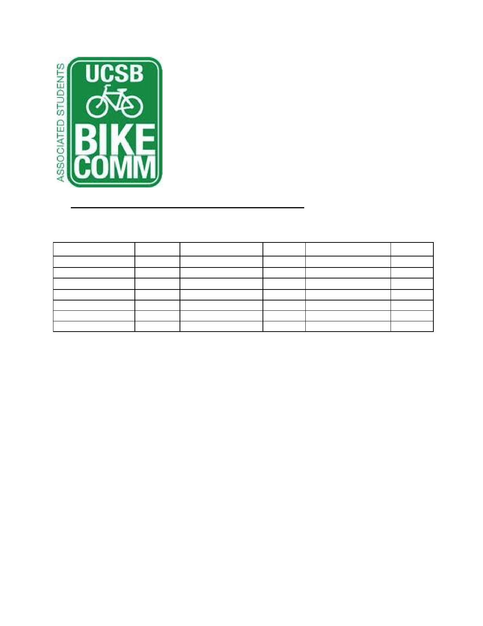

Associated Students

01/16/15@ 11:00 AM Bike Committee Office

**CALL TO ORDER: 11:00AM by Emily Littleworth, Chair**

**A. Meeting Business**

a. Attendance

Name Present? Name Present? Name Present?

Emily Littleworth Present Sarah Siedschlag Present Joey Lee Absent

Mac Kennedy Present Aaron Jones Present Fabi Perez-Lua Present

Richard Lo Present Dennis Whelan Present Tiffany Wu Present

Chris Bustos Present Tom Kenna Present Kevin Jin Present

Nicole Ng Absent Jamey Wagner Present Jennifer Liem Absent Ava Cheng Present Matt Stern Absent Jimmy Villareal Present

Cody O'Reily Absent Steve Conner Present

**B. Public Forum**

a. General Announcements

i. **Aaron Jones**

1. Petty cabs donated to DSP and on trial

ii. **Dennis Whelan**

1. On hiatus until the end of the quarter

2. PSP North closed due to construction

b. Appreciations/Concerns

c. Requests to have items added to the agenda

**C. Committee Member Reports**

a. Administrative Officer Report

b. Treasurer Report

i. Purchase shirts and bike lights

c. Project Manager

i. Working on bike auction, CSO truck broken.

ii. Start discussing bike path names

d. Social Media Report

e. Vice Chair Report

i. Pardall Center bike fix-it station

ii. Met with IV CRC (Community Relations Committee), COSWB



(Committee on Student Well Being) to fund fix-it station

f. Chair Report

i. GSA representative needed

ii. Committee email addresses on the way

iii. Bylaws editing and comments

iv. Budget due Feb. 4th

1. Update honoraria

g. Associate Officer Report(s)

i. **Jimmy Villareal**

1. A.S. Assembly Week

ii. **Kevin Jin**

1. Request for storage space & officer help, will store extra bikes outside of Bike Shop (only two bikes), will fund new racks or locks if needed

**D. Action Items**

a. Administrative Coordinator Approval

i. Motion: Mac

ii. Second: Emily

iii. Call to Question: Richard

b. HSSB Parking

i. Motion: Emily

ii. Second: Ava

iii. Call to Question: Mac

c. We funded Jamey Wagner up to $120 for Dero Air Kit repairs

i. Motion: Mac

ii. Second: Emily

iii. Call to Question: Emily

**E. Campus Improvement**

a. **Projects Completed**

b. **Projects Underway**

i. Psychology - project starts end of January

ii. SRB Tree root - completed January 19th

iii. HSSB parking

1. Estimates include site, detail, delivery, and sales tax

a. Total: 501 slots at $34,817.79

c. **Priority Project List Voting**

i. Campbell

1. SAASB parking revamp

2. Get estimate

ii. MCC

1. Get estimate

iii. UCen

1. Get estimate

iv. Library

1. Get estimate

v. HFH



vi. Bike Parking by Henley

1. Not a priority anymore

vii. Music / Girvetz path

1. All flatwork in area needs to be removed completely

2. Not a priority anymore

d. **Future Projects**

i. Bike path Stadium Road / Rob Gym

1. Path needs to be widened

ii. Bike plan / transportation grant

1. A cohesive bike plan for the campus.

2. Concern: As a student funded entity, where else would

money come from to formulate bike plan

iii. Bike signage at San Joaquin (bike lot ID)

1. ID not needed, simple signage will suffice

e. **Maintenance**

i. Dero Air Kits

1. 2 kits down and need immediate repair

2. 3 choices, tentative vote

a. Choice 1: 2

b. Choice 2 : 0

c. Air Kit 2: 2

d. Air Kit 3: 5

3. El Collegio Signage in front of Health Center

4. Fading Roundabout Striping

5. Trim Leaves Storke Roundabout

a. Waiting on reply

**F. Committee Business**

a. Raising Fee Initiative

i. Talking to Marc Fisher

b. Bike lights

i. Bike Shop waiting on estimates

c. Shirts and tanks

i. Waiting on response from Alex Kim

d. Bike Path Naming

**ADJOURNMENT at 1:00PM**