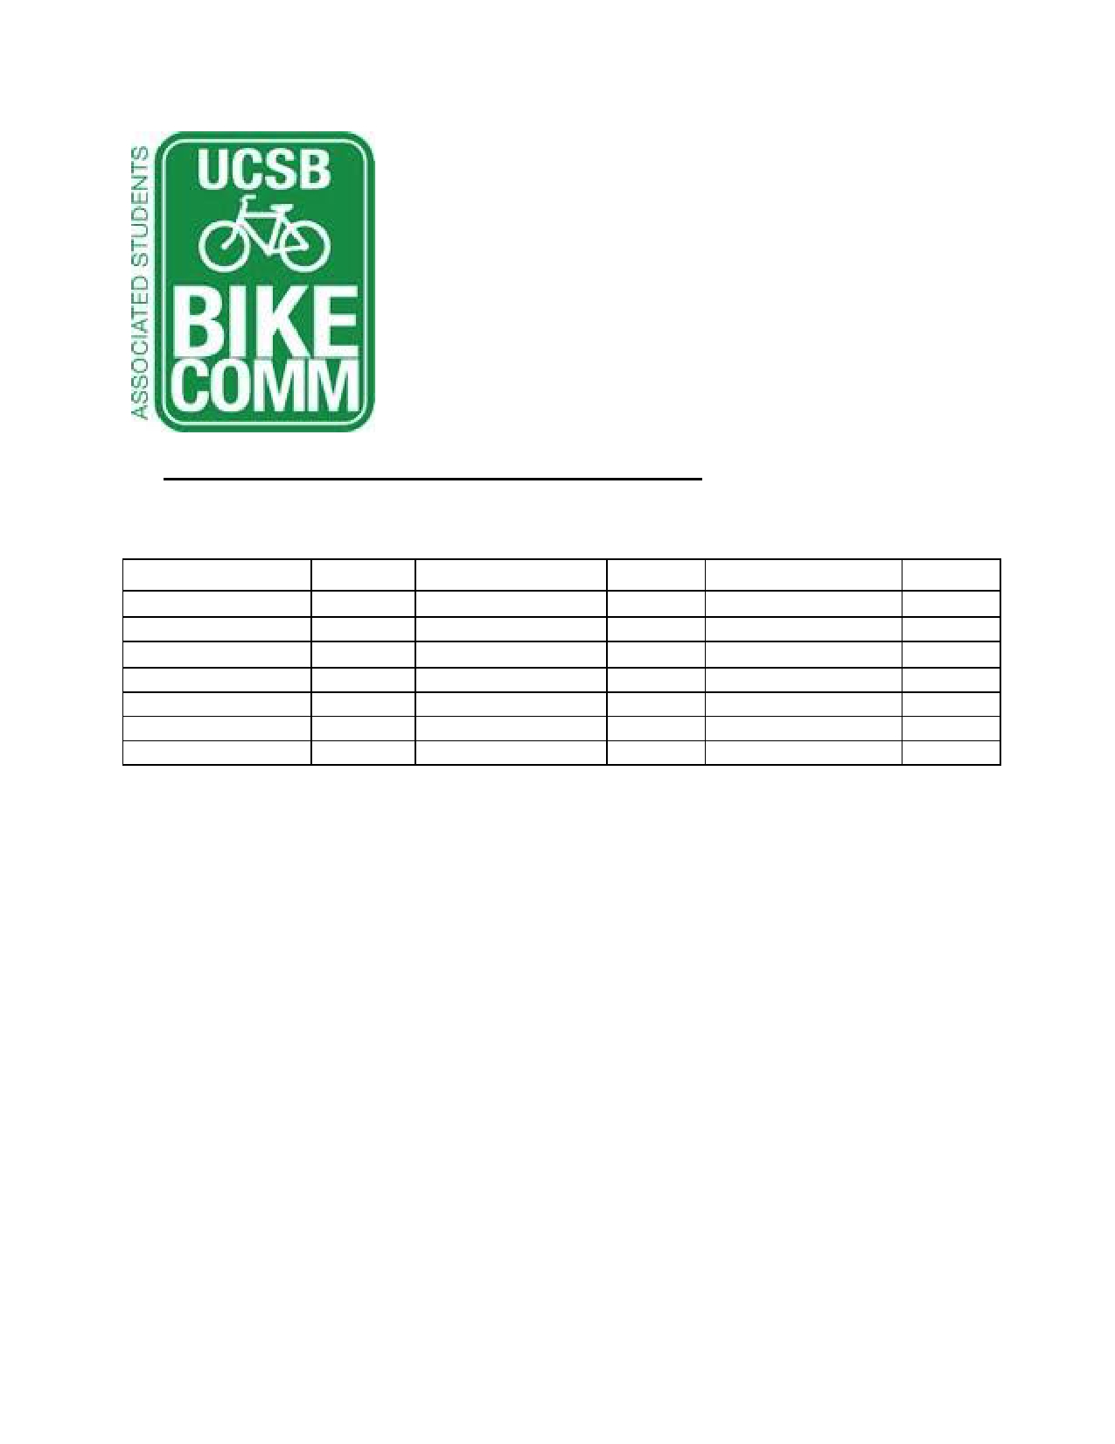Bike Committee Minutes
Associated Students
01/16/15@ 11:00 AM Bike Committee Office

CALL TO ORDER: 11:00AM by Emily Littleworth, Chair

A. Meeting Business
a. Attendance
Name Present? Name Present? Name Present?
Emily Littleworth Present Sarah Siedschlag Present Joey Lee Absent
Mac Kennedy Present Aaron Jones Present Fabi Perez-Lua Present
Richard Lo Present Dennis Whelan Present Tiffany Wu Present
Chris Bustos Present Tom Kenna Present Kevin Jin Present
Nicole Ng Absent Jamey Wagner Present Jennifer Liem Absent Ava Cheng Present Matt Stern Absent Jimmy Villareal Present
Cody O'Reily Absent Steve Conner Present

B. Public Forum
a. General Announcements
i. Aaron Jones
1. Petty cabs donated to DSP and on trial
ii. Dennis Whelan
1. On hiatus until the end of the quarter
2. PSP North closed due to construction
b. Appreciations/Concerns
c. Requests to have items added to the agenda
C. Committee Member Reports
a. Administrative Officer Report
b. Treasurer Report
i. Purchase shirts and bike lights
c. Project Manager
i. Working on bike auction, CSO truck broken.
ii. Start discussing bike path names
d. Social Media Report
e. Vice Chair Report
i. Pardall Center bike fix-it station

ii. Met with IV CRC (Community Relations Committee), COSWB
(Committee on Student Well Being) to fund fix-it station
f. Chair Report
i. GSA representative needed
ii. Committee email addresses on the way
iii. Bylaws editing and comments
iv. Budget due Feb. 4th
1. Update honoraria
g. Associate Officer Report(s)
i. Jimmy Villareal
1. A.S. Assembly Week
ii. Kevin Jin
1. Request for storage space & officer help, will store extra bikes outside of Bike Shop (only two bikes), will fund new racks or locks if needed

D. Action Items
a. Administrative Coordinator Approval
i. Motion: Mac
ii. Second: Emily
iii. Call to Question: Richard
b. We fund $34,817.79 for HSSB Parking, including new racks, delivery, set and tax
i. Motion: Emily
ii. Second: Ava
iii. Call to Question: Mac
c. We fund Jamey Wagner up to $120 for Dero Air Kit repairs.
i. Motion: Mac
ii. Second: Emily
iii. Call to Question: Emily

E. Campus Improvement
a. Projects Completed
b. Projects Underway
i. Psychology - project starts end of January
ii. SRB Tree root - completed January 19th
iii. HSSB parking
1. Estimates include site, detail, delivery, and sales tax
a. Total: 501 slots at $34,817.79
c. Priority Project List Voting
i. Campbell
1. SAASB parking revamp
2. Get estimate
ii. MCC
1. Get estimate
iii. UCen
1. Get estimate
iv. Library
1. Get estimate

v. HFH
vi. Bike Parking by Henley
1. Not a priority anymore
vii. Music / Girvetz path
1. All flatwork in area needs to be removed completely
2. Not a priority anymore
d. Future Projects
i. Bike path Stadium Road / Rob Gym
1. Path needs to be widened
ii. Bike plan / transportation grant
1. A cohesive bike plan for the campus.
2. Concern: As a student funded entity, where else would
money come from to formulate bike plan
iii. Bike signage at San Joaquin (bike lot ID)
1. ID not needed, simple signage will suffice
e. Maintenance
i. Dero Air Kits
1. 2 kits down and need immediate repair
2. 3 choices, tentative vote
a. Choice 1: 2
b. Choice 2 : 0
c. Air Kit 2: 2
d. Air Kit 3: 5
3. El Collegio Signage in front of Health Center
4. Fading Roundabout Striping
5. Trim Leaves Storke Roundabout
a. Waiting on reply

F. Committee Business
a. Raising Fee Initiative
i. Talking to Marc Fisher
b. Bike lights
i. Bike Shop waiting on estimates
c. Shirts and tanks
i. Waiting on response from Alex Kim
d. Bike Path Naming
ADJOURNMENT at 1:00PM

