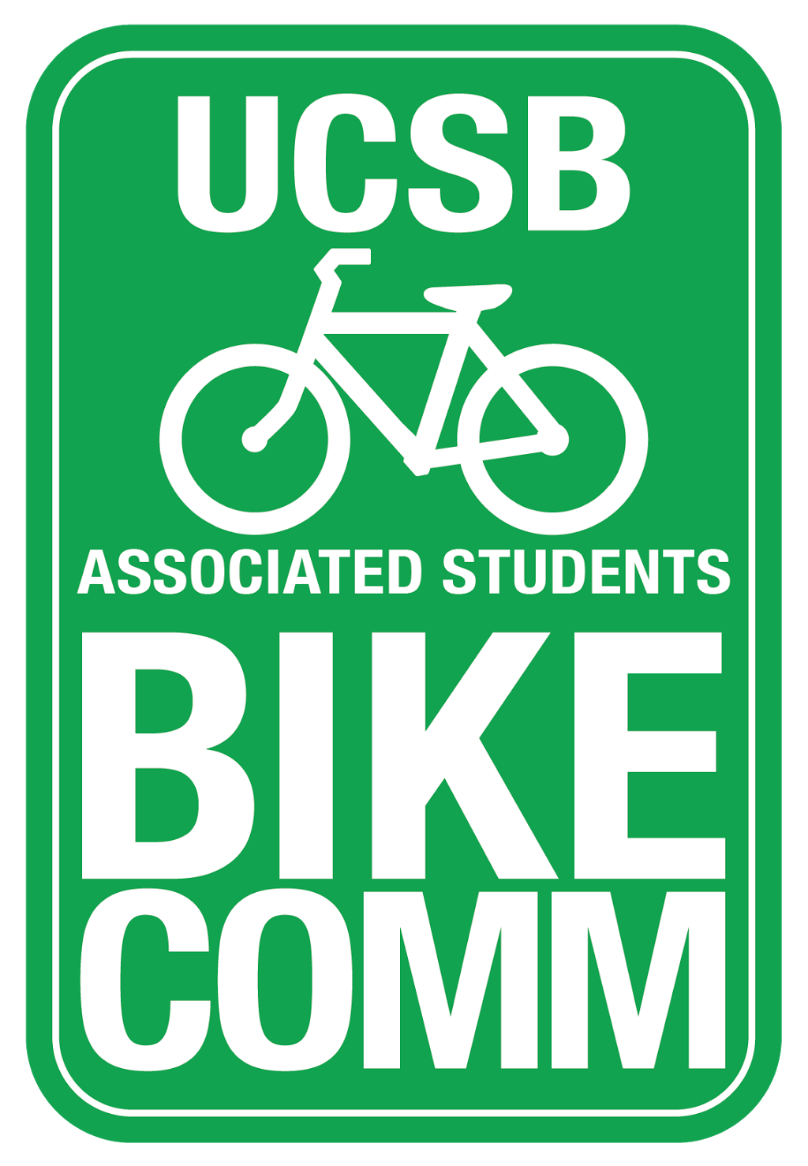
Bike Committee Weekly Meeting Agenda

Associated Students
May 30, 2017 5pm
AS Nati Conference Room

CALL TO ORDER: 5:06

A. MEETING BUSINESS
- Roll Call

Name | Note:  absent (excused/not excused)  arrived late (time)  departed early (time)  proxy (full name) | Name | Note:  absent (excused/not excused)  arrived late (time)  departed early (time)  proxy (full name)
Kevin Jin  Chair | Present
Annie Golay  Vice Chair | Present | Angela Ho  Associate Officer | Present
Tiffany Yeh  Project Manager | Present | Daniel Kolosta  Associate Officer | Present
Rohan Malpure  Finance Manager | Absent (excused) | Ngoc Hoang  Associate Officer | Absent (not excused)
Lianna Nakashima  Media Coordinator | Absent (excused) | Navpreet Khabra  Associate Officer | Present
Jorge Sandoval  Admin Coordinator | Absent (excused) | Sarah Siedschlag  Advisor | Present

- Acceptance of attendances and Proxies
MOTION/SECOND: Khabra/Golay
Motion to accept excused absences and proxies
ACTION: Vote: Consent

B. PUBLIC FORUM
  - General Announcements
  - Appreciations/Concerns
  - Request to have item added to today’s agenda

B. Committee Business

D. REPORTS
- Advisor Report
  - Requisitions due this Friday to Associated Students
  - AS Awards this Friday at 5:30-7:30 pm
- Associate Officer(s) Report
- Administrative Officer Report
- Education Officer Report
- Project Manager Report
  - Have about $155,000 in unallocated funds
  - Will not get new funds until the end of Fall quarter
- Media Coordinator Report
- Finance Manager Report
- Vice-Chair Report
  - Annie finished her GIS project heat-mapping bike accidents on campus
- Chair Report
  - bikes at surplus store
    - People are willing to have around five bikes there
  - bike donation
    - Once we gauge interest we refer them to Heather Perry

E. Old Business

F. New Business

- Lights and Tshirts (will purchase during fall quarter)

G. DISCUSSION ITEMS

- Prioritized list of projects
  - Hold off on another South Hall lot until Fall quarter
  - On standby for UCEN reracking
  - Danny and Kevin will meet with Dennis on Friday to get estimate/quote for each project
- Bike Count recap
  - No updates as of now
- Update about storage bike tips (Navpreet)
  - Tips to go on graphic to be created by Zero Waste Committee
    - Do not leave bike on campus or it will be impounded
    - Store with a friend
    - Donate
    - University Bike Storage for $40 over summer (not UCSB-affiliated)
- South Hall sandwich sign (Navpreet)
  - Talking to Kelsey about a sandwich board to direct people to other lot
  - We can easily allocate for a new board to use
- Anonymous survey and feedback for next year
  - Public opinion survey just about biking at UCSB
MOTION/SECOND: Jin/ Khabra
Motion motion to allocate $200 to install a sandwich board with printed advice
ACTION: Vote: Consent

ADJOURNMENT

MOTION/SECOND: Jin/Yeh
Motion to adjourn meeting a 5:46
ACTION: Vote: Consent

