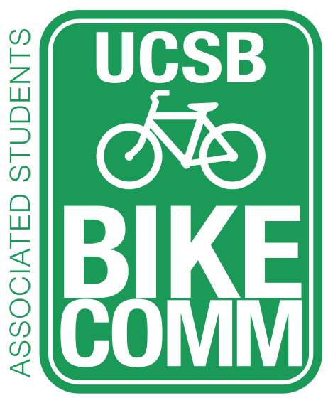
Associated Students Bike Committee
Officer Meeting Minutes

5/1/15 @ 12PM, Nati Conference Room

CALL TO ORDER by Emily Littleworth at 12:05PM

- Meeting Business
  - Attendance
Name | Present/Absent | Name | Present/Absent
Emily Littleworth | Present | Cecilia Guevara | Present
Mac Kennedy | Present | Cody O’Reilly | Absent
Richard Lo | Present | Fabi Perez-Lua | Absent
Chris Bustos | Absent | Kevin Jin | Present
Ava Cheng | Present | Joey Lee | Absent
Nicole Ng | Present | Sarah Siedschlag | Absent
Han Bae | Present
- Public Forum
  - General Announcements
  - Appreciations/Concerns
    - Appreciations to Nicole for making cookies
  - Requests to have items added to the agenda
    - Mac: $470 for 25 S, 20 M, 5 L green shirts
- Committee Member Reports
  - Associate Officer(s) Report
    - Cecilia: Sustainable Transportation forum update
      - Make a list to send to Michael (Transportation Planning)
    - Kevin & Han: Garden Courts found around 20 abandoned bikes for IV Bike Project
  - Administrative Officer Report
    - BikeFix – provide them with Easy Up or grease
    - Table Harder Stadium, continue emailing
    - Tom from TAP making list of summer construction projects
    - Manual: contact list, Bike Tabling, Auction
  - Treasurer Report
    - Contacted IV Screen Printing - 25 S, 20 M, 5 L
    - Manual: started contact list, interpreting bike reports, how to fill out forms
  - Project Manager Report
  - Social Media Report
    - Decorations for the Bike Committee office
    - Video of bike path
    - Manual: Introduction, Photoshop tutorials
  - Vice Chair Report
    - Manual: help Chair, motivate committee, make facilities & administration pay for bike path
  - Chair Report
    - Manual: added info of hiring process
    - Announcing interviews this weekend.
    - Jennifer Massey from Bren –mini bikeshare program. Meeting next week. Include bikeshare program in senior letter
- Action Items
  - Mac motions to fund up to $470 for 25 S, 20 M, 5 L green shirts.
    - Emily seconds, Tiffany calls to question.
    - Motion approved by consent.
- Discussion Items
  - Psych Lot Entrance
    - Complaints
    - Chris will send formal email to Dennis
  - Thunderdome/Student Health Roundabout
    - Discussion came up before – no space for a roundabout
    - Put under Potential Projects List
    - Follow up with Dennis
  - Ocean Meadows Class I – Potential Projects List
    - Bike Path to Rec Cen/HSSB
    - Music/Girvetz path repaving
    - Signal intersection at Pardall/Embarcadero del Norte
    - Mesa Road/Los Caneros
    - Add Sustainable Transportation Forum list.
    - Stadium/El Colegio car/bike roundabout.
      - Ask for plans for Stadium/El Colegio intersection
  - Pardall Dero Air Kit
    - Sarah will send check. Dero will deliver, Peak Racks will install.
- Campus Improvement Updates
  - Side comments: South Hall roundabout – accidents due to students coming in. Chris will follow up.
  - Projects Completed
  - Projects Underway
    - HSSB Parking
      - Chris confirm with Jon Cook.
  - Priority Project List
    - LSB
      - Check on bike path plans in conjunction with lot
    - HFH
    - SAASB Parking
      - Chris get lots count next week
    - UCen
      - MCC and UCen equally important
    - MCC
      - Ralph Furtig memorial rack. Time crunch, but not a large priority overall.
    - Library
- Committee Business
  - Committee should look at Student Feedback folder for next week.
  - Ava will record survey information.
  - Setting interview times next week.

ADJOURNMENT by Emily Littleworth at 1:11PM.

