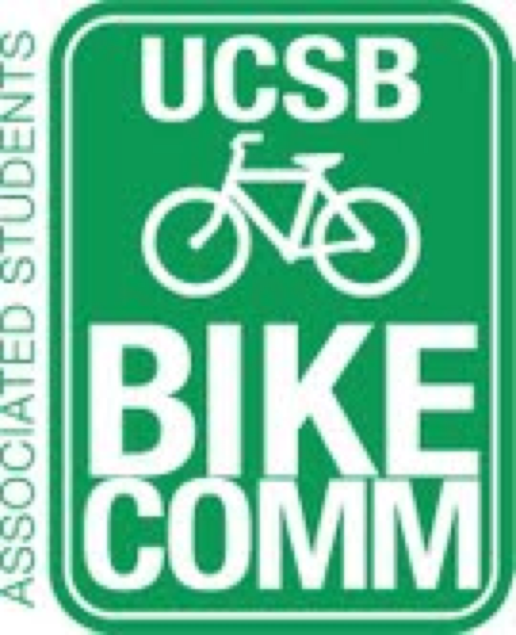

Bike Committee Minutes
Associated Students
04/11/14@ 3:00 PM
A.S. Conference Room

CALL TO ORDER

- Meeting Business
  - Attendance
Name | Present/Absent | Name | Present/Absent
Emily Littleworth | Present | Mac Kennedy | Present
Richard Lo | Present | Reida Khan | Present
Chris Bustos | Present | Alex Kim | Absent
Zac Armour | Present | Aaron Jones | Present
Dennis Whelan | Present | Frank Castanha | Absent
Jamey Wagner | Present | Ralph Fertig | Present
Thomas Bell | Present | Steve Conner | Present
Ava Cheng | Present | Alisa Rangwala | Present
Nikki Cooper | Present

- Public Forum
  - General Announcements
    - Ralph – UCSB transportation analysis
      - Students Biking to school decreased
      - Possibly dependent on where students are living now
  - Appreciations/Concerns
  - Requests to have items added to the agenda
- Committee Member Reports
  - Treasurer Report
    - In progress
  - Bike System Analyst Report
    - Absent
  - Social Media Report
    - In what situations would a bike tank as a reward be appropriate
    - To take pictures of all the problem areas around campus
  - (Ava’s Ecoalition Report)
    - Next Monday is the meeting
- Action Items
  - Approval of Funds
    - Library 3rd row and other row ends
      - Held off from last week due to question of bulk pricing
        - No bulk pricing
      - Mac motions to approve $7750.40/Emily seconds/Richard calls to question
        - Dennis to follow up with peak racks to make sure removal price is included in the proposal.
    - Pardall Center is in need of the new racks their moved to another place on site
      - Pardall Center will incur the cost
- Campus Improvement
  - Projects Completed
    - Arts
  - Projects Underway
    - SAASB Intersection
      - Ballot Initiative
        - Campus Funded
          - The issue is the word “safety”
            - If this is a question then it is up to the University to fund this project
            - This will not be at the forefront of the University’s to do list however and may take a while to complete
            - Mac to get the statistics for the accidents at the SAASB intersection
          - $280,952.90 is the estimated cost of this project
          - To set up meeting with Mark Fisher
        - Advertising
  - Primary Prospective Projects
    - Library 3rd row
    - Other racking projects
      - HSSB
        - Dennis on proposal
      - South Hall
        - Dennis on proposal
      - Campbell
      - Broida
      - Life Science Building
        - Has been competed
        - No alleviation on Psych lot however
        - Advertising of the lot and peak counts for both LSB and Psychology are necessary
  - Maintenance
    - Underway
      - Dero Airkits
        - Check on durability
          - Need replacement for Mike to check on these pumps and perform the necessary maintenance
        - How to do signage
      - Bike Fix it Stations
    - Prospective
      - University Center Root
      - El Colegio signage
        - Need follow up email to Matt Stern for additional signage by student health
      - Bike Path near San Ynez
      - Building 387 Racks
        - To put older racks there
- Outreach, Business, and Events
  - Bike Safety Week
    - Doodle Poll to figure out tabling dates and times
    - Zac to create posters of bike map for sticker markings
    - Zac to recreate survey
  - Bike Auction
    - April 16th 1-4
  - Bike traffic safety education
  - Bike Rental Program
- Closing Remarks
  - New Bike Shop head named
  - New bike path and roundabout where library T-intersection is has been planned
    - Need to move Psychology parking west to accommodate
    - Allocate Please Walk bike sign to that area
  - Pardall Embarcadero del Norte Intersection
    - Email Matt Stern, Matt Dopperteen, Doreen Farr
  - Zac to look into 2:00 pm meeting room
    - Can meet in the office with just the officers

ADJOURNMENT

