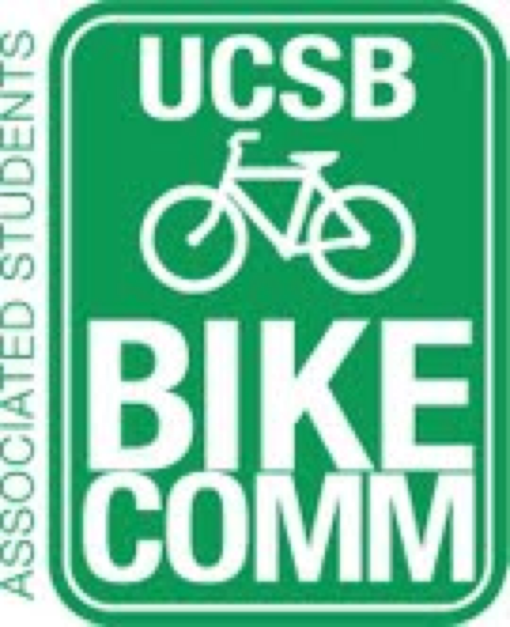

Bike Committee Minutes
Associated Students
02/24/14@ 3:30 PM
A.S. Conference Room

CALL TO ORDER

- Meeting Business
  - Attendance
Name | Present/Absent | Name | Present/Absent
Emily Littleworth | Present | Mac Kennedy | Present
Richard Lo | Present | Reida Khan | Present
Chris Bustos | Present | Alex Kim | Present
Zac Armour | Present | Aaron Jones | Present
Dennis Whelan | Present | Frank Castanha | Absent
Jamey Wagner | Absent | Ralph Fertig | Absent
Thomas Bell | Present | Mike Rogers | Absent
Ava Cheng | Present | Steve Conner | Present

- Public Forum
  - General Announcements
  - Appreciations/Concerns
  - Requests to have items added to the agenda
    - Extra racks from TAP
    - Extra racks to housing
- Committee Member Reports
  - Treasurer Report
    - 671.84 now left in AS account only change form last week
      - due to tanks approval
  - Bike System Analyst Report
  - Social Media Report
    - Website construction underway
- Action Items
  - Approval of Funds
    - Arts
      - Emily motions to approve $16976.46 to rerack the parking lot at Arts with all peak racks/ Ava seconds/Chris calls to question
    - Clipboards
      - Motions to approve up to $30 for new clipboards
- Campus Improvement
  - Projects Completed
    - Yield at Pardall
    - Campbell Numbering
  - Projects Underway
    - SAASB Intersection
      - Signatures
        - Well over 2000 to go
        - Places to get these signatures
          - CLASSES!
          - Bus stop
          - Arbor
          - Dining commons
          - Dorms
          - IV Theater Movies
        - Need more clipboards
          - See D. Action Items
      - University Loan
        - Yet to hear back
  - Primary Prospective Projects
    - Girvetz
      - Possibility of doing this because of the excess money we have
      - May be more than the 100k that was originally estimated
      - Perhaps a better idea would be holding off until next year
      - May take 4 or 5 months to plan also
      - Standardizing peak racks should take precedent
    - Arts
      - With that in mind we have the proposal to rerack arts so it makes sense to set that in motion
      - See D. Action Items
    - Other lots in the makings for reracks
      - South Hall
        - Estimate is next in line
        - Will relieve pressure off of music and Kerr
      - Library
      - Campbell
      - Broida
        - Be careful not to invest money that will be undone due to university plans for that part of campus to be renovated
      - HSSB
      - Life Science Building
        - Actual racking in the works
  - Maintenance
    - Underway
      - Housing
        - Matilda Mead
          - Possibility of bringing the bike shop to San Catalina for a day to the lack of accessibility those students have
          - Mike Rogers is the contact, Chris to follow up.
          - Side note: Housing does their own abatement internally
      - Alex Choate
        - Bike parking at the UCen needs to be addressed
        - Question of safety, one nasty root in particular
        - Should be a priority of the committee
        - John Cook as head of campus gardening is the contact
        - Possibility of getting funding from other sources (Jonathan Abboud)
    - Prospective
      - El Colegio signage
        - Committee to evaluate necessity of signage here
      - Building 387 Racks
        - To add graveyard racks in this area
        - Tom from parking services is the contact
      - Pardall center
        - Also in need of graveyard racks
        - Aaron to ask which type they would prefer
      - Psychology Racks
        - LSB should relieve pressure off this lot
- Outreach, Business, and Events
  - Budget Reorganization
    - Need to set up additional meeting outside of the weekly meeting
  - Bike Safety Week
  - Shirts
    - A week and a half to two weeks
- Closing Remarks

ADJOURNMENT

