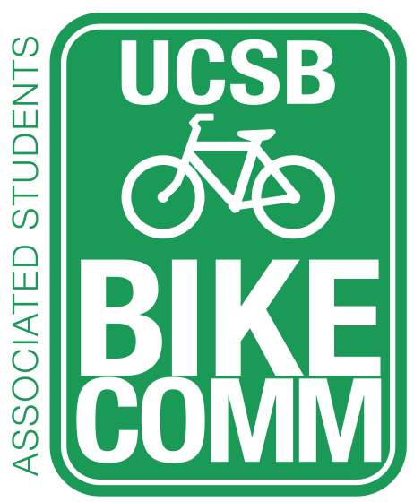
Bike Committee Officer Meeting Minutes

Associated Students
February 19, 2016, 2:00PM
Nati Conference Room

CALL TO ORDER 2:05 by Yeh

A. MEETING BUSINESS
- Roll Call

Name | Note:  absent (excused/not excused)  arrived late (time)  departed early (time)  proxy (full name) | Name | Note:  absent (excused/not excused)  arrived late (time)  departed early (time)  proxy (full name)
Tiffany Wu  Chair | Absent (Excused) | Sarah Siedschlag | Present
Tiffany Yeh  Administrative Coordinator | Present | Krystalin Bullicer  Associate Officer | Absent (Not Excused)
Ines Hernandez  Project Manager | Present | Cynthia Jiang  Associate Officer | Absent (Excused)
Constantine Chong  Finance Manager | Present | Kevin Jin Mei  Associate Officer | Absent (Excused)
Lianna Nakashima  Media Coordinator | Present | Stacy Kowsz  GSA Representative | Absent (Excused)

- Acceptance of Excused Absences and Proxies

B. PUBLIC FORUM
  - General Announcements
  - Appreciations/Concerns
  - Request to have item added to today’s agenda

- REPORTS
- Advisor Report
  - Went to IV Bike Safety Meeting, everything is set for the event Now on March 2, 5:30-8:30 pm Pardall Center. Going to have 1000 pairs of lights and CHP will be there with some sort of mascot. UCPD
    - IV Lux is the official name of the event
    - we can have table and pass stuff out
  - Been hearing from different people UCSB Sustainability wants to do a bike ride around the campus for CycleMAYnia with a stop at bike shop and show off our bike stuff. BC Centro wants to do some sort of bike ride, so we should be more specific
- Associate Officer(s) Report
- Administrative Officer Report
  - Dennis and I went on a ride around before winter break and identified part of the bike path that needed to be repaved and re-striped between HSSB and Storke Circle. He gave me an estimate, so I just wanted to share that with everyone. I’ll have him go into more detail next time
  - Next week VC Fisher will be coming to talk about the UCen Parking lot and the MSRB/Bren lot
- Project Manager Report
  - Question about needing to get volunteers for the IV Lux event
    - Sarah: BC Centro is also going to be there and CHP, so I’m not sure that they need anymore
- Media Coordinator Report
  - New article from the Nexus that is accurate so I plan on posting this
    - Sarah: Let’s check it before they post it
- Finance Manager Report
    - Going to the budget hearing at 3:15 today
    - Need to finalize the design, changing the design is really the only thing we need to work on, extra dollar is we want white writing
- Chair Report

- ACCEPTANCE of ACTION SUMMARY

D-1. Acceptance of Minutes from 2/12/16 in an Email Vote on 2/20/16
Motion/Second: Yeh/Nakashima
Jiang calls to question
Motion approved by consent

- DISCUSSION ITEMS

E-1. T-Shirts
- Same design, but the change of logo in the back
- Lianna: Wanted to change the font
- Sarah: The font before was really rounded and bubbly
- Yeh: Can you make the design with the different font and then email it to everybody so we can vote on it
- Chong: There different brands, American Apparel and the other is Canvas. More towards American Apparel because we are all
- Yeh: So we need to figure out what color shirts because making a green shirt with white lettering is more expensive
- Chong: We could do green tanks and white shirts
- Yeh: How many do we want?
- Chong: I have the count from the last time, but that was just an extra order. Think about $10-12 per shirts
- Sarah: the other company that I have that has the color people don’t like comes to $9 per shirt. The more you get, it makes it cheaper per shirt. I think in the first run they got 100 tanks and 100 shirts
- Chong: Set up fee 35 for front 35 for back. But they don’t make it cheaper for larger orders. Also need to check price for the tanks
- Sarah: Quantity wise it just depends on what we want to do with them
- Yeh: Well we want to do bike safety week, but maybe we can just give shirts to people who participate in whatever activity we make
- Decide: Color shirt, tank or t-shirt, text font, finalize logo on back and the design on the front
  - White shirts and green tanks (Kelly Green for green color)
  - 150 each
  - designs emailed by Sunday by 3pm

E-2. Announcement for the Street Signs along Ocean Road Bike Path
- Yeh: Since the signs won’t have a bike comm logo on it, we need to think of how we will tell people that their student fees went to making the signs. I was thinking about getting in touch with the project manager of this and see if we can take a picture of the signs before they are put up and then pictures of them getting installed. What else should we do?
- Sarah: set up a sandwich boards by one or two signs

E-3. IV Lux, Light
- Yeh: Event is from 5:30 to 8:30. From the last time we asked, everyone one on the committee should be available at some point of the event to help out. Do we want to get bike safety tip cards?
- Sarah: BC centro is also passing things out. There was talk about maybe make a box with papers for people to put things they want to see or concerns they have

E-4. Bike Safety Resolution
- Yeh: the resolution is saying that Senate will support the committee with any education campaigns
- Sarah: so if you had all the money to hold an event, what would you want?
- Yeh: basically food, lights, and shirts
- Sarah: Zero Waste Committee is hosting a couple of speakers putting on a workshop of how to start a campaign of any sort. How to use aspects of social media, utilize organizations, publicize and get people to pay attention
  - February 29 5-7 pm in the SRB Multipurpose Room, first hour is listening to these people and second hour is breaking into small groups and they go around and help out.
- Yeh: We can ask them to fund a big event during bike safety week?
- Sarah: Ask them to fund freshman bike lights

E-5. CycleMAYnia events
- Yeh: As of right now we have the two bike rides from campus to Trader Joe’s and Costco. What else do we want to do?
- Lianna: We can bike Sands and maybe a picnic
- Yeh: The deadline for submitting events is March 17

E-6. Social Media Presence
- Yeh: So Stacy emailed about the social media page and how we’ve had to take items off after they were posted. We talked about how the Nexus article was inaccurate and then it was posted. And then Tiffany said she took down TBL article because the quote that was pulled and put in the description of the post was biased. We’ve also had issues last quarter about things having to be removed. So Tiffany, Stacy and I discussed having the committee approve the things that are posted before they are posted because the things put on our social media page reflect all the members of the committee.

ADJOURNMENT 3:00 Yeh

