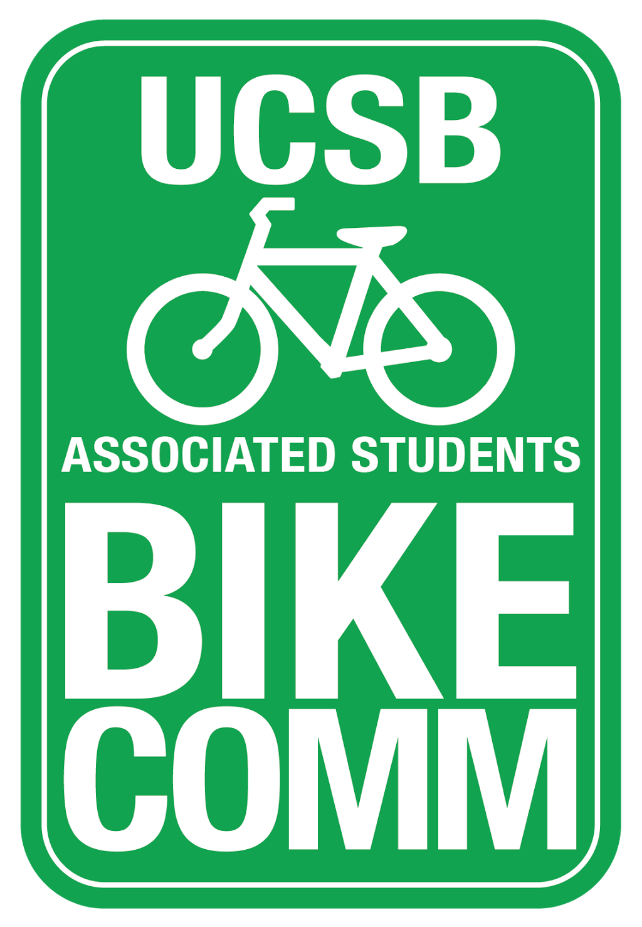
Bike Committee General Meeting Minutes

Associated Students
February 26, 2015, 2:00PM
Nati Conference Room

CALL TO ORDER 2:04 by Wu

A. MEETING BUSINESS
- Roll Call

Name | Note:  absent (excused/not excused)  arrived late (time)  departed early (time)  proxy (full name) | Name | Note:  absent (excused/not excused)  arrived late (time)  departed early (time)  proxy (full name)
Tiffany Wu  Chair | Present | Matt Stern | Absent
Tiffany Yeh  Administrative Coordinator | Present | Marc Fisher | Present
Ines Hernandez  Project Manager | Present | Stacy Kowsz  GSA Representative | Absent (Excused)
Constantine Chong  Finance Manager | Present | Kevin Jin Mei  Associate Officer | Present
Lianna Nakashima  Media Coordinator | Present | Cynthia Jiang  Associate Officer | Present
Sarah Siedschlag  Advisor | Present | Krystalin Bullicer  Associate Officer | Present
Dennis Whelan | Present | Ashcon Minoeifar  Senate Liaison | Absent
Steve Conner | Present | Reilly Hobson  Senate Liaison | Present
Jamey Wagner | Present
Javier- Co chair of Public Safety Commission
- Acceptance of Excused Absences and Proxies
Motion/Second: Wu/Nakashima
Jiang calls to question
Motion approved by consent

B. PUBLIC FORUM
  - General Announcements
    - Javier: Came to this meeting because I was incredibly alarmed that Gaucho FYI dropped bike safety lesson plan. Don’t know why, but I’m here to work with bike comm to educate student body on bike safety. More specifically looking at the Pardall intersections. Talked to Pardall center and they have big chalkboard we can use to make warning signs
        - Wu: Sarah mentioned that Matt Stern is working on a campaign to give people cookies when they stop at stop signs
        - Cut because they didn’t have enough time so they cut off the bike safety part to shorten the presentation
        - Wu: Waiting to hear back from George about re-adding
  - Appreciations/Concerns
  - Request to have item added to today’s agenda

- REPORTS
- Advisor Report
  - Everything seems to be set for IV Lux
- Associate Officer(s) Report
  - Cynthia: Want to talk about the bike safety videos that I brought up last quarter, and have narrowed it down to five big tips. In the process of creating bike parking, yielding in roundabouts, stop signs, traffic rules and passing on the left lane and hand signals.
    - series of artworks and drawing out the rules and putting it into a 20 second videos
    - different from the CSO videos where they apply the rules, but my videos will be more informative
    - consider with cross-promoting with other groups
- Project Manager Report
  - Do we want a larger sign up sheet?
    - Yeh: Stacy emailed and said they were looking to have at least 10 people volunteering at all times. So we should start looking for other volunteers
- Media Coordinator Report
  - Since the posts have to be checked before, how many people need to approve a post?
  - Wu: two people and email the posts to everyone in the committee
- Finance Manager Report
  - Got in touch with Olga, and will have an updated by Tuesday
- Chair Report
  - IVDBA wanted a volunteer sheet
  - main ideas they want to get across: stop at stop signs, actually use the lights, hand signals and biking on the right side of the road

- ACCEPTANCE of AGENDA/CHANGES to AGENDA
Motion/Second: Wu/Nakashima
Chong calls to question
Motion approved by consent

- ACCEPTANCE of ACTION SUMMARY
E-1. Acceptance of Minutes from 2/19/16
Motion/Second: Wu/Yeh
Chong calls to question
Motion approved by consent

- ACTION ITEMS

F-1. New Business:
- Bike Committee Shirts
  - Chong: 150 tanks and 150 shirts comes out to $3,056.40
    - all cotton or poly cotton, poly cotton is 50 cents more
  - Nakashima: We decided on the American Type-writer font
  - Chong: Once we get this approved I just have to send him the design
    - poly cotton are the ones people are more familiar with, but this should be fine
  - Sarah: We’ve spent about $3000 so far. So if you want to spend $3000 it will leave about $1500 for the rest of spring quarter
  - Yeh: We can take the quantity down so we can buy bike lights for next quarter.
  - Chong: It is also nice to just have money in the account
  - Yeh: What do we need shirts for? Like we know shirts are needed for Ride with Ramen
  - Nakashima: 15 or less shirts
  - Jiang: We also need to plan for shirts to pass out at Pardall Carnival because we ran out super quick and recruitment events
  - Sarah: Bike Comm gives shirts out more freely so maybe tighten the way to give out shirts
  - Yeh: Well we should make it so that people have to post on Instagram or Facebook some bike safety tip before getting a shirt
  - Chong: If we drop the quantity to 125 then it will take the cost to $2559.60. We can at least order extra at the end of the quarter with the left over budget, but we need to order at least 25-55 of each type of shirt
  - Motion to allocate $2,600 to print 125 tanks and 125 shirts
Motion/Second: Yeh/Nakashima
Bullicer calls to question
Motion approved by consent

- DISCUSSION ITEMS

G-1. UCen and Bren/MSRB Lot Update from Vice Chancellor Fisher
- Dennis: meetings and process?
- VC: Two meetings, one for Bren Hall. When we put a lot by academic buildings, we have to work with the people in the building
  - Looking at the place between the two buildings, so we want to design something that will keep the landscape looking the same
  - There is a history of resistance to bike lot in the area
  - With UCen, it is just working with the UCen, less about the politics with the place.
- Dennis: The meeting will be with VC, me and the heads of the departments
- VC: there is a lot more construction going on and it will move around the campus, this first phase and will go until March. The impact in front of MCC will be only for a week or so. The big one is the bike path in front of Music, which will be during summer. Projects are focused on fixing water, sewer, and gas lines. There will also be a project
- Dennis: There will be one in front of Rob Gym on Ocean Road. Hoping to fix the flooding that happens between Music and Girvetz
- Sarah: Would the drainage that will be rebuilt be the same?
- Dennis: The bike path should be asphalt so that we can tell the difference between bike and pedestrian path.
- Dennis: Might have to ask the committee for more funds for the project
- VC: It will happen after commencement when the population on campus drops.
- Dennis: Would use tape to make an alternate route
- Sarah: How long?
- VC: Months
- Chong: With all the construction going on, people start parking their bikes at the Arbor and walking around. So if there is construction going on we can advocate parking their bikes at the center of campus. The lot behind South Hall is always completely filled.
- Jiang: There is just one rack by the Sunset room of the library that is just put aside

G-2. Old Bike Racks
- The ones by the library
- Dennis: Most lots packed to capacity
- Javier: What about Campbell or Phelps?
- Dennis: We would have to expand the lots
- Nakashima: We talked about putting peak racks by the Thunderdome. And the Library and HSSB. There was extra space with woodchips.
- Yeh: It looks like we want to just get rid of them because it seems like people want peak racks
- Dennis: They serve the Psych building more, not so much the library. When bioengineering is done will be expanded. The sycamore trees are stressed so we could take out the existing pavement and re-doing the whole lot.
- Javier: Are they going to open an entrance on the south side?
- Dennis: They want a limited amount of doors into the library
- VC: when the bike path reopens there won’t be as much of an issue with bringing the bikes through the library

G-3. Resurface and Restripe of Bike Path from HSSB to Storke Circle
- Dennis: Recoating the whole segment and then restriping it, bring the striping up to the current standards
  - There are two small pedestrian crossing where the stripes just stop by the sand volleyball courts. So did that with this area
  - Had a calculation done, but there is no cost yet, maybe 2 smaller projects
- VC: Would this be during summer?
- Dennis: we are running out of time to do it during spring break
- Yeh: would this be something we would fund
- Dennis: It would come out of the maintenance funds not student fees
- Chong: I think this is one of the most used parts of the path so this is a good project to get done
- Dennis: There is a curb that I would like to remove

G-4. Event Center/Lot 22 intersection
- Dennis: The roundabout that I’ve drawn up is the size of the Storke circle
- VC: This could work, but there is an issue with how much space it would take over
- Jiang: What if we did the same yield system as the HSSB yield?
- Dennis: 71 feet in diameter, which is the standard size for roundabouts
- Most accidents from people leaving the tunnel to campus turning left.

G-5. CycleMAYnia Events
- Jamey: Measure A money to do bike education, Bike Coalition focuses on that. Three classes: learn your bike, obstacle course, and on the road. Talk about working these on campus. Need to know when to do it and which ones to do.
- Wu: It would be helpful to have meetings with them.
- Jamey: May 3 is the morning event, the week of the bike to work week is the week of the 15th or 16th of May. Education could happen before to get ready to ride your bike May. Talked about including bike shop as well.
- Sarah: Jule also talked about doing a bike tour and it would be helpful to have a stop at the station.
- Jamey: That’s an off-shoot of the education part as well. And it could be part of the tour
- Nakashima: I’m not sure that a bike tour of our campus is useful. People could bike to the bike shop and spend a few hours learning to repair. We could also give out shirts and post on social media some bike safety tips to get the shirt.
- Jamey: They also talked about having rental bikes for people who don’t have bikes and learn about the bike system.
- Sarah: As you plan, think about May 8th is mother’s day, May 15th is extravaganza 28-30 is Memorial Day weekend. so plan weekend events accordingly

ADJOURNMENT 3:34
Motion/Second: Yeh/Nakashima
Chong calls to question
Motion approved by consent

