Bike Committee Weekly Meeting Minutes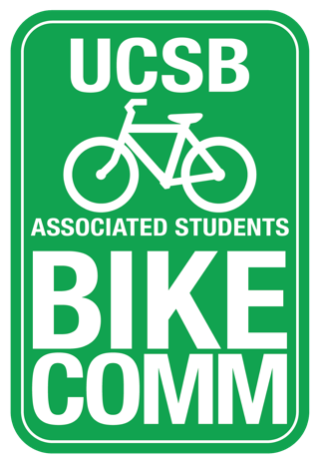

Associated Students
March 27, 2018 1PM (Ex: January 20, 2017 11:00am)
Email vote

A. MEETING BUSINESS
- Roll Call

Name | Note:  absent (excused/not excused)  arrived late (time)  departed early (time)  proxy (full name) | Name | Note:  absent (excused/not excused)  arrived late (time)  departed early (time)  proxy (full name)
Kevin Jin  Chair | Present | Adriana Ocasio  Associated Officer | Absent
Annie Golay  Vice Chair | Present | Sara Lafia  Graduate representative | present
Lianna Nakashima  Media Coordinator | Present | Sarah Siedschlag  Advisor | Present

Motion: Kevin Jin
Motion to allocate an additional $6,975 to the Bren Bike Lot proposal.
Second: Lianna Nakashima
Vote: Yes/no/abstain: 5/0/1
Motion passes

Motion: Kevin Jin
Motion allocate up to $350 for the material and repair of bike pumps on campus
Second: Lianna Nakashima
Vote: Yes/no/abstain: 5/0/1
Motion passes

ADJOURNMENT

Adjourned at April 1, 1pm
ACTION: Consent

