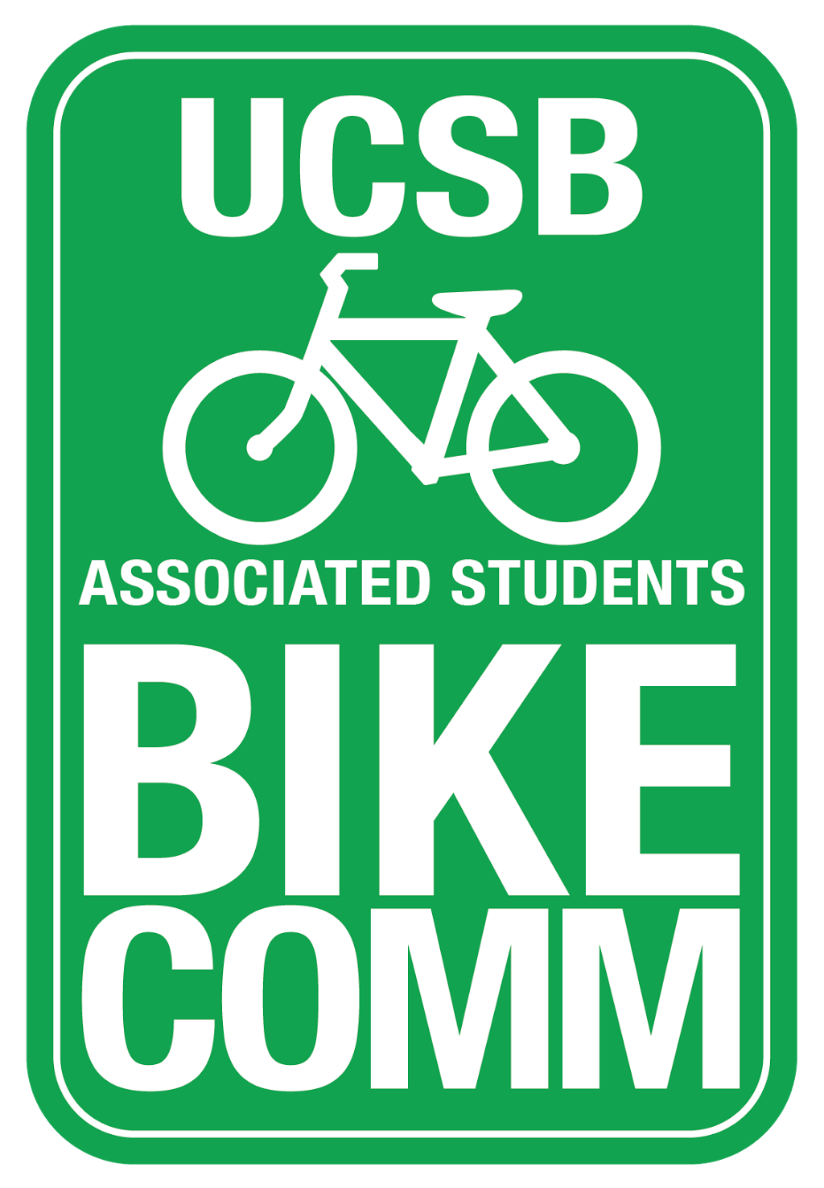
Bike Committee Weekly Meeting Minutes

Associated Students
October 26, 2016 3:30pm
Bike Committee Office

CALL TO ORDER 3:31pm

A. MEETING BUSINESS
- Roll Call

Name | Note:  absent (excused/not excused)  arrived late (time)  departed early (time)  proxy (full name) | Name | Note:  absent (excused/not excused)  arrived late (time)  departed early (time)  proxy (full name)
Kevin Jin  Chair | Present | Eric Boessencker  Educational Officer | Present
Annie Golay  Vice Chair | Present | Angela Ho  Associate Officer | Present
Tiffany Yeh  Project Manager | Arrived late (3:33pm) | Daniel Kolosta  Associate Officer | Present
Rohan Malpure  Finance Manager | Present | Ngoc Hoang  Associate Officer | Present
Lianna Nakashima  Media Coordinator | Present | Navpreet Khabra  Associate Officer | Arrived late (3:39)
Jorge Sandoval  Admin Coordinator | Present | Sarah Siedschlag  Advisor | Present

- Acceptance of Excused Absences, Proxies and Attendance
MOTION/SECOND: Jin/Nakashima
Motion to accept attendance
ACTION: Vote: Consent

B. PUBLIC FORUM
  - General Announcements
    - Introductions of new officers
  - Appreciations/Concerns
  - Request to have item added to today’s agenda

B. Committee Business

D. REPORTS
- Advisor Report
- Associate Officer(s) Report
  - Kolosta- Climate Action Plan: They talked about the bike share and adding it to the Climate Action Plan
    - Not too much to report on bikes but it was mainly about carbon neutrality
- Administrative Officer Report
  - Ride Around 11/1 at 4pm
    - Be on time
  - Add Renee to the Bike Comm Agenda mailing list
  - People who are available is everyone but Annie, Danny and Lianna
- Education Officer Report
  - Implementing a course for .5 to 1 unit for general campus health and safety that would include a lot of campus organizations to contribute
  - 1 Hour a week and there would be a lot of people who would want to add that class for the extra unit
- Project Manager Report
- Media Coordinator Report
  - New officers, do your bios
- Finance Manager Report
- Vice-Chair Report
  - Wrote a draft to Marc Fisher for the new lecture hall designs
  - Improving safety, enhancing accessibility, improve effiencey
    - Widen bike paths and add more bike parking
  - Wheelen- Question the validity of the bike parking they designated
- Chair Report
  - Creating a heat map from data that shows where the majority of bike theft happens in campus and around IV
  - Free and For sale will advertise the UCSB Bike exchange facebook group
  - For the Bike rental program, we need to figure out liability and maintanence of the bike.

E. Old Business

F. New Business

G. DISCUSSION ITEMS

- Dennis – Project Estimates
  - Signs for bike lots
    - $90 for each sign with mounting hardware, total of 12 signs for $1,087
      - Plus $150.00 for labor
    - South Hall West Improvements- $11,500
    - South Hall NW - $10,500
    - UCEN/Music- $25,500
    - Library South- $32,500
    - Psych North- $7,000
    - Life Science -$12,500
    - Rob Gym- $31,000
    - Dennis will meet with racks manufacturer to find talk about and find estimates for our projects
    - Improvements could be made with plaques that give commendation to the Bike Comm
    - Total - $130,500 for all prospective projects
    - Goleta and on November 9th at 12pm in State Street Room
      - Publicize it
- Education Efforts with RHA
  - Navpreet has been trying to set up a meeting with RHA members to organize the event
  - Ideas?
    - One at each dorm
    - Have food and raffle
    - Have Kevin teach people how to fix bikes n things
    - Bike tour to visit different food retailers around campus, IV and Goleta
      - With the Food nutritional
    - Eric will help with ideas and presentations
- Bike Gripes Event, New Name?
  - Table at the arbor during busy times and ask people to tell us where accidents happen and what they want fixed
  - Prizes needs to be used for education so prizes need to be given out for educational workshops, like with RHA
  - We would like to have this event next week
  - We want new stickers and we also need a new map
  - Food, shirts and bike lights
  - Bike n’ blast, Bike Spite, Bike n’ grumble
  - Voted for Bike n’ Blast
- Stop for Cookies
  - Buy cookies from Costco, give out at the MCC intersections
  - Probably needs to be postponed until next quarter
- Priorities list
  - We can have people stand by racks during peak hours to see what the needs ot students are in the bike racks
  - Schedule people to count racks that Dennis gave us estimates for
  - Also take pictures
- Ride and Ramen
  - We could include this with the initial RHA collaborations
  - We would ride around and ask for Tuesday tips and use those for improvements, and then after give out ramen that is home made

ADJOURNMENT

MOTION/SECOND: Jin/Nakashima
Motion to adourn the meeting at 4:53pm
ACTION: Vote: Consent

