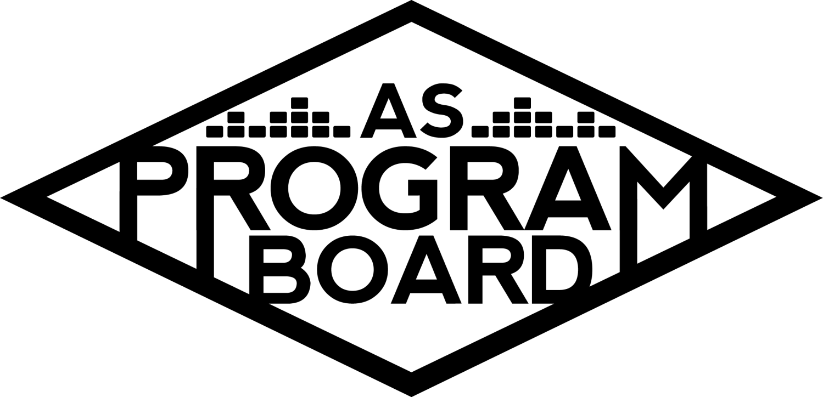
Program Board Minutes

Associated Students

June 13th, 2022
Zoom

CALL TO ORDER: 6:02 PM by Emily Kocis
A. MEETING BUSINESS
- Roll Call
Name | Note:  absent (excused/not excused)  arrived late (time)  departed early (time)  proxy (full name) | Name | Note:  absent (excused/not excused)  arrived late (time)  departed early (time)  proxy (full name)
Cameron Heid |  | Kurt Melvin Ventura
Cassandra Leviste |  | Larry Huynh
Clarissa Ann Mendoza |  | Ligaya Chinn
Dallin Porter |  | Martell Hernandez
Emily Duong |  | Montana Woods
Emily Kocis |  | Sophie Kimura | Late Arrival 6:04
Grace Freese |  | Tiana Ly
Graham Glass |  | Wally Corngold

Acceptance of excused absences, absences, early departure and proxies
Motion to accept the late arrival of Sophie Kimura at 6:04 PM. Motion by Wally, second by Clarissa. Consent with 16 present.

B. PUBLIC FORUM

C. ACCEPTANCE of AGENDA/CHANGES to AGENDA
Motion to accept the agenda. Motion by Emily D, second by Wally. Consent with 15 present.

D.ACCEPTANCE of ACTION SUMMARY/MINUTES
No previous minutes.

E. ANNOUNCEMENTS
- Land Acknowledgement
- Introductions: Name, Year, Major, Position, Last Concert You Went To or Upcoming Concert You’re Most Excited For
- Robert’s Rules of Order
  - Motion, second, consent, voting, meeting quorum
  - Example: “Motion to pass $5 million dollars for Bad Bunny on 6/13/2022” “Second” “Call to consent?” {pause}” Consent with ___ present”
  - When do you break consent?
    - When you disagree with the artist or budget being passed (you are more than welcome to vote no)
    - When you cannot commit to the event
      - When passing an event and you do not break consent, you commit/pledge your time to be at the event
    - When we break consent -> we move to a vote that includes the options of: yes, no, abstain
- Zoom Etiquette
- Email Votes
  - Will be conducting business about passing artists/artist discussions/budget via email votes
  - Everyone needs to be involved in email discussions and attentive!
  - Artists and events we put on are important to student body, which is done through our active conversations
  - Be timely!
  - There are usually reply deadlines
  - Have informed sources!
- Contact guidelines
  - Email, Slack
  - Groupme
  - You should be reached out by your previous Boardie by the end of this week, let Emily K know if you have not been reached out yet
  - Email and Slack accounts are strictly business related since these are shared accounts and include previous business conversations
- Retreat: 9/10-9/11 or 9/17-9/18
  - All day commitment to learning the majority of all things ASPB
  - Official Date: 9/17-9/18

F. WEEK IN REVIEW

G. PREVIEW OF THE WEEK

H. OLD BUSINESS

I. NEW BUSINESS
- Summer Board 6/20-9/11
  - Budget
  - Applications due 6/15 to commissioner@as.ucsb.edu
  - Students in summer sessions pay lock in fees, which funds our summer programming
- Lagoon Lawn Film 9/21
  - Budget
  - Annual film before fall quarter starts, first ASPB event of the year!
  - Often upbeat/animated/comedy films
- Film Budget 2022-2023
  - Budget
  - Every Tuesdays at 7pm and 10pm in IV Theater
  - This is a Half Board event (half of board required to work)
- Welcome Back 9/24
  - Budget
  - First big concert of the year held at Storke Plaza
  - Traditionally book artists that are on the rise for this event
  - Wally will be sending out a research document discussing artists soon
- Delirium
  - Annual Halloween concert at the Thunderdome
  - Budget will be passed soon
- Storke Shows
  - Budget
  - Smaller scale concerts that usually highlight local IV bands/artists and take place at Storke plaza every week during Noon
- 2022-2023 Merch
  - Budget
- Publicity Budget
  - Budget

J. ACTION ITEMS

K. FINANCIAL ACTION ITEMS
- Motion to pass $60,000 for the Summer 2022 Programming Budget from 6/13-9/18. Motion by Grace, second by Montana. Consent with 15 present.
- Motion to pass $5,850 for the Lagoon Lawn Film on 9/21/2022. Motion by Melvin, second by Ligaya. Consent with 15 present.
- Motion to pass $45,550 for the 2022-2023 Films Budget. Motion by Ligaya, second by Marty. Consent with 15 present.
- Motion to pass $62,700 for the Welcome Back Concert on 9/24/2022. Motion by Graham, second by Larry. Consent Broken. Move to a vote. V: Y-15, N-0, A-0.
- Motion to pass $12,000 for 2022-2023 Storke Show Budget. Motion by Grace, second by Dallin. Consent with 15 present.
- Motion to pass $4,000 for 2022-2023 Merch Budget. Motion by Marty, second by Emily D. Consent with 15 present.
- Motion to pass $2,610 for the Fall 2022 Publicity Budget. Motion by Dallin, second by Melvin. Consent with 15 present.

L. REPORT
Facebook Factory / Tuesday Slide / Thursday Ad/ Free & For Sale post

Kudos
To everyone who motioned
All of ASPB 2022-2023 Board!
Emily for leading first meeting
Nyah for explaining everything and being amazing
Ambassadors !!!
Everyone who created and passed budgets!!
Both Emilys for leading meeting

The Marilyn Report
It is very important that we make sure to keep confidentiality about artist discussions outside of board. ASPB receives stipends so you should be enrolled into UC Payroll. We look forward to working with you next year, let us know if you have any questions!

The Kris Report.
Welcome to the new boardies! Will be working remotely this week but will be in the office M-F. Stop by in the office if you’re around!

Commissioner's Report.
Please consider joining summer board and send in those apps by this Wednesday end of day! Ask any questions. If you do not hear from your old boardie by the end of this week for your guide and logins, reach out please! Join the groupme!

Deputy Commissioner’s Report .
Congrats to everyone! Stop by the office, in the MCC first floor. Please join summer board! Reach out to any of us with questions, returners are happy to help with anything.

Coordinators’ Reports
Wally Corngold- first report as special events, woo!!! Once you get ahold of your logins/drive, look through the position guide(s) to gather questions before the school year starts/retreat. Get ready for bootcamp!
Ligaya Chinn- Happy to be here and am excited to work with everyone!
Larry Huynh- Still working on finals but excited to work with and learn from everyone!
Dallin Porter- New to board but excited to get to know everyone and learn and work hard!
Kurt Melvin Ventura- Really excited to be here. I enjoyed being an ambassador last year and am excited to be on board this year. Please feel free to message me any film ideas/your favorite movies! Need as many perspectives as much as possible.
Montana Woods- Happy to be here, excited to learn about position and board, looking forward to doing cool things next year
Sophie Kimura- Nice to meet everyone, just moved out! Scary bug bit my eye.
Clarissa Mendoza- Excited to work with everyone! If anyone needs anything, feel free to text me!
Tiana Ly- Great to meet everyone, here to support everyone, cool to hear about work we’re going to do, hope to accurately capture and present it!

Assistants’ Reports
Grace Freese- Excited to be here and will be a fun year of learning. Glad to be doing things in person!
Cameron Heid- Excited to meet everyone and learn about programming
Graham Glass- Excited to start, will be open to helping anyone else outside of publicity
Cassandra Leviste- Feeling hopeful about this year, excited to bond with everyone
Martell Hernandez- Really happy to be here and finally excited to be on board as a previous ambassador.

Senator’s Reports

ADJOURNMENT: 7:20 PM by Emily Kocis

Artists mentioned: N/A.

