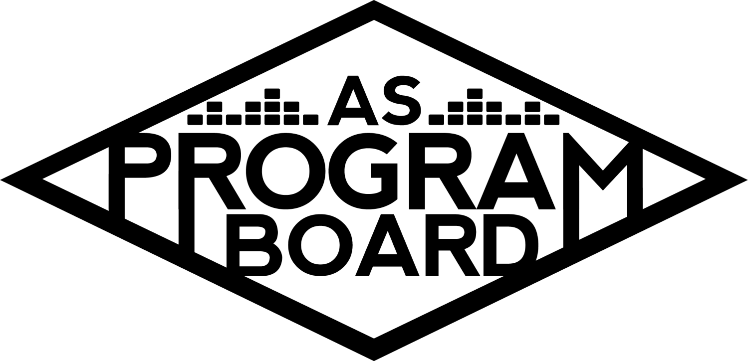
Program Board Agenda

Associated Students
November 4, 2019
SB Harbor Room

CALL TO ORDER: 5:01PM by Kiyomi Morrison
A. MEETING BUSINESS
- Roll Call
Name | Note:  absent (excused/not excused)  arrived late (time)  departed early (time)  proxy (full name) | Name | Note:  absent (excused/not excused)  arrived late (time)  departed early (time)  proxy (full name)
Adam Salton |  | Kari Liu
Alexis Xa |  | Kathryn Quinones
Bethel Tammerat |  | Kiyomi Morrison
Brenna Collins |  | Lucas Jackson
Brett Friedman |  | Mikio Sacramento | Late Arrival 5:10
Carlos Aviles-Sullivan | Absent | Mitchell Lewis
Conner Jones |  | Nathaly Pacheco
Enaiya Judkins |  | Sarah Danielzadeh
Erica Ko |  | Benjamin Chocron | Absent
Esteban Alvarado | Absent
Gabriel Reyes
Greer Jacobs

Acceptance of excused absences, absences, early departure and proxies
Motion by Nathaly, second by Lucas. Consent with 16 present.

B. PUBLIC FORUM

C. ACCEPTANCE of AGENDA/CHANGES to AGENDA
Motion by Conner, second by Mitchell. Consent with 16 present.

D.ACCEPTANCE of ACTION SUMMARY/MINUTES
Motion by Gabe, second by Conner. Consent with 16 present.

E. ANNOUNCEMENTS
- SEND MARILYN AND I YOUR STUFF ON TIME…I’M BEGGING…
  - Things for Monday meetings need to be sent by the Friday before. Send to both Kiyomi and Marilyn.
- New tablecloth :0
  - In commissioner’s office- do not put food on it.
  - Will be ordering another and a table runner.
- Mid Quarter meetings
  - Will finish up this week.
- Events for next quarter
  - If you want to do an event, let Kiyomi know.
- Minutes
- Postering/Tabling
  - Posters were assigned last week- please put them up ASAP.
  - Help pub all events!
- Half-Board events
  - Roy Blair
  - Dia de los Muertos
  - Earthgang
  - Meet the Board
  - Holiday Photos
    - Day 1
    - Day 2
      - You have to do ½ of the half board events every quarter.
      - Holiday photos- each day is its own half board event.
- NO MEETING 11/11 - Veterans Day

F. WEEK IN REVIEW
- Free Tues Film: Scary Stories to Tell in the Dark - 10/29- Esteban
  - 7PM- 116 people
  - 10PM- 252 people
    - Highest attendance for film yet!
  - Had Earthgang & free Tuesday film numbers and gave away candy
  - Both ran smoothly and left IV Theater around midnight.
  - Conner- Ambassadors are in effect and shared on their socials.
- Storke Show-Extremophiles -10/31- Nathaly
  - Call time for Storke shows will be 11:15am from now on
  - 4 people worked, 40-60 people attended
- Dia de los Muertos - 11/1- Gabe
  - Sent out event report sheet
  - Ambassadors posted on socials and a few of them came.
  - People said it was a nice touch of home for people who couldn’t make it home to celebrate that weekend.
  - Think main draw may have been free food.
  - Good to have our name out there for cultural events that target different demographics on campus!

G. PREVIEW OF THE WEEK(S)
- Free Tues Film: Hobbes & Shaw - 11/5
  - Call time 6:30 and 9:30,
    - 7PM- Conner, Brett Mitchell
    - 10PM- Nathaly, Mitchell, Adam
  - Please pub!
  - Movie is 2 hours, 16 minutes
- Storke Show: Misty Mtn - 11/7
  - This Thursday, NOT Monday (Veteran’s Day)
  - Call time 11:15-1:05PM
  - Please pub, and need more people to sign up to work show
- Hub Concert: Earthgang 11/7
  - Last graphic was approved with opener so announcement will be going up tonight
  - G.D. approved on Friday and just released a new album
  - Ticket sales have slowed down- keep pubbing and reminding people
    - Tickets are at 421 currently
  - Tabling tomorrow 11/5?
    - If you haven’t signed up to table, please try to find time
    - Tabling sign ups sent in Slack
  - Event Jobs:
    - Hosp (call time 3:30 DOS)- Brenna, Nathaly, Bethel, and Kat will handle it
      - Bethel and Kat will be named on sheet
      - Cash advances need to be done through requisition forms and need to be turned in ~2 weeks before it is needed
    - Runner (call time 4:00PM DOS)- Enaiya
    - Info Table- Greer will set up and Conner will be there by 8:30.
    - Production got quotes- $3k for backline and everything they need
- Free Tues Film: Blinded by the Light-11/12
  - Call times 6:30 and 9:30
  - 6:30PM- Erica, Kari, Brett
  - 10:30PM-Mikio, Erica, Brett
  - Esteban can’t be there due to a prior commitment, but will assign someone as Coordinator for each movie
- Meet AS Program Board 11/13
  - Name:
    - In Conversation with AS Program Board?
    - Food related title could get more people at event?
      - Chips and Guac Talk?
      - Graphic could also just say that there will be food there
    - Backstage with Board?
  - In Conversation with AS Program Board wins
  - Graphic- Catchy opener that has to do with events people know about
  - Currently only $500 set aside for food- not enough for a lot of people- should we put more money in for food?
    - UCen catering can be pricey- Passing $300 more ($100 of which goes to caterers) so $700 total for food?
    - Could we book a different venue and cater different food?
  - Could make a suggestion box for event
  - Timing: 6PM start, planning on having food ready at 7PM
  - Giveaway?
    - Extra Delirium shirts, posters, fast passes for future shows (X?), bundle of merch, posters of actual photos of previous events, phone wallets, pop-sockets, “limited edition” shirts,
  - Need to pub ASAP, and will announce as soon as we have a graphic- can be simple
    - Aim to have it done by tomorrow
  - Working: Greer, Lucas, Nat, Enaiya, Alexis, Gabe, Adam, Erica, Conner, Mikio, Kiyomi, Kari
    - Call time 5PM, set up 5-6PM
    - Nathaly, Greer, and Conner will help with presentation about Ambassadors
- Storke Show: Tastegood-11/14
  - Call time 11:15AM, show 12-1PM
  - Working: Conner, Mitchell, Enaiya, Brenna
  - More info will be sent in Slack
- Co-sponsorship Isla Vista Backyard Boogie-11/16
  - Contacting them today about staging- they will have to pay for generator and staging

H. OLD BUSINESS
- Holiday Photos - 11/20 & 11/21
  - Confirmed with company that will be working it
  - Said they wanted to set up at 10AM, but we have room booked at 11AM. Will need to adjust budget to accommodate times
  - Event is from 12-4PM each day
  - In previous years, we had a custom ASPB background- contact graphics about this
  - Announcement will probably be available by next Monday

I. NEW BUSINESS
- Event Safety Shirts
  - Don’t have cohesive uniform right now- creating set uniform.
  - Going with polos from sustainable company for around $460
- Production Needs
  - Put together a budget for basic things production needs
    - Extension cords, tape, etc. Totaling ~$250
    - Please keep track of them if they are borrowed
- The Warm Up - 4/4/2020
  - Budget- Adjusted some numbers based on Delirium costs
    - Had to adjust for increase in minimum wage
    - Changed ticket teller’s price as well and ticket breakdown
  - Can we put artist names on merch?
    - Yes, but issue is timing with approvals
  - Run into issues with Coachella and Deltopia every year with this event
    - Prepare to be available entire day
  - Starting discussions for artists this week
  - May be able to benefit from putting money into pubbing this event
    - Online promotion, stickers, shirts

J. ACTION ITEMS

K. FINANCIAL ACTION ITEMS
- Event Safety Shirts
  - Motion by Alexis to pass $500 for Event Safety shirts,, second by Gabe. Consent with 16 present.
- Production Inventory Needs
  - Motion by Lucas to pass $200 for basic production needs, second by Adam. Consent with 16 present.
- The Warm Up - 4/4
  - Motion by Nathaly to pass $152,332 for the Warm Up, second by Conner. Consent with 16 present.
- Meet AS Program Board 11/13
  - Motion by Conner to pass an additional $500 for food for Meet AS Program Board event, second by Gabe. Consent with 16 present.

L. REPORT
Facebook Factory / Tuesday Slide / Thursday Ad
- Free & For Sale post
  - Different person will be sharing events on Free and For Sale every week

Kudos

The Marilyn Report
- 2 meetings left this quarter. Stay healthy!

The Kris Report

Commissioner's Report
- Looking into getting a TV for the office instead of a whiteboard- smartscreen. Finishing up mid-quarter meetings.

Deputy Commissioner’s Report
- Securing sponsorships for Yerba and Kind bars. Seeing who wants to take over the drive in. Working on shirts too.

Coordinators’ Reports
Adam- Earthgang on Jimmy Fallon tonight. Quotes for Earthgang.
Brett - Show this week!
Carlos -
Conner - Ambassadors are tabling this week, website is updated, and a new website is in the works.
Erica- Announcement is going up at 7PM- please share. Tabling starting soon.
Esteban -
Gabriel - Working on stuff for next quarter. Happy Native Heritage Month!
Greer - Talked to volunteers- we have 6 for sure.
Kari - If there are problems with tickets for Earthgang let me know.
Mitchell -
Nathaly - Selling Flog ticket. Working on X and ECen show.

Assistants’ Reports
Alexis - Event safety has been showing up on time and working well. If you have concerns, let Carlos or I know.
Brenna -
Enaiya - If you haven’t put posters up, please put them up. Let me know if you need help.
Kathryn - Excited for this week’s show!
Lucas - Working on making a Facebook!
Mikio - Working on graphic for Meet the Board. Uses questionable music apps

Senator’s Reports
Benjy -
Sarah - Started sharing on Twitter more- has been more effective

ADJOURNMENT: at 6:41PM by Kiyomi Morrison

Artists mentioned:

