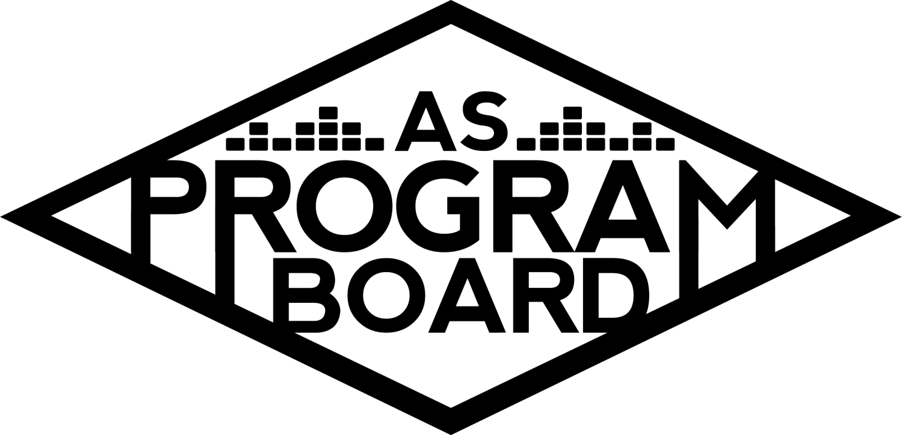
Program Board Agenda

Associated Students
November 25, 2019
SB Harbor Room

CALL TO ORDER: 5:01PM by Kiyomi Morrison
A. MEETING BUSINESS
- Roll Call
Name | Note:  absent (excused/not excused)  arrived late (time)  departed early (time)  proxy (full name) | Name | Note:  absent (excused/not excused)  arrived late (time)  departed early (time)  proxy (full name)
Adam Salton |  | Kari Liu
Alexis Xa |  | Kathryn Quinones
Bethel Tammerat |  | Kiyomi Morrison
Brenna Collins |  | Lucas Jackson
Brett Friedman |  | Mikio Sacramento | Late 5:15PM
Carlos Aviles-Sullivan |  | Mitchell Lewis
Conner Jones |  | Nathaly Pacheco
Enaiya Judkins |  | Sarah Danielzadeh | Absent
Erica Ko | Absent | Benjamin Chocron
Esteban Alvarado
Gabriel Reyes | Early departure 7:30PM
Greer Jacobs | Late

Acceptance of excused absences, absences, early departure and proxies
Motion by Enaiya, second by Bethel. Consent with 15 present.

B. PUBLIC FORUM
- Propaganda Club - 1/31
  - Having a show at the hub, have had 2 successful shows in the Hub recently.
  - Bringing 1 EDM artist and 2 student DJs
  - Pre meeting- 8PM, doors at 8:10pm, Headliner at 10:40, concert ends at 11:50
    - Can move pre-event meeting time up
  - Planning on having 10 cso’s, 2 police officers, 2 millers, and ~15 student staff
    - Ticket office employees usually check tickets
  - $14 students, $19 general admission, $22 at door
  - Want ASPB help with barricades, event staff, and production-lighting and sound
    - Planning on opening beer garden- have event safety staff help out there
- Winter Wonder Drag Show - 1/23
  - In the hub, already booked the day
  - Need ASPB help with doors, sound, and lighting
    - Want 3-5 event safety staff
  - Doors ~7:45/8PM, end around 11/11:30
  - FREE
  - Open to the public
  - Generally about 8-10 members from group helping out
  - Expecting 300+ people this year- main event of the quarter in the hub

C. ACCEPTANCE of AGENDA/CHANGES to AGENDA
Motion by Nathaly, second by Conner. Consent with 17 present.

D.ACCEPTANCE of ACTION SUMMARY/MINUTES
Motion by Conner, second by Gabe. Consent with 17 present.

E. ANNOUNCEMENTS
- LAST MEETING!!!
- Office Hours for Thanksgiving week
  - Still have them this week- can make them up but let Kiyomi and receptionists know
- Submit req forms / wrap out your events from this quarter!
- Wrap up meeting on 12/2?
  - Short, ~1hr, food, but during dead week
    - ~12 people can make it
    - Make sure someone from each department can make it
- Winter break
  - Start planning for next quarter and keep an eye out for email votes
- BOARDIE OF THE QUARTER!!!
  - Submit your votes here
  - Secret prize GET EXCITED

F. WEEK IN REVIEW
- Free Tues Film: The Kitchen - 11/19
  - 7PM- 17 people 10PM- 18 people
  - Lowest attended movie- end of quarter and film wasn’t that popular
- Holiday Photos - 11/20 & 11/21
  - Day 1-
    - Dylan arrived smoothly and set up was quick, needed an extra table and tablecloth
    - Printed ~700 prints (think it’s around 300 people)
    - Waitwhile system didn’t really work
    - People said they liked the quality of photos more than last year
    - Lower attendance than usual
    - Too many board members worked the event, people sitting around
    - Had volunteers
  - Day 2
    - A lot busier than day 1
    - Needed members to be more proactive and help with crowd control
    - Think we should stick with Dylan- nice and easy to work with, efficient
    - Wasted money on the app- error on app’s part day 1, but we didn’t need it
      - Should look into refund for the first day, only used it for 2-3 hours total
    - Had over 1000 prints the second day
    - Need to commit to line or to wait app, it’s hard to use the app when there are already people/busy
- Storke Show - Honeysticks - 11/19
  - Show went well but booking was difficult with timing
  - No yerbas, call time 11:30
  - Sold (out) merch on their own after show
  - High turnout even though FB event went out the day before

G. PREVIEW OF THE WEEK
- Student Choice Holiday Film - ELF - 11/26
  - 6:30PM- Enaiya, Kari, Conner 9:30PM- Brenna, Ka, Kiyomi
  - Thanksgiving week- people are going home tomorrow during the day
  - Bought popcorn and hershey’s kisses and candy canes filled with candy to give away
  - Keep pubbing that we have snacks to give away
  - ~60 people answered poll to choose movie, ~20 said Elf
    - Ask for hand raise at movie to see how many people there answered poll
- Bagel Day Fall 19 - 12/9 & 12/10
  - Greer is running it this year, just sent out shifts- currently 2 per shift
  - Will be getting bagels from Costco

H. OLD BUSINESS
- Revised Holiday Photos Budget - 11/20 & 11/21
  - Budget
    - UCen fees and app
- Winter ECEN Show - 2/15
  - Budget
    - Depends on artist(s) selected- ticket prices may also depend on this
      - Ticket prices go on offer and can’t be changed once accepted
  - Artist Research
    - Artist A is planning a tour that could route well through here
    - Research guide has been sent out
  - Discussion
    - Since it isn’t something we normally do, we could try a different genre- point of new show could be to try something new
      - Artist B & Artist A
      - Artist C, Artist D, and Artist E
        - Artist A and Artist D as headliners
    - Artist F fits our demographic
    - Since we are trying to make it a safer option- Artist A would have entire team for production and pub
      - Still waiting to hear on openers, tour stops, and ticket prices
        - Could be best option because of his team
    - Artist G is highly requested and fits demographic and would be easy to get support for
      - They just released an album and isn’t on tour yet, and asking price is still low
        - But going up- this could be the right time to book them
      - Another school booked them for a free show and instagram had over 150 comments
      - Could be a DJ opener- easy to book
      - Production would be easier and cheaper than Artist F
      - Could be cool to have an Indie opener to cater to a wider audience
    - Artist I may not be relevant enough to sell out venue and they are traveling before and after show right away
    - Not convinced that any artists are big enough to go through with the risk of not selling out show
  - 3-Day weekend- would people actually go to this show?
    - A lot of people do go home this weekend
    - We didn’t sell out Mustard for $5
      - He isn’t an “artist” like Artist G and she is more of a character
    - In the winter as well- can’t have it in Storke Plaza
  - Ticket prices may be too high as well
  - Want to feel strong support from people to agree to this big of an undertaking- could be different and fun and new
    - But need to find someone worth doing this show for
  - Informal vote:
    - Artist- Artist G, Artist A, and Artist F
      - Artist G

- Winter Hub Shows
  - All are available unless indicated on sheet
  - Discussion
    - Artist J recently came out with an EP and she has a lot more views on youtube and spotify than other artists
    - Artist K- girl band with low asking price
    - Artist L and Artist M could be good options as well
      - Artist M just released a new EP
    - Artist N doesn’t have the highest numbers but they have worked with a lot of larger artists
      - Colorado- support for show with 550 capacity
        - But that’s support
      - Could pair well with Artist O
        - But they aren’t from the states- not their demographic
    - Artist P just released an album and is doing well
      - Played at the novo- 2300 capacity
      - But asking price ends at $25k- on the higher side
    - Artist P opened for The Drums and the show sold out and had large crowd at recent festival
    - R&B artists
    - Artist R is a strong performer
      - Just headlined show in LA
    - Artist S- lower asking price than usual
    - Hearing a lot of Artist J, Artist S, Artist P, and Artist P
      - May not have seem impact as Guapdad4000 so wary about budget
      - Only have budgets for Artist P and Artist J right now
        - Informal- Artist P, Artist J, or Both
          - Artist P- 0
          - Artist J- 9
          - Both- 9

I. NEW BUSINESS
- Artist T - 2/6-changed to 2/13
  - Speaker for Black History Month- organizer during the Civil Rights Movement, close with MLK, one of the original Freedom Riders and did all of this while he was in college
  - Show would be FREE
  - Think Corwin would be a cool setup
  - Could have professors give extra credit for attending
  - Could pub with topic, not just name
    - “Nonviolence in a time of civil protest”
- Drive-In - 2/23-
Coordinating the conference with other Program Boards. Date as Feb 23, but Corwin not available so looking at other dates or locations. If we can’t do it in Corwin the budget would probably go down. Will work on and re-present the budget. Will probably be discussed on email over the break.
- Battle of the Bands - 2/27-
Hoping to get feedback on what would make a better show--5 student performers or a talent fee for a professional performer. Hoping to start pubbing to get student performers. Discussion regarding professional band vs local only show. Informal vote--no outside band.
- Publicity Tabling Budget-want to get acrylic stands for tabling.
- ASPB Reunion - 3/7--Looking into a reunion day for former ASPB members.

J. ACTION ITEMS

K. FINANCIAL ACTION ITEMS
- Revised Holiday Photos Budget - - 11/20 & 11/21
MSC $220 Kari/Bethel consent with 17 present
- Winter ECEN Show - 2/15
MSC $122,770 for ECen show with Artist J offer starting at $30K-$45K with student tickets at $18.50, GA $25.50; student door $22.50 GA door $30 Nathaly/Conner 12-3-2 Motion passes
- Winter Hub Show-
MSC $17,392 for Artist J in the Hub on January 28 with offer starting at $5K and end at $8K ; student tickets $14, GA
$18/Door $22. Brett/Kat Consent with 16 present.
MS for $15,392 for Artist Q in the Hub on January 15 with offer starting at 4k ending at $7K. student tickets at $14, GA
$20, Door $22. Brett/Esteban Motion carries with 12-3-1
- Artist T - 2/6 Motion to pass $7932 for Artist T on February 13 with offer starting at $4.5 and ending at $6.5k. Gabe/Lucas consent with 16 present.
- Drive-in - 2/23--Motion to table the drive in Bethel/Brett consent with 16 present.
- Battle of the Bands - 2/27--Motion to pass $7647 for Battle of the band on February 27. Brenna/Brett Motion carries with 15 present.
- Publicity Tabling Budget-Motion to pass $45 for 2 display stands Enaija/Conner Consent with 15 present.
- ASPB Reunion - 3/7 Motion to pass $800 for ASPB reunion on March 7. Bethel/Brett--Motion 11-0-4 Motion passes
- Propaganda Club-Motion to pass $768 for Event Safety and $900 for APSB production ($1668) January 31. Bethel/Carlos Consent with 15 present.
- Winter Wonder Drag Show-Motion to table Bethel/Kat Consent with 15 present.

L. REPORT
Facebook Factory / Tuesday Slide / Thursday Ad
- Free & For Sale post

Kudos

The Marilyn Report-Harder, Invoices, Celeb Access, Happy Thanksgiving

The Kris Report

Commissioner's Report
Excited for next quarter hope to make things easier next time.
Deputy Commissioner’s Report
Looking for another date/place for drive in.
Coordinators’ Reports
Adam - Hope everyone gets home safe.
Brett - Cool quarter. Planning for Winter. Love stuffing.
Carlos - Been great quarter, hope the 101 doesn’t close and excited for Thanksgiving dessert
Conner - If you have any volunteer sign up sheets please give them to me. Happy THanksgiving.
Erica -
Esteban - Sent rough line up for winter films to dana. Hope to collaborate with BSU on black history film. Have fun however you celebrate this week.
Gabriel -
Greer - Just excited for beautiful bagel day.
Kari - Thanks to everyone who helped with holiday photos.
Mitchell -
Nathaly -

Assistants’ Reports
Alexis - It’s been a really good quarter. Thanks for going through it with me.
Brenna - Been a really fun quarter and a lot of fun things happening next quarter--hope everyone has a good break.
Enaiya - Been.a great quarter, thanks everyone.
Kathryn - Had a lot of fun.
Lucas - Fu quarter, get home safe!
Mikio - Been a good quarter.

Senator’s Reports
Benjy - Been a cool quarter. Both appreciative of what you all do and been good to see how you work. Thank you for that. Hope everyone gets home safely.
Sarah -

ADJOURNMENT: 7:47PM

Artists mentioned: Dr. Lafayette, Benee, Young Nudy, UMI, Swae Lee, Goldlink, Denzel curry, Dominic Fike, Still Woozy, Kari Faux, Sad girl, Choker, Gus Dapperton, Girl in Red, Channel Tres, Goth babe, Doja Cat, Omar Apollo, Alison Wonderland

