Program Board Minutes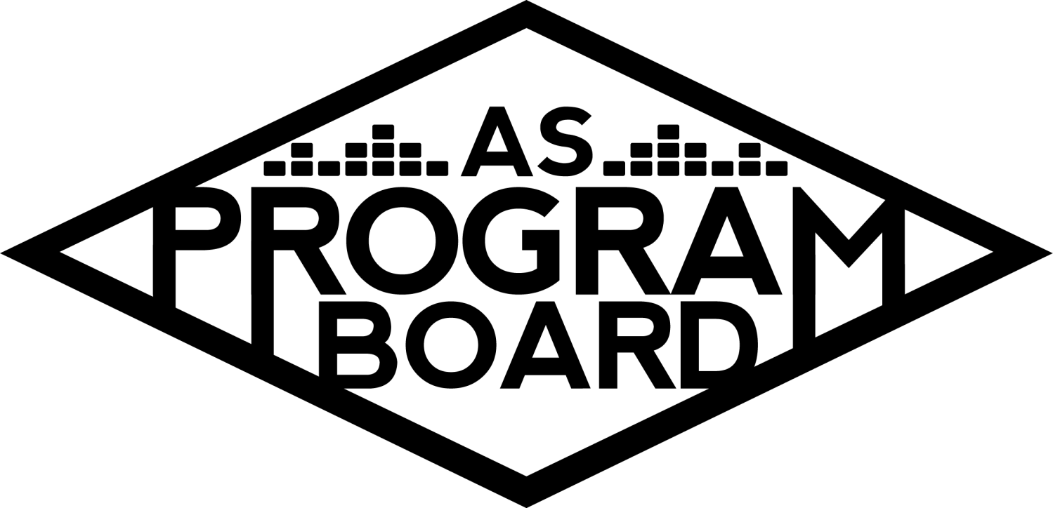

## Associated Students

January 31st, 2022

Henley Board Room

**CALL TO ORDER: 5:01 pm**

**A. MEETING BUSINESS**

1. **Roll Call**

| **Name** | **Note:**  absent (excused/not excused)  arrived late (time)  departed early (time)  proxy (full name) | **Name** | **Note:**  absent (excused/not excused)  arrived late (time)  departed early (time)  proxy (full name) |
| --- | --- | --- | --- |
|  |  |  |  |
| Ashley Yeh |  | Kim Kryshak |  |
| Clarissa Mendoza |  | Lauren Schaeffer |  |
| Emily Duong |  | Lucas Jackson |  |
| Emily Kocis |  | Nyah Scott |  |
| Enaiya Judkins |  | Sophie Kimura |  |
| Flora Mehdi |  | Talia Heimanson |  |
| Kathryn Quinones |  | Wally Corngold |  |
| Kathryn Supple |  | Jessy Gonzalez |  |
|  |  | Kian Mirshokri |  |
|  |  |  |  |

**Acceptance of excused absences, absences, early departure and proxies**

Motion to accept. Motion by , second by. Consent with present.

**B. PUBLIC FORUM**

1. Laughology Co-Sponsorship Request
   1. Asking for help with funding for booking Embarcadero Hall to hold shows
   2. Not one show but multiple shows (6, starting Feb 26th). Asking for funding for the first three shows, solely for the venue.
   3. Typically ask other orgs for funding, CAB and TQComm have responded about potentially helping with some money, waiting to hear back from some other orgs.
   4. Embarcadero for each show is $220 and they’re asking for $660 from us. Grand total for all shows is $6920 and they’re asking different orgs to cover different areas of the cost.
   5. Typically get around 60 people per show.

**C. ACCEPTANCE of AGENDA/CHANGES to AGENDA**

Motion to accept the agenda. Motion by Emily D, second by Ashley. Consent with 16 present.

**D.ACCEPTANCE of ACTION SUMMARY/MINUTES**

Motion to accept the minutes from 1/24/2022. Motion by Nyah, Second by Emily K. Consent with 16 present.

**E. ANNOUNCEMENTS**

1. [Land Acknowledgement](https://drive.google.com/file/d/1E-PZKDH6p3gF2cET7L_W0gbz40eGv5ca/view?usp=sharing)
   1. Next week: Ashley
2. Check In: what lyric has been living in your mind rent free lately? And how was your first day back :p
3. Mid-Qtr Check Ins

**F. WEEK IN REVIEW**

1. Free Tuesday Film: James Bond 1/25
   1. LJ- 37 people registered, no hiccups with anything

**G. PREVIEW OF THE WEEK**

1. Free Tuesday Film: Jackass Pre-Screening 2/1
   1. LJ- Nyah and Wally signed up to work, 7:30pm call time for one showing at 8pm. Tickets should be through the ticket office but need to check in with them about that. Haven’t received anything from them but we should have last week.

**H. OLD BUSINESS**

1. Ambassadors
   1. [Sheet](https://docs.google.com/document/d/1wqOyThYKoPY5fl7u9W5huSNoaOhQnMb9m73wGsUiz7c/edit?usp=sharing)
   2. ED- meeting this Sunday, Kim and Lauren are presenting
2. Playlists
   1. [Winter 2022 Spotify Playlists](https://docs.google.com/spreadsheets/d/1aaky9-GujkfJnLcoNxVHC8lkBQJK9L1lEVGXMKzpEQA/edit?usp=sharing)
   2. ED- probably going to do festival headliners this week
3. Blogs/Podcasts
   1. [Sheet](https://docs.google.com/spreadsheets/d/1pORJ7H5y2VtgIeEWw6VIwcRlmNgkpqPCI1a2hORPvCk/edit?usp=sharing)
   2. ED- did review of January albums for the blog
4. [Social Media Takeovers](https://docs.google.com/document/d/1xEyVTBqiSj7-m8LbpDWw2iUnDrK7-2gMc1iR_PlmTtw/edit?usp=sharing)
   1. NS- Kim is doing this Wednesday
5. Collab Event w RCSGD 2/10
   1. EK- Insurance being filled out now, talked to RCSGD’s coordinator earlier and we’re coming up with questions, want them done by Friday.
   2. RCSGD wants to do registration on Shoreline for this event
   3. Got permission to sell this book at the event. They might have someone on their team sell their merch at the event.
   4. Gonna rent IV Theater 2 to use as a hosp room.
   5. 45-60 minute comedy set + Q&A after that? Thoughts? RCSGD is fine with either.
   6. KK- the video Emily sent was really entertaining. Since we’re also doing a Q&A I think things that would have been brought up in the keynote will probably also be addressed in the q&a
   7. NS- Comedy would maybe resonate more with a younger audience + it’d be something kinda different from Alok
   8. EK- pro comedy for reasons nyah and kim brought up, could be pubbed to a wider audience as a comedy show, would be engaging. As long as we have the Q&A I don’t see why not
   9. AY- agreed, people will also probably be more likely to come out for standup comedy
   10. Graphic will be sent out for approval soon, hopefully we can announce tomorrow or Wednesday. RCSGD will share our posts and said they could help with tabling.
   11. [Tabling Schedule](https://docs.google.com/document/d/1vd1qXDxelMBZFKCFchXte0kaU_pgpqe4jNsYnIYV6cY/edit?usp=sharing)
   12. EK- RCSGD has a moderator and is helping with questions, but still let me know if you can help with questions
6. Battle of the Bands 2/24
   1. WC- Listening party this Friday at 4pm at Enaiya’s
   2. Raul from LivenotesSB will judge, Zach Gill might be able to judge, someone at Nexus might be able to judge as well.
   3. Raul offered to stream BOTB on the Livenotes website and will help with someone else.
   4. Storke Plaza being discussed as a backup venue. Hub was confirmed for the 24th, but need to confirm covid details.
   5. KE- Jill mentioned last week that we should be good to go in the Hub
7. Battle of the DJs (3/3)
   1. LS- still no submissions so keep pushing. Talked to DJ as guest judge and asked her about performing.
   2. KQ- put together a doc with potential guest performers so we can vote on it. Send any potential performers to Lauren please and pub push for submissions.
8. Free Tuesday Films
   1. Sign up to work 2 films!
   2. 2/1- Jackass Forever, 2/8- Eternals, 2/15- Encanto, 2/22- Venom 2, 3/1- House of Gucci
9. Spring Cultural Event
   1. EK- would be a big event in the ECEN and open to the public so we still don’t know if it’s possible.
   2. Would probably be April 27th or 28th
   3. Could send a low offer and guarantee a portion of the ticket sales
10. Meet the Board 2/16
    1. ED- gonna be working on it with Enaiya this week, figuring out what Rockfire might be able to do for us
    2. Could do a pop culture trivia (Kahoot maybe).
    3. Have some retro swag that could be given out.
11. Winter Hub Show 2/17
    1. TH- think the Hub would probably be easier on all of us, but there’s a time crunch if we do it there.
    2. Would need to reserve Hosp rooms that aren’t the normal ones because of the conference.
    3. Artist A only available March 4th
    4. TH- have gotten a bunch of requests for Artist B, looks like they have an audience in this area and we’ve gotten a lot of requests for them. Their asking is high though and we don’t really have time to negotiate a price. But we only had one Hub show last quarter
    5. FM- in support of B, definitely have a big audience here
    6. NS- if we did try to rush for 2/17 it feels like B would be a bit messy especially for them being the highest asking. Also really like A, very on the rise and would be good for an outdoor show.
    7. CM- really strongly for B, people talk about them so much and I’m sure they’d be able to bring in a big crowd and I feel like they could draw people in even with reduced pub
    8. LS- B has really big name pull, C is second choice because I know they’re good live.
    9. KS- Also like B for the Hub for Feb 17th, very big name pull, would be cute for Valentine’s Day. Also want to bring up D, and think he would do really well. Just released an album and is going on tour soon. If we were to do a big Storke/Commencement Lawn show C would be perfect.
    10. KK- B would be better show inside but I don’t think that would sway anyone from going. Also think D would be great outdoors. 2nd choice is D, he’s gone on tour with larger artists and has a unique sound
    11. EJ- Would rather do B outside on the 4th just to give more time to negotiate, and pub, and people would still come
    12. TH- Day after BOTDJs, don’t want production to be overworked, would be a gorgeous vibe inside.
    13. Could try to do B in the Hub Spring quarter
12. The Warm Up 4/2
    1. KK- Offer’s drafted and should be going out this week. Would like to discuss openers on Slack this week.
    2. Merch-wise, people are into brown aesthetic and brown bases for tote bags and shirts.
    3. KS- 2020 totes were like natural/beige/cream which would be a nice match
    4. EJ- really like beige-y, something about dark brown is scaring me and thinking it’s gonna be ugly.
    5. KK- if we were to do hats we were thinking about doing a ASPB logo that’s TWU tailored versus doing a full blown Warm Up logo on the hats
    6. EK- not sure if anyone who isn’t on board would want an ASPB hat, so would be more interested in doing some type of design
    7. ED- think a fire-y kind of design would look cool. Think about the PopPay hat. Would be in favor of a trucker hat
    8. SK- for the hat, the logo would be spicy (like on fire or something)
    9. NS- we have old TWU hats from last year, I think the ASPB logo would have more longevity whereas the phoenix logo changes every year
    10. KQ- think TWU hats are primetime for Spring, don’t think we should wait till May for X. In favor of the logo especially if it’s yassified
13. Extravaganza
    1. KK- if you have ideas about theme and release or whatnot let me know.
    2. KE- Shade structures? Something to think about.
    3. ED- really like idea of SZA’s Good Days mushroom set
14. KCSB Collab Proposal
    1. EJ - Ryan hasn’t been able to get in touch with the agent… more info next week.
    2. 7-8k for speaking engagement. Inquired about performance plus speaking thing, but we don’t have an asking for it.
    3. EK - Book is hot rn. Still worth doing a speaking event even if we don’t get performance negotiated.
    4. EJ - No date yet. No idea if it’s a book tour or nah.
15. BHM Event Ideas
16. NS- SCORE said they’ll forward us events. Will reach out to BSU officers via email to make sure they have us for promo and boosting.
17. EJ - BWHC meeting to sit in tomorrow?
18. Valentine’s Day Event
    1. EJ - Confirmed Storke Plaza 11:30am - 4:30pm. Photo booth is gonna happen…maybe…most likely.
    2. KQ - Half board event.
    3. ED - Puppies?
    4. NS- could do roses and To/From ASPB tags

**I. NEW BUSINESS**

1. Future Meetings
   1. Mosher will be $45/meeting in the future. Would you rather do Zoom meetings or do this?
   2. People in favor of meeting in person.
2. Laughology Co-Sponsorship Request
   1. [Their budget](https://docs.google.com/document/d/1KfZj3DIvP1L7I8zQBfaLCZuuEh1TR_vjCbEi9W8hrUE/edit?usp=sharing)
   2. Said they’d put our logo on their promotional materials

**J. ACTION ITEMS**

**K. FINANCIAL ACTION ITEMS**

1. Motion to pass $28,580 for Hub Show on 2/17/22. Motion by Wally, second by Ashley. Consent with 16 present.
2. Motion to pass Artist B for Hub Show headliner on 2/17 starting at 13k and ending at 20k. Motion by Nyah, second by Kat S. Consent with 16 present.

**L. REPORT**

**Facebook Factory / Tuesday Slide / Thursday Ad/ Free & For Sale post**

Jackass, botdjs, blog post, collab event soon

**Kudos**

Kim emily d emily k and sophie for postering the other day

Clarissa for the staple gun

Nyah for the staple gun

Lucas for dropping off duffl last night

Interviews kat q and enaiya

Enaiya for resume talk

**The Marilyn Report**

Try to get OH up for Kris and I soon

**The Kris Report**

Production and event safety interviews this week

**Commissioner's Report**

Budget presentation next friday the 11th so thats something, will be filling out budget q’s, mid qtr meetings pls sign up!

**Deputy Commissioner’s Report**

Working on valentine’s event and meet the board. Will be in office this week very excited. Working on merch and stuff, pls remind me if we’re supposed to be working on sum.

**Coordinators’ Reports**

**Ashley-** excited to see y’all in OH, ticket stuff being ironed out

**Emily D-** working on meet the board, ambassadors!

**Emily K-** will be in office ™, if you wanna help me w questions LMK! Remind me if we have stuff to work on!

**Kathryn S-** will be updating OH for the week

**Kim-** lots of ppl to contact about diff things, excited about my ambassador presentation, full circle moment

**Lucas-** working on pre-screening tmo, 7:30pm call time is only for jackass

**Nyah-** excited for in person, send a slack about announcements, will investigate roses, reach out BSU via email

**Sophie-** gonna do OH from zoom tuesday and wednesday, drawing pad broken </3 can still do work just nothing too quirky

**Talia-** ty for discussion about the Hub, be in the office for OH on T come talk

**Assistants’ Reports**

**Clarissa-** going home tmo so my OH are virtual Thursday and Friday

**Flora-** shy girl

**Lauren-** send me DJs please, have really exciting events coming up!

**Wally-** excited for listening party woooooot, excited for planning

**Senator’s Reports**

**Jessy-** calls to go back online, trying to work it out, budget due by tomorrow the first

**Kian-** what jessy said

**ADJOURNMENT at 7:20 PM by Kathryn Quinones**

**Artists mentioned: Dijon, TV Girl, Greer, Hope Tala**