Program Board Minutes 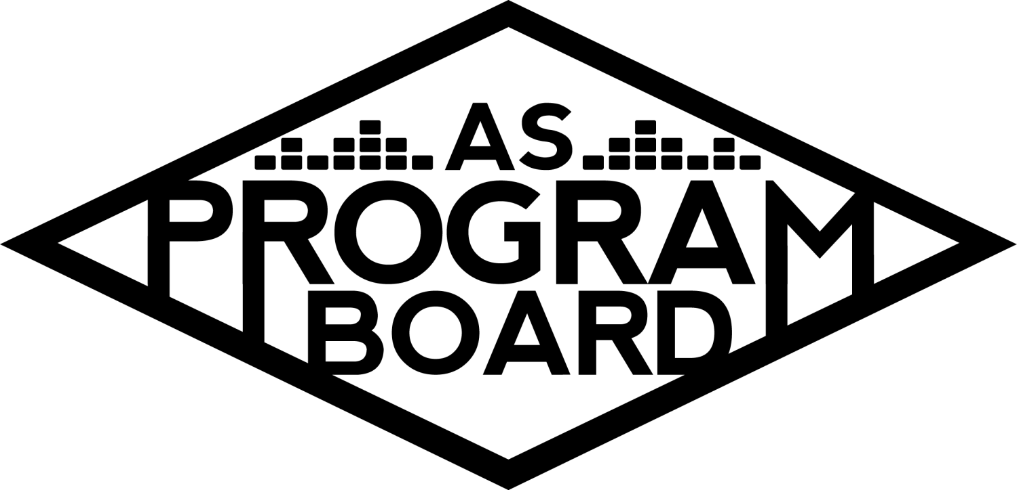

## Associated Students

January 24th, 2022

Zoom

**CALL TO ORDER: 5:02 pm**

**A. MEETING BUSINESS**

1. **Roll Call**

| **Name** | **Note:**  absent (excused/not excused)  arrived late (time)  departed early (time)  proxy (full name) | **Name** | **Note:**  absent (excused/not excused)  arrived late (time)  departed early (time)  proxy (full name) |
| --- | --- | --- | --- |
|  |  |  |  |
| Ashley Yeh | Late Arrival 6:30 | Kim Kryshak |  |
| Clarissa Mendoza |  | Lauren Schaeffer |  |
| Emily Duong |  | Lucas Jackson |  |
| Emily Kocis |  | Nyah Scott |  |
| Enaiya Judkins |  | Sophie Kimura |  |
| Flora Mehdi |  | Talia Heimanson |  |
| Kathryn Quinones |  | Wally Corngold |  |
| Kathryn Supple |  | Jessy Gonzalez |  |
|  |  | Kian Mirshokri |  |
|  |  |  |  |

**Acceptance of excused absences, absences, early departure and proxies**

Motion to accept the late arrival of Ashley. Motion by Emily D, second by Talia. Consent with 13 present.

**B. PUBLIC FORUM**

**C. ACCEPTANCE of AGENDA/CHANGES to AGENDA**

Motion to accept the agenda. Motion by Nyah, second by Wally. Consent with 13 present.

**D.ACCEPTANCE of ACTION SUMMARY/MINUTES**

Motion to accept the minutes from 1/18/2022. Motion by Nyah, Second by Sophie. Consent with 13 present.

**E. ANNOUNCEMENTS**

1. [Land Acknowledgement](https://drive.google.com/file/d/1E-PZKDH6p3gF2cET7L_W0gbz40eGv5ca/view?usp=sharing)
   1. Next week: Kim
2. Check In: If you could stay one age forever which would you choose and why? Would you accept?
3. Return to In-Person: Mtg Poll
4. Boardie of the Qtr Reveal

**F. WEEK IN REVIEW**

1. Free Tuesday Film: Shang Chi 1/18
   1. LJ- 52 people registered, apparently there was an issue with the links but I was unaware until 8pm Tuesday. After addressing the issue I didn’t get anymore emails about issues
2. PTR Hub Show 1/21
   1. TH- 130 approved registrations, 89 people came with a max of 66 at one time, ~10 people left before Q&A, audio and visual lagged during performance but it was clearer during the Q&A
   2. WC- Q&A was fun, they had great energy, I hope they come back
   3. EJ- no preshow graphics which would be nice!
   4. MD- maybe should have done another runthrough after they logged back on right before the show after the soundcheck because it seems like that’s when the problems started. Seems like they changed some things in between the soundcheck and the show
   5. KE- wonder if they’d be able to run an ethernet cable
   6. SK- as an audience member I had a lot of fun, the distribution of the performance and q&a was perfect
3. [Social Media Takeovers](https://docs.google.com/document/d/1xEyVTBqiSj7-m8LbpDWw2iUnDrK7-2gMc1iR_PlmTtw/edit?usp=sharing)
   1. NS- Talia did an incredible takeover last week
   2. TH- hard for me to stay serious during introduction so i showed off my personality instead

**G. PREVIEW OF THE WEEK**

1. Free Tuesday Film: James Bond: No Time to Die 1/25
   1. LJ- got link late so post went up around 2pm, still was able to include it in newsletter, so far 15 people are registered

**H. OLD BUSINESS**

1. Ambassadors
   1. [Sheet](https://docs.google.com/document/d/1wqOyThYKoPY5fl7u9W5huSNoaOhQnMb9m73wGsUiz7c/edit?usp=sharing)
   2. ED- at meeting yesterday we talked about kickstarting our TikTok, if you have TikTok ideas feel free to make them and send them my, Nyah, or Kat S’ way
2. Playlists
   1. [Sheet](https://docs.google.com/spreadsheets/d/1cgF6vRQVy5ORtM2OjxrTnFu4ORviUm1lPvHab-AZ1Ro/edit?usp=sharing)
   2. ED- maybe doing something around WWWY Fest or Coachella headliners
3. Blogs/Podcasts
   1. [Sheet](https://docs.google.com/spreadsheets/d/1pORJ7H5y2VtgIeEWw6VIwcRlmNgkpqPCI1a2hORPvCk/edit?usp=sharing)
   2. KS- interviewing Gabe and maybe Nathaly about being an alum working in entertainment
   3. If you have ideas feel free to hop on and try something out
4. Collab Event w RCSGD 2/10
   1. EK- Artist A confirmed! Will be in IV Theater at 7pm with a 35 minute keynote and 25 minute Q&A.
   2. Sent EPK to Sophie and part of bio to Nyah.
   3. NS- even if we don’t have a graphic we can still announce with a photo
   4. EK- i know we have to put the other orgs’ logos on our graphic when we announce
   5. MD- we’ll probably have to limit capacity and require registration which can be set up through AS Ticket Office
   6. EK- someone from RCSGD will be moderating and I can see if any of them are available to work it. Would prefer to have all 8 people working
   7. Nyah will do hosp, Kat S is runner, working: Enaiya, Flora, Lucas, Kim, Talia
   8. NS- probably will have flyers and posters available next week. Probably don’t need to table until the week of the event and will send out a schedule
   9. EK- Artist A’s team approached about selling merch at the event. They want their book to be available at the merch table but their team kind of anticipated this would be a problem?
   10. They’re also interested in doing an interview with the Nexus ahead of the event, also thinking about doing a blog post with them on our website.
5. Battle of the Bands 2/24
   1. WC- we had 10 submissions, contacting Zack Gill and (probably) Raul about judging, planning listening party
   2. Let Wally know if you can’t attend so accommodations can be made!
6. Battle of the DJs (3/3)
   1. LS- everything is up, thanks for putting that together! Working on securing final judge who will also be doing a set
   2. CM- lots of engagement on the IG post, flyers and posters have come out so lmk if anyone is free to poster this Thursday/Friday afternoon
7. Free Tuesday Films
   1. LJ- tentative Jackass 4 pre-screening next week in person, not sure if we can have more than 25 people inside still (probably not). WILL check in about this and let everyone know.
8. Spring Cultural Event
   1. EK- with return to in person it may be a little more of a possibility, keep it in ur thoughts
9. Meet the Board 2/16
   1. ED- nothing super new in terms of updates, this week we can probably reach out to businesses since we’re moving back to in person
   2. Wednesday Week 7
10. Winter Hub Show 2/17
    1. TH- thinking about a big Storke show instead of a Hub show. Artist B will be in NC on the 16th
    2. KK- I agree that having indoor Hub show probably won’t work out, kind of concerned about all of our shows being in the same venue, could be good for consistency but also might be repetitive
    3. SK- was gonna suggest People’s Park or Anisq’oyo, kinda gives me Hub vibes
    4. MD- convocation green is a possible option, People’s or Perfect we’d need to bring generators in. Pardall Center has been used as a Hosp room
    5. TH- would you guys be ok with pushing the date back a bit to have it outdoors
    6. EK- we have a pretty packed calendar
    7. TH- I like the idea of the commencement lawn and i think getting the approval might be easier
    8. TH- still want to bring a Hub show kind of artist
    9. More laidback, band type artist might be better
    10. KQ- Artist C sold out a show in SLO
    11. EJ- I think middle of the day middle of the week would really limit the amount of people who could come enjoy the show especially because I think more people would want to see a bigger artist
    12. TH- i think a Thursday/ Friday afternoon moment could work pretty well. Probably 2/25
11. The Warm Up 4/2
    1. KK- Artist D had the most votes on the form, any thoughts?
    2. EK- not totally sold on D, worry I’ve only heard of them bc of ASPB, Artist E for ex, seems more niche than people we’ve had before, also worried about it going online
    3. SK- confident on D, but E would be my 2nd, I think both are good options but E have a bigger name
    4. KS- D is my top choice, F #2, feel like EDM is more of a night choice but i think artist D makes more fun mixes and feel like people listening to D are the types to go to Deltopia. Feel like F has daytime-y music, has album coming out Feb 18th, unsure how popular they are w/ UCSB crowd. Not sure about their following here. Playing the shrine, sold out shows are 1-2k
    5. ED: D as top choice. Headlined EDC. if trying to cater to ppl -> most will be hearing EDM anyway. Not other names
    6. NS: Tomorrowland headliner which is a huge festival, if we can decorate and make storke plaza look less like storke plaza I think that would make it more appealing
    7. EJ: If D mixes popular songs thats good, but worried about name pull and just bringing people out. Like F as a second option, would translate well to online, ppl that are listening to edm-type things would like F.
    8. SK- i think night would be best for EDM, having really awesome lights would be a pull from DP, would be comfortable with F as 2nd choice
    9. KS- D is more stagnant in growth, F has the potential to grow a lot bigger especially this year
    10. KM- D is my top choice, think lighting lacking during the day sucks but if we curate the correct vibe it’ll be kind of like a dayge, think F is a great 2nd option but really like D
    11. LS- during the day i think F would be really cool, having something different from DP would make us stand out, if we can do D at night that would help but I still think F during the day would be better
    12. KK- nothing is set in stone, during the day is not 100%
    13. CM-D>F, D might do a better job of attracting students from Deltopia, could be creative during the day (maybe a color fest)
    14. WC- F’s numbers are intriguing but I’d go against thinking that just because D plays EDM means they don’t stand out.
    15. EK- I think if I didn’t know who D was and didn’t know who F was I’d be more interested in F because i’d want to see a performance and not necessarily an EDM artist I’m not familiar with at all
    16. EJ- I think DP effects will be more realized if we do have it during the day
    17. KM- In broader scope of EDM you’ll probably be more attracted by D, I think F would be insane any time of the day, think people don’t want to come to a concert in the middle of the day, if people party during the day and crowds get rowdier, a sunset performance might be nice. I think D would be great during sunset-y time.
    18. TH- EDM fans want to see an extravagant performance that we might not be able to allow D to deliver production wise
    19. SK- might be biased but I think people who like EDM definitely know who D is
    20. KK- merch, ppl like t-shirts and totes (maybe bigger than in the past), gonna reach out to graphics for more conversation abt it but send me cool ideas if you have any
12. Extravaganza
13. KCSB Collab Proposal
    1. EJ: reached out to Ryan, they were planning on reaching out to agents, did so today, agent said maybe around coachella time & asked about budget, pretty unsure
14. BHM Event Ideas
    1. BWHC: want support on events they're already throwing, just helping with publicity. Will get back on blogs etc
    2. BSU & SCORE: letting them know we can help boost events, updates to come

**I. NEW BUSINESS**

1. Valentine’s Event
   1. EJ: OH group talked about Holiday photos, suggesting Valentine’s day card making, reached out to last holiday photos group but haven’t heard back. Even without photos, cards may be cute. Location: submitted req for storke plaza

**J. ACTION ITEMS**

**K. FINANCIAL ACTION ITEMS**

1. Motion to pass Artist F for headliner for The Warm Up on 4/2/2022 starting at 60k and ending at 75k. Motion by Kim, Second by Talia. Consent with 15 present.
2. Motion to pass Artist D as headliner contingency for The Warm Up on 4/2/2022 starting at 60k and ending at 75k, Motion by Kim, second by Kat S. Consent with 15 present.

**L. REPORT**

**Facebook Factory / Tuesday Slide / Thursday Ad/ Free & For Sale post**

James Bond, BOTDJs

**Kudos**

Talia and wally for PTR!!!

Emily D and Kat s for filling out housing survey

Kat s for being prepared for discussion!

Nyah for being boardie of the qtr!

Emily D and Kat q for receiving noms for botq

Graphics for being amazing

Kudos to everyone for having sweet stuff to say about each other

Sophie for inviting Kim to play spike ball with her when I saw her on the beach

**The Marilyn Report**

Kris and I are not in person in the office this week but will resume in person schedules next week. Will post when in-person schedules are finalized.

**The Kris Report**

In contact with production vendors for BOTB, will be reaching out to Kat and Enaiya for interview times for event safety

**Commissioner's Report**

2 midterms this week and another next week, will be meeting with MD to talk about next year’s budget, excited to go back to office and start printing out photos of us

**Deputy Commissioner’s Report**

Excited to continue working on v day, meet the board, reach out to kcsb, photographer, twu merch!, fill out housing form

**Coordinators’ Reports**

**Ashley-** school’s rough, excited for in person and to see y’all, excited for TWU, lmk if you need anything

**Emily D-** schools rough, back in iv, little nervous but hope you're all healthy! Working on ambassadors, podcasts, meet the board

**Emily K-** excited to move forward with Artist A event, also taking midterms

**Kathryn S-** midterm due tomorrow, working on paper 3/11, working on alumni entertainment podcast

**Kim-** will be busy with TWU stuff, DOMINIC FIKE LIKED MY TWEET, be safe stay healthy

**Lucas-** working on films and stuff, back in iv, continuing working on the usual

**Nyah-** excited to see what in person classes will look like, lots of pub, will probs be sending lots of Slack messages

**Sophie-** postering: let flora take one or both

**Talia-** thanks again for supporting the PTR show, thanks for discussion on winter hub show, will be reaching out to artists

**Assistants’ Reports**

**Clarissa-** excited for upcoming events, will be working on midterms this weekend and pubbing for botdj

**Flora-** have a good week <3

**Lauren-** midterms szn, negative covid test yay, working on botdj stuff, starting plan for storke shows since we’ll be back in person

**Wally-** super happy to have finally done ptr, keep your eyes out for a survey regarding listening party, will have judging updates next week

**Senator’s Reports**

**Jessy-**

**Kian-** senate stuff, good luck on midterms

**ADJOURNMENT at 7:34 PM by Kathryn Quinones**

**Artists mentioned: TV Girl, Polo and Pan, Alok Vaid-Menon, Alison Wonderland, Yung Gravy, Oliver Tree**