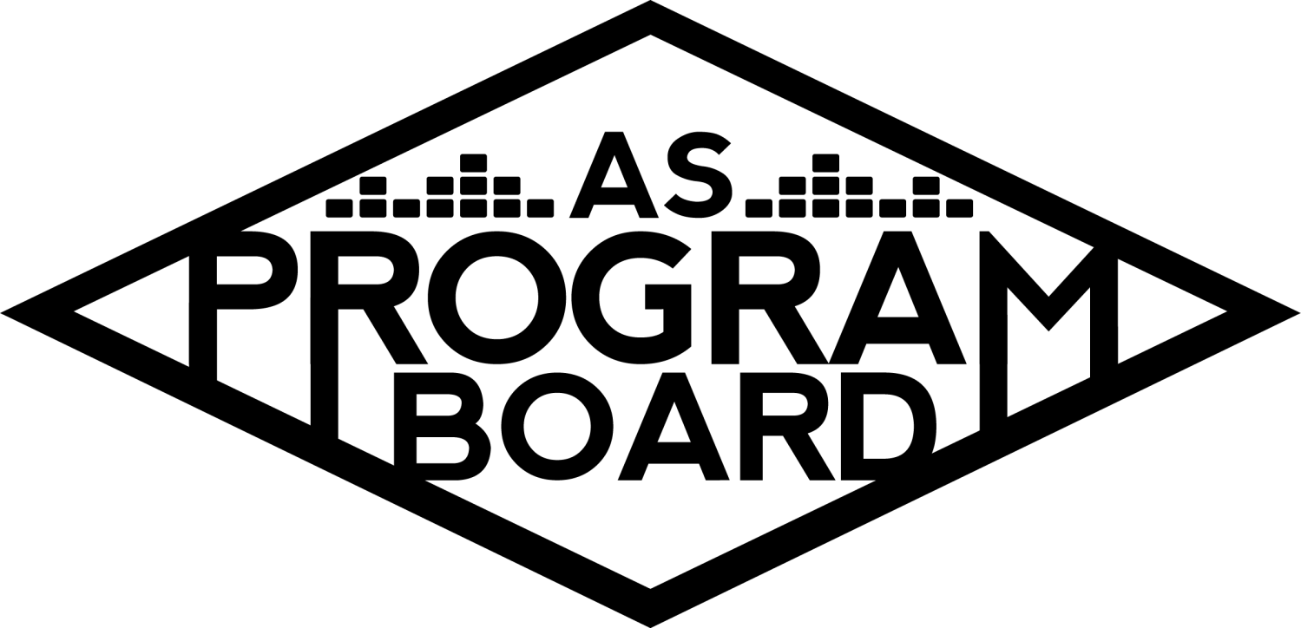

Program Board Agenda

## Associated Students

January 13, 2020

SB Harbor Room

**CALL TO ORDER: 5:00PM by Kiyomi Morrison**

**A. MEETING BUSINESS**

1. **Roll Call**

|  |  |  |  |
| --- | --- | --- | --- |
| **Name** | **Note:**  absent (excused/not excused)  arrived late (time)  departed early (time)  proxy (full name) | **Name** | **Note:**  absent (excused/not excused)  arrived late (time)  departed early (time)  proxy (full name) |
| Adam Salton |  | Kari Liu |  |
| Alexis Xa |  | Kathryn Quinones | Late Arrival |
| Bethel Tammerat |  | Kiyomi Morrison |  |
| Brenna Collins |  | Lucas Jackson | Late Arrival  Early Departure 6:45PM |
| Brett Friedman |  | Mikio Sacramento |  |
| Carlos Aviles-Sullivan |  | Mitchell Lewis |  |
| Conner Jones |  | Nathaly Pacheco |  |
| Enaiya Judkins |  | Sarah Danielzadeh | Late Arrival 6:15PM |
| Erica Ko |  | Benjamin Chocron | Late Arrival 6:50PM |
| Esteban Alvarado |  |  |  |
| Gabriel Reyes |  |  |  |
| Greer Jacobs | Absent |  |  |

**Acceptance of excused absences, absences, early departure and proxies**

Motion: Gabe Second: Brett. Consent with 15 present.

**B. PUBLIC FORUM**

**C. ACCEPTANCE of AGENDA/CHANGES to AGENDA**

Motion by Bethel, second by Enaiya. Consent with 17 present.

**D.ACCEPTANCE of ACTION SUMMARY/MINUTES**

Nov. 25, 2019- Motion by Nathaly, second by Esteban. Consent with 17 present.

Jan. 6, 2020- Motion by Enaiya, second by Bethel. Consent with 17 present.

**E. ANNOUNCEMENTS**

1. Office Hours
   1. Submit them by the end of the day
2. Marilyn Announcement
   1. Taking on a new role in AS! There may be some changes and she will be in and out more often- make sure to only go to her with important questions- she will be busy!
3. Next week--MLK holiday on Monday
   1. No meeting MLK Day

**F. WEEK IN REVIEW**

1. Free Tues Film: Hustlers - 1/7
   1. 7PM- 115 people
   2. 10PM- 155 people
   3. Low FB numbers but high attendance- good start for the first week
   4. Sound wasn’t working for first showing but it was fixed quickly

**G. PREVIEW OF THE WEEK**

1. Free Tues Film: Maleficent - 1/14
   1. Call times 6:30PM and 9:30PM- need one more person for 10PM showing- let Esteban know by tomorrow
   2. Please keep sharing on socials!
2. Sad Girl - 1/15
   1. Decided to postpone show until 5/21/2020
   2. Planning on brainstorming more ideas for how to get higher ticket sales- only about 41 tickets sold before it was postponed
      1. Need to figure out what didn’t work this time and fix it for next time
3. Noon Storke Show: The Mouth-Breathers - 1/17
   1. Made a sign up sheet and put it in the drive- for this and other shows
   2. Call time 11:15-1:05
   3. Slight issue with the graphic- should be finished soon
   4. Will have Yerbas
4. Free Tues. Film: Knives Out-1/21
   1. 6:30PM and 9:30PM call times
   2. FB page isn’t up yet but it will be up soon
   3. Movie got nominated for an Oscar today!

**H. OLD BUSINESS**

1. UMI - 1/28
   1. Announced today and tickets go on sale Friday
   2. Graphic should be confirmed soon
   3. Still working on confirming opener- haven’t gotten a rider but should have it by tomorrow
   4. Asking is still ~$500
   5. Looking into other openers and will have list compiled this week
   6. Pubbing falls on everyone on board and even though we think people may be excited, everyone still needs to pub hard- good first response though
      1. Will also use ambassadors to help table
   7. Same day as a movie- if you aren’t going or working show please sign up to work movie
      1. Have 2 people for each time for the movie
   8. Runner: Conner, Hosp: Gabe, Front: Mikio & Nat, Merch: Bethel; Kiyomi will probably work it too
2. Artist A - 2/13
   1. No longer available in Feb., looking at dates in March now
   2. Venue is already booked for 2/13- looking for another event to have that day
3. Battle of the Bands - 2/27
   1. Post went up but link was incorrect- working on fixing graphic and post
      1. Link in the bio is correct, just need to fix graphic
4. The Warm Up - 4/4
   1. New contingency-
      1. Artist B fell through
      2. Waiting on riders from other options- only Artist C is available now
      3. Artist D is blowing up now- may not accept below $80k
         1. Could consider adding more money to talent budget
      4. Artist E has been booking and selling out larger venues lately- given asking price we could pair him with someone else- Artist F or Artist G?
         1. Artist E asking is $15-30k which leaves a lot of money leftover for talent
      5. Worried about Artist D- may be too big of a shot then we waste some time with it
      6. Discussion:
         1. Artist D- competing for #1 spot on Billboard and worked with Mustard
         2. Artist A also played Red Rocks like Artist E- speaks about how big he is
         3. Why are we looking at EDM when hip hop artists have larger numbers
            1. Trying to cater to different genres- trying not to book the same genre for every big show
            2. Do people actually want EDM?

Surveys on social media are biased

Comm survey!!

* + - 1. TWU is meant to keep people safe, it may be good to book a “bigger” artist to get more people there even if it’s not EDM
         1. “Bigger” is subjective

Streams vs followers vs size of venues played

* + - * 1. There aren’t a lot of things going on after Deltopia- people may be planning on going regardless- attendance may not be affected by having a “bigger” artist
      1. Artist D may be a better option for X slot 2
         1. May not be worth the risk of skipping an offer for TWU if we can’t get an artist at all
      2. Possible contingency- Artist H? Or possible B2B- Artist H has higher asking price so they would have to be headliner
      3. Be cognizant of your own music taste when considering artists too
      4. Artist I and Artist E would be great together and Artist D only has a couple of very popular songs. Artist I has more popular songs
         1. & makes Nat tingly
      5. Artist M? Performed here in 2017 (and Artist H was here in 2014)
      6. Artist J God- very fun performances
      7. Artist E and Artist K?- sold out some venues and performed at Coachella and Bonaroo and she’s a woman!
      8. Artist L?- a lot of listeners and streams on spotify and playing Coachella
         1. Could also be part of a group of a few artists that perform
    1. Coachella radius clause??- we are closed shows but it depends
    2. Need to narrow down contingencies- informal vote- 2 votes per person
       1. Voting between: Artist L, Artist G, Artist I, Artist E for 1 contingency
          1. Artist L: 3
          2. Artist G:12
          3. Artist I: 9, 11
          4. Artist E: 9, 5

Artist I vs Artist G

Artist I: 7

**Artist G: 9**

Artist G is next contingency

* + - 1. Results: Artist D, Artist G, then Artist I- contingencies in order
    1. If you have suggestions send them to Nat

1. Extravaganza - 5/17
   1. Theme voting- Racing/MarioKart/X Games, Wild West, Vegas, Carnival, Future/Outer Space/Kaleidoscope
      1. If we lean too hard into a festival that already exists, people may think we are booking an artist that matches
         1. Ex: Gauchoworld for Travis Scott
      2. For racing theme- cute outfits and blow up obstacle course- x games and eXtravaganza puns??
         1. Certain activities may damage the grass- important to consider for themes
         2. Could also be easier for graphics and it seems like we have more concrete ideas for this theme
      3. Kaleidoscope could also be abstract art- could get student art and cut costs
         1. Could also use 1920’s and modern mixes, Gatsby vibes- only time we can do this
            1. Could also do something with 20/20 vision and give people diffraction glasses
            2. Could include future and past decades for more photo opportunities
   2. Vote- Carnival, X Games, Time Travel- 1 vote between
      1. Carnival- 2
      2. **X Games- 11**
      3. Time Travel- 4
2. Bonding?!
   1. What kind of bonding activity do you want to do? Bowling, lazer tag, hike, beach day, kayaking, bonfire, Kiyomi will investigate.

**I. NEW BUSINESS**

1. Event Safety Team Bonding-having a meeting with event staff and want to do a mixer with them.
2. Electrician - Capital Reserves $1,750

**J. ACTION ITEMS**

1. The Warm Up - 4/4--no action
2. Extravaganza - 5/17
   1. Theme voting X Games theme--17-0-0-

**K. FINANCIAL ACTION ITEMS**

1. The Warm Up - 4/4 Motion to pass Artist D starting at $70K and ending at 80K for Warm Up. Nathaly/Bethel, MS 13-2-2 passes
   1. Motion to pass Artist G as contingency for Artist D 65k ending at 75k Nathaly/Bethel-MSC 9-5-3 passes.
   2. Motion to pass Artist I as the second contingency for The Warm Up (after Artist D and Artist G) starting at 40k ending at 65k Nathaly/Bethel MS 14-1-2 passes.
2. Event Safety Team Bonding
   1. Motion to pass $110 for event safety bonding activity Carlos/Kat Consent with 16 present
3. Electrician - Capital Reserves
   1. Motion to pass $1750 for electrical work for the TV from Capital Reserves. Bethel/Gabe MSC with 16 present

**L. REPORT**

**Facebook Factory / Tuesday Slide / Thursday Ad**

* **Free & For Sale post**

**Kudos**  To people who pay attention in mtgs. Kudos to Kiyomi for taking care of everything in meetings. Kudos to the people who set up the Secret Santa yesterday--was really fun. Thanks to Alexis for Elfster, Mikio. Conner and Mikio for all the work and changes they had to make to the graphics. Kudos to Esteban for the good film schedule. Enaiya for being so positive this year! MD for helping with BOTB.

**The Marilyn Report**

Thank you for all the good wishes with my new position. Will keep you updated as much as possible. Excited about it!

**The Kris Report**

Great to see all the teamwork. Congrats Marilyn.

**Commissioner's Report**

Thank you secret santa was really fun**.**

**Deputy Commissioner’s Report**

Picked up a bunch of Yerbas today for the Storke show. If you have any brands or companies for X please send to me.

**Coordinators’ Reports**

Adam -started working on quotes for the Warm Up. Storke show on Friday. Lucas and I are working on getting a meeting together.

Brett - Excited for the Umi concert and starting to plan X. Hope everyone had a good start to the quarter.

Carlos - Just excited for the artists picked for TWU.

Conner -Excited we are working on X as well. Ambassadors are tabling so if we decide to table let’s send it out to them to schedule first.

Erica - Our pub meetings will be Fridays, time TBD-- will send out. If you want to change anything in your bio let me know.

Esteban -Thank you Kiyomi for saying my schedule is awesome, makes me feel great. Please share the films for the next coming weeks so we can increase attendance each week.

Gabriel - I’m trying!

Greer -absent

Kari -I’m really excited about Umi concert.

Mitchell - Excited for UMI, finishing up the graphic right now. Then it’s full force into TWU.

Nathaly -Also want to give another Kudos to Carlos for cooking for us yesterday. Was really fun and excited to start working on Extravaganza. Make sure to stay on top of the things you are assigned. Really appreciate everyone’s hard work.

**Assistants’ Reports**

Alexis - Carlos and I went to an on-campus job mixer to promote ASPB. Excited for TWU.

Brenna -Excited for X and all the events we talked about today. Thanks for those that signed up for the Storke show on Friday.

Enaiya - Glad we voted. Free Tues film posters are in your box, please pick it up!

Kathryn - Announcement for BOTDJ is suppose to go up tomorrow at noon. OFfers going back and forth, excited. I think about the seniors leaving a lot and it makes me sad. Let’s have fun.

Lucas -

Mikio - Good meeting. Excited for artists and Extravaganza.

**Senator’s Reports**

Benjy - Don’t have updates right now. Still having Senators share your events. Will help on anything else you need.

Sarah

**ADJOURNMENT: 7:00PM**

**Artists mentioned:** Ghastly, Duke Dumont, Yaeji, Oliver Tree, Griz, Dr. Lafayette. Alison Wonderland, Roddy Rich, Jai Wolf, Swae Lee, City Girls, Maddeon, Ski Mask Slump God