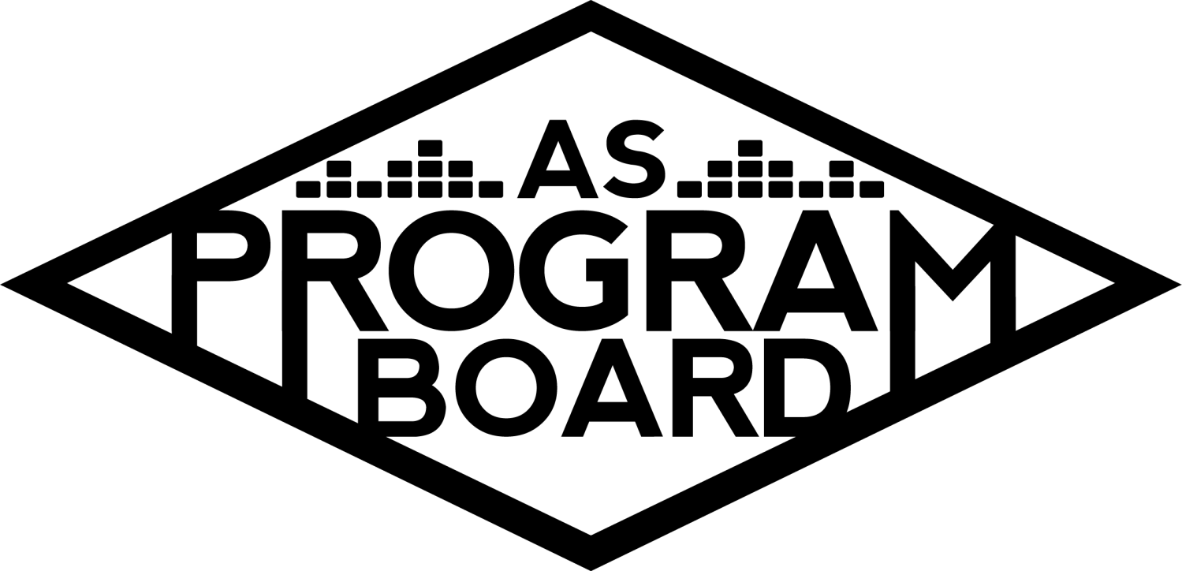
Program Board Agenda

Associated Students
February 10, 2020
SB Harbor Room

CALL TO ORDER: 5:01 PM by Kiyomi Morrison
A. MEETING BUSINESS
- Roll Call
Name | Note:  absent (excused/not excused)  arrived late (time)  departed early (time)  proxy (full name) | Name | Note:  absent (excused/not excused)  arrived late (time)  departed early (time)  proxy (full name)
Adam Salton |  | Kari Liu | Late
Alexis Xa |  | Kathryn Quinones
Bethel Tammerat |  | Kiyomi Morrison
Brenna Collins |  | Lucas Jackson | Absent
Brett Friedman |  | Mikio Sacramento
Carlos Aviles-Sullivan |  | Mitchell Lewis
Conner Jones |  | Nathaly Pacheco
Enaiya Judkins |  | Sarah Danielzadeh | Late Arrival 6:15PM
Erica Ko |  | Benjamin Chocron | Absent
Esteban Alvarado
Gabriel Reyes
Greer Jacobs

Acceptance of excused absences, absences, early departure and proxies
Motion by Mitchell, second by Bethel. Consent with 15 present.

B. PUBLIC FORUM
- BSU So Icy Ball - 5/7
  - No show
- Black Quare & RCSGD - 2/24
  - No show

C. ACCEPTANCE of AGENDA/CHANGES to AGENDA
Motion by Bethel, second by Conner. Consent with 16 present.

D.ACCEPTANCE of ACTION SUMMARY/MINUTES
Motion by Kat second by Bethel. Consent with 16 present.

E. ANNOUNCEMENTS
- TV!!!!!
  - Please only use for board related content
  - Instructions for the new wifi and airplay are on the side of the fridge
- No meeting next week 2/17

F. WEEK IN REVIEW
- Free Tues Film: Joker - 2/4
  - 7PM- 196, 10PM- 242 people
  - Printed out flyers with mental health hotlines and put them on the doors to IV theater and had one person stay outside if people needed a break and someone to talk to

G. PREVIEW OF THE WEEK
- Free Tues Film: Waves - 2/11
  - Would like one more person to sign up for the 10PM- only have 2 people now
    - Talk to Kiyomi if you have issues working enough movies
  - FB: 131 interested
  - Please pub this movie today
- Dr. Lafayette - 2/20
  - Only 23 tickets RSVP’d
  - Pub has been reaching out to professors and departments
  - Work on pubbing this too!
  - Will send out DOS job sheet at the end of the week- Half board event
  - Working
    - esteban
    - nath
    - brenna
    - adam
    - lucas
    - brett
    - mikio
    - enaiya
    - kari
    - mikio
- Free Tues Film: Queen & Slim - 2/18
  - If anyone wants to work the 7PM, Enaiya could take her name off
  - Post will be up soon
- Noon Storke Show: Better Than Sex - 2/21
  - No one is signed up as of now- reminder: Need to work 1 storke show this quarter
  - Post will be going up by end of week

H. OLD BUSINESS
- Battle of the Bands - 2/27
  - KCSB has a programmer willing to host the band on his show
  - Listening Party
    - 2 separate days or both in one day?
      - Wednesday night for both after X meeting?
        - May not need to have X meeting- could start it earlier
        - Carlos, Gabe, and Conner can’t make it after X meeting (~8PM)
        - Brett can’t make 7PM
      - Should be ~1.5 hours total
    - If you have to come you have to stay the whole time to keep things fair
    - Start with bands then listen to DJs
    - 7PM START TIME FOR NOW- depends on X meeting
  - Pre-event meetings will be happening for both battles together
  - Updated posters when lineup is finalized
  - Hosp- Nathaly, Runner: Conner
  - Working- Esteban, Mitchell, Alexis, Kat, Conner, Brett, Nathaly, Gabe, Enaiya
- Drive-In - 2/29
  - Have been reaching out to schools-4 schools have interest as of now and have until Thursday to respond with availability
  - Minimum number of attendees to make this event happen?
    - Different schools have different board structures
    - At least 2-3 other schools
      - Berkeley, Merced, Fresno State, UCSD, UCI, Cal Poly
  - Want to have 2-3 more people help out with food and hosp and planning
    - Nat, Enaiya, Brenna, Kari, Gabe, Esteban, Erica
  - All of board is expected to attend- if you can’t make it, let Bethel know
- Battle of the DJs - 3/5- half board event
  - Sent out pre-event meeting times today and talked to Jill about hosp room
  - Hoping to have contract by end of week
  - Posters to be made after listening party
  - Made a sheet with 22 slots with space for rankings and comments
  - Hosp is separate requisition form- Brett is hosp manager and Gabe will help. Runner: Carlos
    - Need to book a hosp room- all DJ’s share one and get food
  - All 3 judges confirmed!
  - NOTE: Need to do 3 half board events this quarter
  - Working: Gabe, Brett, Eniaya, Carlos, (maybe) Nathaly
- The Warm Up - 4/4
  - Headliner Contingency
    - Removed Artist A from contingency- talking about Artist B- looking to send out offer tomorrow
    - Have notes of artists discussed at previous meetings sent out and based on those:
      - Possible contingencies: Artist C, Artist D, Artist E, Artist F
        - Artist C has some recent good reviews- could be well-received by people who like EDM. Every tour stop of his recent tour sold out. Also playing Coachella
        - Artist F- has most monthly listeners on Spotify out of list and female headliner option
          - She can only perform for max of 30 minutes
          - Isn’t the best live performer
          - Has 2 popular songs and the rest have a fraction of the number of listens
        - Artist E- He cancelled the end of his 2019 tour but is performing at Coachella. Released a new song and has a lot of streams already
          - His top songs all have a lot of streams, not just a few songs
        - Artist D- may not be the right vibe for the warmup- not intense enough- and isn’t a great performer
      - Artist G- showed up in recommendations and range isn’t out of reach. Released album with other regional artists
        - Rap may not be the vibe for this show- EDM instead
      - Could also look at Artist H, Artist I, Artist J, Artist K
        - Could pick a mix of 3
          - Easy transitions between them
      - Artist L- haven’t checked availability yet
        - In Canada :(
    - Some support of keeping Artist A as contingency
      - Wanted more money than we offered
      - Rider looks good
      - Band, not DJ- don’t always cater to this group
        - Is a band not the vibe we want? It seems like some people may be mad if we bring a band?
      - Has also collabed a lot with Whethan- big name pull
        - EDM artist may have more support over him and he’s a meme
    - What happened to Artist M?
      - Co-headline, isn’t big enough
    - Artist N- may not have enough pull to be a headliner
      - Last year- thought opener would get big but it didn’t happen and may not happen with Artist N either
  - Scheduling pre event meeting for end of month- other logistics14 are in progress and going well
- Extravaganza - 5/17
  - Urban Decay Cosponsorship
    - Sending out promotional items they want to give out-
      - Worried that pens and notebooks would end up on the ground and would be trash
    - Want 2 10x10 booths- one for giveaways and email sign ups and one would be a photo booth
    - Asked about other items and adding our logo onto the photo backdrop but photobooth was already made. Also said they would stay to the end and help pick up trash
      - But they could just leave- we would need to be okay with cleaning them up after
    - Pay: $1400 for 2 booths
      - Typically one 10x10 booth is $1500 but we wouldn’t need a photobooth and they are also giving out tote bags so we could reallocate funds from that
        - Could have a second ASPB photo booth too
  - Headliner Contingency
    - Last week we passed Artist O and Artist P as contingency for first slot
      - Artist Q- played festivals with a lot of attendees and has 16 million monthly listeners on Spotify
      - Artist R- smooth jams. 4.8 million monthly listeners on Spotify and released an album in the last 2 years. Have also talked about her in the past. But she has a high asking price but may be able to get it down
        - She played the SB bowl and has been in the area a lot recently
        - Could be problematic because of past things said
      - Artist T- just came out with a new single that has a lot of listens
      - Artist S- touring with big name right now
        - Billed higher than Artist O in recent festival. Also has more of a pop sound
      - Artist T- 28 million monthly listeners on Spotify and won 2 Grammys. Also has songs with a lot of listens
        - Can only perform for 30 minutes and has high asking price ($100k plus) which could be a big problem. This price also may have gone up recently
        - People might make fun of it but would have a good time
        - May not be able to send an offer that high and if he is only playing for 30 minutes we should get a 5th slot but we may not have enough money for it
      - Artist U- Good option for TWU and focused on Coachella, but X is after that. Also get a lot of requests
        - Said they would confirm at $100k
      - Artist P headline then Artist V as 2nd- getting bigger lately
      - Artist W- big here and asking price could be in range
        - May be better for a lower slot but the asking is still high
        - Low social media following and streams compared to other options
    - Most seconded options: Artist Q, Artist S, Artist T, Artist U, Artist P
  - Sponsorship Packet has been approved

I. NEW BUSINESS
- Prescreening ft. Artist X
  - April 14, 15, or April 21, 22
  - Hub booked for April 16, 18, and 24
    - We should have a good turn out if limited to students
    - Consider pre-sale tickets to students before opening it up to public
    - Ticket price- Between $10 -$14- want to break even
    - Student pre-sale at $15, $20 at door.
    - Wednesday might be best, before Hub show
    - Tickets for Artist X can be found at $30 elsewhere
    - 60% for students, 40% for general public

J. ACTION ITEMS
- TWU
  - Artist E
    - 16
  - Artist A
    - 1
  - Abstain
    - 1
- Extravaganza
  - Artist P- 15
  - Artist Q- 2
  - Artist S-7
  - Artist T-6
  - Artist U -5
    - Arist S - 10
    - Artist T - 8
      - Artist P - 12
      - Artist S - 6

K. FINANCIAL ACTION ITEMS
- BSU So Icy Ball - 5/7
  - N/A
- Black Quare & RCSGD - 2/24
  - N/A
- Prescreening ft. Artist X
  - Motion to pass $16,655 for Bad Trip Pre-Screening on April 15, 2020 in IV Theater 1 with student prices at $14, general at $20, and $25 at door.
  - Motion Gabe, Second by Brett
    - Consent with 18 present
- TWU
  - Motion to pass Artist E as contingency starting at 50k ending at 60k
  - Motion by Nat and Second Kat
  - Consent with 18 present
- Extravaganza
  - Motion to pass Artist P as headliner starting 80k ending at 95k.
  - Motion by Nat, Second by Greer
  - Consent with 18 present

L. REPORT
Facebook Factory / Tuesday Slide / Thursday Ad
- Free & For Sale post

Kudos
Kudos to Alexis for rice krispies
Kudos to Sean, Hugo and Kat for installing the new TV
Kudos to Enaiya for signing up for stuff and great communication
Kudos to Esteban to making time to meet about film suggestions

The Marilyn Report-
Stipends need to be turned in the last week of Feb
Best day to get MD’s time this week is Thursday

The Kris Report
February 18 we’re working on a training for production at the hub, going over lighting and audio. Out on friday!

Commissioner's Report
Dietary Questionnaire going out for alumni reunion

Deputy Commissioner’s Report-
I’ll let you know about responses for the Drive in on Thurs!
Emailed about defensive driving training -- please sign up!

Coordinators’ Reports
Adam - Working on a training for production.
Brett - Started looking into artists for Spring
Carlos - Yield
Conner - Working on a theme for Extravaganza, need help with postering, PLEASE HELP.
Erica - Working on the theme, please share Dr. Lafayette!
Esteban - TIred, working on future films, helping Gabe, I’m open to talking about films coordinator position if interested.
Gabriel - Working with Esteban, finishing up stuff for the lecture. Wanting to inquire about spring speakers as well. Side note Taika Waikiki was the first indigenous person to win best director at the oscars!
Greer - Having surgery 2/21, available by email.
Kari - Tired.
Mitchell - Also tired.
Nathaly - Working on X, Please Venmo me soon if you need to pay me back or I’ll reach out to you all.

Assistants’ Reports
Alexis - Happy valentines day!
Brenna - Super excited for Waves!
Enaiya - Was excited for Waves, but midterm season!!
Kathryn - Excited for Waves and Frank, BOTB and BOTDJ
Lucas - N/A
Mikio - Good luck on midterms!

Senator’s Reports
Benjy - absent
Sarah - Excited for waves

ADJOURNMENT: 7:27PM

Artists mentioned: Joey Badass, What So Not, Brownies and Lemonade, Sofi Tukker, Eric Andre, Jai Wolf, Joji,
Whethan, Baby Keem, OliverTree, Lil Yachty, Good Times Ahead, ATrack, Duke Dumont, Saweetie, ASAP Ferg, Alison Wonderland, City Girls, Kali Uchis, Lil Nas X, Sean Paul, Swae Lee,Denzel Curry, Polo & Pan, Maddeon, Dominic Fik,

