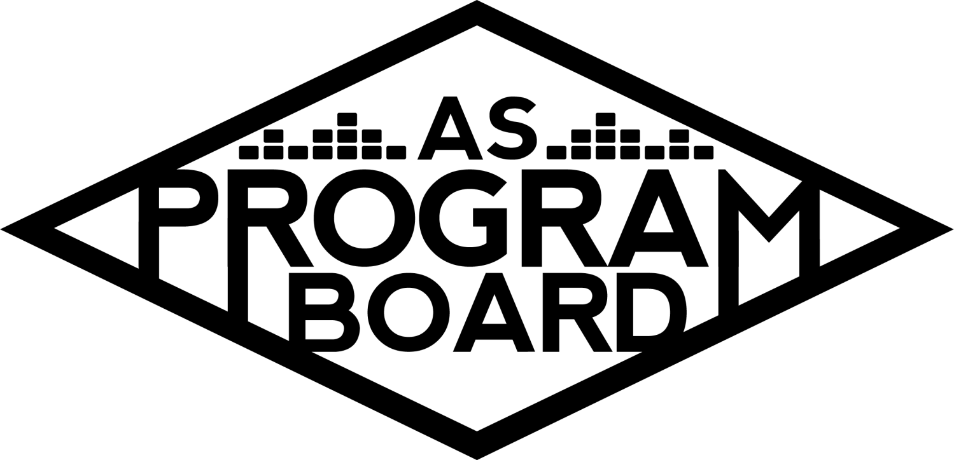
Program Board Agenda

Associated Students
March 30, 2020
Remote

CALL TO ORDER: 5:00PM by Kiyomi Morrison
A. MEETING BUSINESS
- Roll Call
Name | Note:  absent (excused/not excused)  arrived late (time)  departed early (time)  proxy (full name) | Name | Note:  absent (excused/not excused)  arrived late (time)  departed early (time)  proxy (full name)
Adam Salton |  | Kari Liu | Absent
Alexis Xa |  | Kathryn Quinones
Bethel Tammerat |  | Kiyomi Morrison
Brenna Collins |  | Lucas Jackson
Brett Friedman |  | Mikio Sacramento
Carlos Aviles-Sullivan |  | Mitchell Lewis
Conner Jones | Late (5:50pm) | Nathaly Pacheco
Enaiya Judkins |  | Sarah Danielzadeh
Erica Ko |  | Benjamin Chocron
Esteban Alvarado
Gabriel Reyes
Greer Jacobs | Absent

Acceptance of excused absences, absences, early departure and proxies
Motion by Gabe, second by Brett. Consent with 17 present.

B. PUBLIC FORUM

C. ACCEPTANCE of AGENDA/CHANGES to AGENDA
Motion by Nathaly, second by Bethel. Consent with 17 present.

D.ACCEPTANCE of ACTION SUMMARY/MINUTES
Motion by Bethel, second by Mitchell. Consent with 17 present.

E. ANNOUNCEMENTS
- Zoom meeting etiquette
  - Mute mic if you are not talking
  - Raising hand: Click on “participants” then “raise hand”. Can press again to lower hand.
    - Raise hand to object to a motion
  - Use chat for meeting related comments
  - Don’t have to have camera on if you don’t want to
- Campus closure and remote life
  - Remote programming- can’t go into the office
    - If you need something from the office, talk to MD
- I LOVE YOU ALL WE’RE GONNA GET THROUGH THIS!!!!!

F. WEEK IN REVIEW
- Free Tues Film: Bombshell - 3/3
  - 7PM- Kat and Mitchell. 58 people attended.
  - 10PM- Mikio and Conner. 44 people attended.
  - Thank you to everyone who helped with movies this quarter!
- Zack Fox - 3/4
  - Well received by students
  - Minor issues with the contract because a lot was going on.
  - Doors were pushed back by 15 minutes. Some people showed up at a wrong time because a FB post had a different time on it.
  - Sold out at the door!
  - Show ran smoothly but a few people waited outside for Zack after the show.
  - Post event: A few problems with the requisition form because AS has been so busy.
- Battle of the DJs - 3/5
  - Event went well but didn’t get an exact attendance count: ~220-250 people
  - Had some problems with insurance before the event.
  - DJs got pictures today from pub and they liked them!
  - Check was sent to DYLN March 12 so he should have gotten it by now.
  - Messed up student checks- MD redid the checks and turned them in
  - For next time:
    - Remind artists not to publicize times (DYLN did this) so students don’t just come to part of the show.
    - Remind students that they can not go over allotted time.
    - Add up numbers after each DJ, not all at the end.
  - Jesse won and after recalculation, numbers still matched up.
  - People showed up for their friends’ performances- hard to get people to stay the entire time
  - Can we avoid telling them set times in the future?
  - Prize ideas (since they can’t perform at X):
    - Could do live stream we host
    - Perform at next year’s welcome back as the opener
      - Too big of a concert? And postponing could be complicated
    - Make them a cool graphic and post it or put it in the yearbook
    - Provide a pre-recorded set to play on KCSB?
    - Send Kat ideas for possible prizes
- ASPB Reunion - 3/7
  - Had Woodstock’s lunch, tour (thanks Gabe!), and dinner
  - In the future, may make Woodstock’s lunch mandatory for everyone and entire event
    - We don’t do this often
  - Most of the people there had a really good time!
    - People have been reaching out to MD with nice messages
  - People were saying we should do this more often
    - Every 5 years?
  - In the future: more position intermingling
  - Thank you everyone for helping!
    - And Kiyomi for putting so much work into it!!
  - PS: don’t dry the tote bags they shrink

G. PREVIEW OF THE WEEK

H. OLD BUSINESS

I. NEW BUSINESS
- ASPB Remote
  - Campus closed
    - Still figuring out how this will work
    - UC’s are still doing student fees so we will still have funding (this could change though)
    - If you aren’t taking classes this quarter, talk to Kiyomi
    - End of the year stuff: transition, hiring
    - No office hours
    - All meetings will be via Zoom
  - Stipends and position expectations
    - Everyone should still be getting a stipend
    - Thinking that stipend will be based on writing position guide that will be passed on to next boardies
    - Also looking into remote programming and other projects
    - Should still have quarter reports at the end of the quarter
    - Attendance- unsure as of now
  - AS
    - Requisition process is moving online and we will know more in a couple of days
  - Sadgirl
    - TBD on postponement
  - The Warmup and X will not be happening this year due to remote programming
    - We can say they have been postponed
    - Students probably know it isn’t happening but we should edit FB to say it definitely isn’t
      - If people said going or interested on the event page, they should get a notification if we postpone it
  - Some agencies have changed up their agents and some are willing to do virtual programming (more on this later)
    - Contracts go through MD, not ED
  - Look into cancelling tshirt and supply orders for these events
  - Should we make a universal email we can send to everyone that our events are being cancelled and we are cancelling all orders?
    - Sponsorships- been in contact and could look into transferring sponsorship to next year
      - Wait for anything remote programming related
  - Any money not used for events will roll over to next year
- ASPB Hiring
  - Hiring is still happening in spring- remote hiring
  - Applications are online and could do Zoom calls for interviews
  - All outgoing board members are able to join hiring committee but you have to be available for it
    - If you are interested, let Kiyomi know
  - This week we will prep and schedule times for info sessions
    - Live info session? Or record a video?
  - We interview every applicant
  - We will also need a hiring graphic, pages on socials, and the hiring website to be put up
  - Timeline: Applications will open April 8, live stream info sessions April 16 and 17th, applications close May 1, final decisions May 22
    - Deadline for position guides will be due before we meet with new hires
- Remote Programming ideas
  - Live streams, playlists?
    - Some agencies have reached out about live streaming comedians and there are some pretty big names on the list
      - Note: We can still pay artists and participant limit for live stream shows is 10,000
    - GIve online access to certain movies we would have streamed
      - Netflix party-type movie viewings?
        - Could use Twitch and would need a moderator
    - Podcast
      - Could interview artists that were scheduled to perform
        - Quarantine topics
    - Agents want us to generate a list of artists and have a plan for what exactly we would want them to do
      - Could also open this up to artists who are usually out of our price range
      - Bring up proposals with budgets early on then work on them throughout the quarter
    - We can’t use third party websites to stream events for students
      - Microsoft teams- 10,000 capacity too
    - Opening up submission ideas to other student orgs?
      - Example: bring a bigger artist for a lecture or a drag queen to do a makeup tutorial
      - Help other campus groups promote their events
    - We could be the place where people go to find out what virtual events are going on
      - Example: At home concerts
      - Could create a doc where people can directly add things
    - Playlists
      - https://open.spotify.com/playlist/4g1gVPxuGLjYKJf4i37iaB?si=e9-AByn3QaWb-7kfjMUY0g
      - One a week? With different themes
      - There is one up right now that is public on Spotify
      - Could make a set schedule for this
      - Could incorporate graphics
        - Photos
        - Graphica made by us
        - Student submissions
    - Online gaming?
      - Redbull/Nintendo could do a gaming competition
      - Twitch has a game where everyone can login and work together to move one player
      - Would need moderators to set rules and go through comments in chat
    - Tiktok
    - Workshops
      - Painting, DJing, producing, editing, cooking, celebrities teaching weird classes
    - Therapist come talk about mental health
      - UTA and CAA have reached out with mental health speakers
    - Virtual job fair
    - Virtual art exhibition
    - Smaller scale videos of board teaching talents
  - If you have an idea, put it in the Slack and see if you can get a little team together
    - Kiyomi will try to help organize this
    - It won’t be super specific in terms of jobs
    - If you don’t sign up for an event, Kiyomi may assign you to one (we’ll see how this goes)
  - This week we can start working on proposals and budgets
  - Could also post options and let people choose what they would like to see
    - Create a poll to gauge interest
  - We can touch base on Wednesday about different projects as we’re coming pretty close to deadlines
  - We need to work quickly if we want things to happen this quarter
  - The Nexus has space for digital ads if we are interested
- Remote bonding
  - Movie night, quiplash, netflix party
- BOARDIE OF THE QUARTER
  - ALEXIS WOOOOOO!!!!!! (she is amazing, but we already knew that)

J. ACTION ITEMS

K. FINANCIAL ACTION ITEMS

L. REPORT
Facebook Factory / Tuesday Slide / Thursday Ad
- Free & For Sale post

Kudos
Brett for being funny, Kiyomi for putting these meetings together and for being the best, MD for being in the office working, to the reunion for being one of the coolest events, everyone who is showing their pets on Zoom, MD for fixing Kat’s req forms, everyone for helping with the reunion

Put kudos in the Slack!!

The Marilyn Report
Let’s go big on the virtual events this quarter! Unprecedented and groundbreaking! Make sure you stay home and take care of yourselves
FYI: AS Food Bank is open on Wednesday and Friday with pre-packaged bags of food. Talk to the financial crisis team if you are having financial difficulties. Can also reach out to her if you have any other issues.

The Kris Report
Silver lining: getting better at our online presence! Looking forward to helping however he can.

Commissioner's Report
This is an opportunity to do some really cool and new stuff! It’s alive! Thank you to everyone on board. Looking forward to a great quarter. Take care of yourselves!

Deputy Commissioner’s Report
Excited for the quarter and interested in podcast idea- contact her if you’re interested on working on it

Coordinators’ Reports
Adam- Excited to look into insomniac/twitch live stream events. Have talked to people who have done live stream events.
Brett- Giving people dirty looks for being outside
Carlos- Looking forward to upcoming programming.
Conner- Feel free to reach out to him with website ideas. Was able to get Sean to give us more access to the website!
Erica- Excited for new projects. Let her know if you need any help.
Esteban- Looking into streaming sites and getting new films for students. Sofi Tukker has live streams every day at 1pm.
Gabriel- If anyone is interested in putting on events or comedy shows let him know.
Mitchell- Doesn’t have a laptop at the moment but is looking to get it fixed soon. Let him know if you need graphics.
Nathaly- Going to work on how to figure out the technical aspect of events. Grateful for everyone’s hard work!

Assistants’ Reports
Alexis- Excited for new ideas. Wash your hands!
Brenna- Looking forward to connecting with the student body online.
Enaiya- Excited to help out and pub projects.
Kathryn- Also interested in cooking/podcast ideas.
Lucas- Promised us dogs.
Mikio- Interested in podcast idea too.

Senator’s Reports
Benjy- Here to help with whatever is needed.
Sarah- Down to help with whatever and also likes podcast ideas.

ADJOURNMENT: 6:48pm by Kiyomi Morrison

Artists mentioned:

