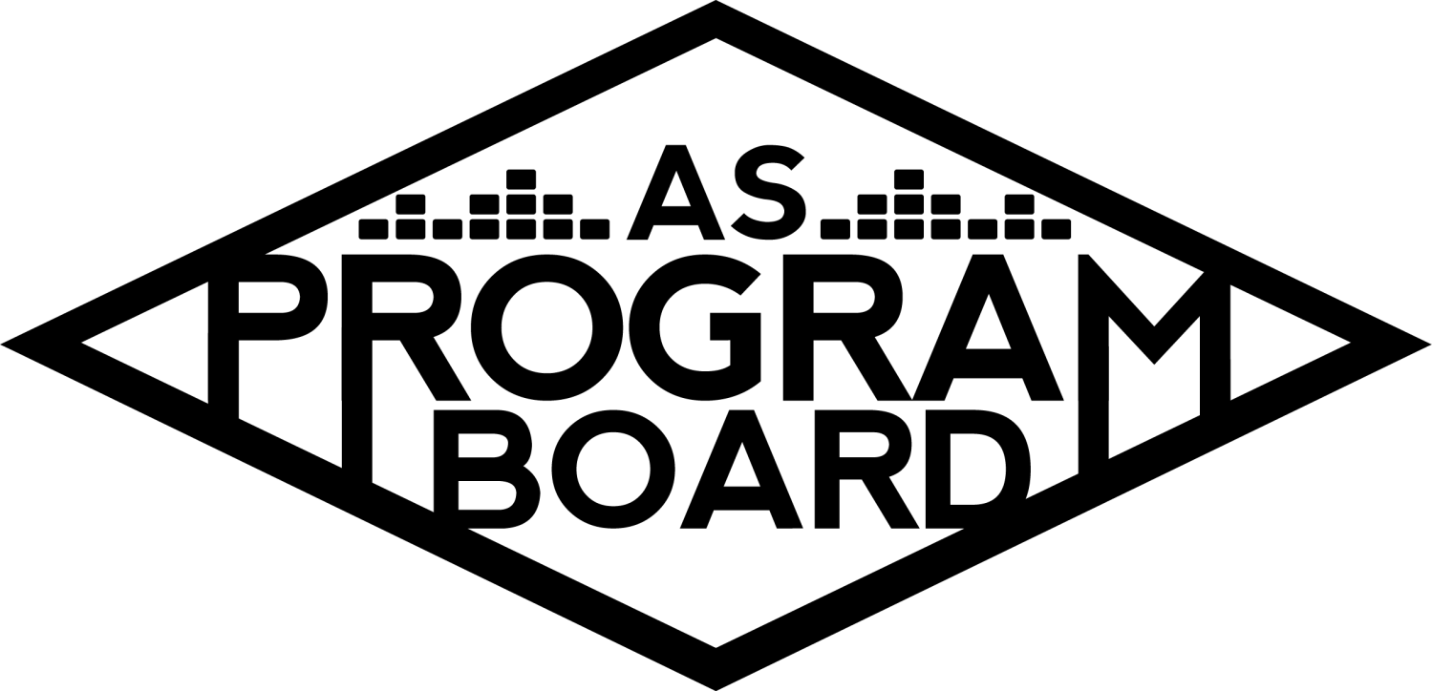
Program Board Minutes

Associated Students

November 2nd, 2020
Remote

CALL TO ORDER: 5:02PM by Kathryn Quinones
A. MEETING BUSINESS
- Roll Call
Name | Note:  absent (excused/not excused)  arrived late (time)  departed early (time)  proxy (full name) | Name | Note:  absent (excused/not excused)  arrived late (time)  departed early (time)  proxy (full name)
Adam Salton
Alexis Xa |  | Kathryn Quinones
Celine Liu |  | Lucas Jackson
Emily Duong |  | Sophia Castro
Emily Kocis |  | Sophie Sharma
Enaiya Judkins |  | Hayley Slater | Early Departure 6:30
Gabriel Reyes |  | Bee Schaefer | Absent
Halle Dawite
Jake Einsiedl

Acceptance of excused absences, absences, early departure and proxies
Motion to excuse the absence of Bee and early departure of Hayley at 6:30. Motion by Gabe, second by Celine. Consent with 13 present.

B. PUBLIC FORUM

C. ACCEPTANCE of AGENDA/CHANGES to AGENDA
Motion by Gabe, second by Celine. Consent with 13 present.

D.ACCEPTANCE of ACTION SUMMARY/MINUTES
Motion to accept 10/26 minutes. Motion by Halle, second by Jake. Consent with 13 present.

E. ANNOUNCEMENTS
- Land Acknowledgement
- Quarter Reports
  - At the end of the quarter you will be expected to summarize everything you did
  - This will be used to see how much of your stipend that you will receive
- Update on Off Campus Events
  - Maricela will put something out later this week

G. WEEK IN REVIEW
- Delirium 10/30
  - About 1200 registered and 878 attended
  - Preliminary stuff was simple and Emily was really helpful
  - Insurance did cause an issue because Alex’s manager did not know about it
  - Run through was held on set on SNL and it felt like it didn't keep the energy after their skit
  - Comments were funny but some questions were a little too personal
  - Student engagement with the artist went well and is really cool for the students
  - Overall great job Gabe!!
- Delirium 10/31
  - Show
    - Omar’s part went really smoothly
      - Omar’s team was really nice
      - Working with Paradigm has been easier because we booked Whethan + Cautious Clay with them
      - People reacted the way we thought they would with Omar
      - Good that Omar looked at comments because it gives students the chance to be noticed
    - 588 people attended (maybe because of giveaway)
    - Gunna’s pre-recorded set didn’t get too much negative feedback
    - Soundcheck for Gunna’s set was way too late, got advance contact very late (agent was traveling)
    - students were accidentally let in early
      - One of the co-hosts accidentally let students in early @ 8:55pm
    - students did realize the set was pre-recorded
    - a lot of winners weren’t there Saturday night as opposed to Friday night
    - we announced really late and as a result, we couldn’t include announcement pt.2 in the giveaway
  - A lot of problems would have been avoided had we booked someone earlier (pre-recorded set, late announcement, etc.) Let’s avoid what happened with 24kGoldn. We lost time by trying to book 24kGoldn and then moving onto Gunna after changing our minds. Taking 2-3 more days to vote on an artist we really want is way better than voting on an artist and then changing our mind in the long run.
  - Giveaway
    - Boosted our social media numbers and garnered a LOT of attention
    - Around 2700 entries
    - A lot of people watched livestreams for the giveaway
    - good pub for night 1 but pub wasn’t as strong for night 2
    - manual entries weren’t too hard just time consuming
    - freshman bundle was hard to execute
    - loopholes (people could send their friends pictures within the 5 minute time frame) -> we should go down to 3 minutes if we do this for TWU
    - a lot of students didn’t follow instructions even though the instructions were on the first page of the graphic
      - Didn’t follow the page, didn’t like the post, etc.
    - When ordering 10 $100 gift cards from Amazon your account can get locked because they think you got hacked
      - We still do not have the gift cards
    - Kat was able to flyer part of IV with a housemate and one of the ambassadors
  - Great job Alexis!!!

H. PREVIEW OF THE WEEK

I. OLD BUSINESS
- Hub Show 11/12
  - Confirmed a 20 minute guided meditation, a 25 minute set, and 15 min Q&A
  - Hopefully will announce on Thurs or Fri
  - Will start at 8pm
  - Enaiya and Lucas will monitor chat
  - Emily K will moderate
- Cultural Event 11/19
  - Almost done with a graphic
  - Artist A’s team seems chill
  - 45min Q&A @ 7pm
  - Should be a good show
  - Hoping to announce after Artist B
  - Lucas, Emily K, Emily D, and Sophie will monitor chat
- Ambassadors Program
  - Last Thursday was the first meeting and they did good on posting for Delirium
  - Ambassadors will make a “this is IV” playlist
  - Also planning on an ASPB year in review playlist
- Storke Shows
  - Jake found a local UCSB band to perform on Wednesday 11/11 for a sunset show but now one has COVID :(
  - Jake has Artist B stuff so Adam might be able to help Jake out with finding talent for the show

J. NEW BUSINESS
- Festive Program Ideas
  - Previous years we would do holiday Christmas card photos
  - Maybe cooking with Artist C
  - Sending out little DIY kits? Ornament making/ gingerbread house making?
  - Have to be inclusive of all religions and such for events like this
  - Snapchat filter?
- The Warm Up 4/3/2021
  - Allocated $90k instead of $80k
  - Send suggestions to Alexis
  - Shirts?
    - Allocated money for them
    - Since we don’t have production fees, spend a little more money on shirts to make nicer ones with more colors

K. ACTION ITEMS

L. FINANCIAL ACTION ITEMS
- Motion to pass $93,300 for The Warm Up virtual concert on April 3rd, 2021. Motion by Alexis, Second by Gabe, Consent with 13 present.

M. REPORT
Facebook Factory / Tuesday Slide / Thursday Ad
- Free & For Sale post

Kudos
Emily K for moderating really well
Whoever helped with delirium
Md for helping with Ben
Adam and Enaiya for taking Gabe food
Everyone for doing Delirium
Adam for helping the production team with Gunna
Adam for working hard and putting your body on the line
Alexis for helping give out prizes for the giveaway
Sophie for giving Gabe Ice cream
Gabe for the event
Alexis for DOING THAT
Enaiya and Alexis for going to get the TV from Costco
Alexis for wow and being helpful
Enaiya for being a Pub queen
Sophie for working at Caje
Gabe for being responsive
Celine for making amazing graphics
Emily for also doing amazing things
Sophia for making the playlists

The Marilyn Report
Not upset about Amazon but working w/ customer service to get the account back. Make sure to ask for insurance early on. Wed 11/11 is a holiday. Take care of yourselves during election week. DO SOME SELF CARE

The Kris Report
Production should always be part of the conversation early on. Also be COVID safe. VOTE!!!!!!!

Commissioner's Report
Try to create a new good habit for yourselves! Proud of you all!

Deputy Commissioner’s Report
Take care of yourselves through week 5!!

Coordinators’ Reports
Adam- do good on midterms!! VOTE!!!!!!!!
Alexis- send her artist suggestions for The Warm Up!!! Go outside!
Celine- Delirium graphics were a little rushed but still went well. Making lots of sick graphics!!!
Enaiya- Glad delirium is over! Pub meetings are every other week if you need to talk to pub! Positive vibes
Gabe- Glad delirium is done! Getting ready for the next event! Talking with co-founder of a new bcu about working on events!!
Jake- thanks to everyone who volunteered! Will keep us updated
Sophie- talking to IV musicians to help Jake with Storke shows

Assistants’ Reports
Emily D- congrats on delirium! Working on some more sick graphics
Emily K- fun moderating for delirium! Excited for future events
Halle- happy delirium is over! Pubbed a lot! Excited for future events!!
Sophia- taking a chill week because midterms suck! Trying to wake up earlier! Send in your songs!!

Senator’s Reports
Bee-
Hayley-

ADJOURNMENT: 6:38 PM by Kathryn Quinones

Artists mentioned: Raveena, Newton Nguyen, John Mulaney

