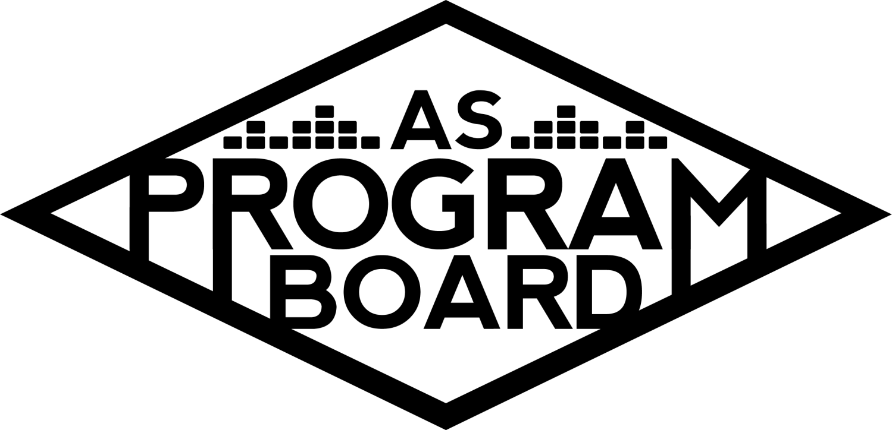
Program Board Minutes

Associated Students

October 26th, 2020
Remote

CALL TO ORDER: 5:04PM by Kathryn Quinones
A. MEETING BUSINESS
- Roll Call
Name | Note:  absent (excused/not excused)  arrived late (time)  departed early (time)  proxy (full name) | Name | Note:  absent (excused/not excused)  arrived late (time)  departed early (time)  proxy (full name)
Adam Salton
Alexis Xa |  | Kathryn Quinones
Celine Liu |  | Lucas Jackson
Emily Duong |  | Sophia Castro
Emily Kocis |  | Sophie Sharma
Enaiya Judkins |  | Hayley Slater
Gabriel Reyes |  | Bee Schaefer | Absent
Halle Dawite
Jake Einsiedl

Acceptance of excused absences, absences, early departure and proxies
Motion by Adam, second by Jake. Consent with 13 present.

B. PUBLIC FORUM

C. ACCEPTANCE of AGENDA/CHANGES to AGENDA
Motion by Adam, second by Sophie. Consent with 13 present.

D.ACCEPTANCE of ACTION SUMMARY/MINUTES
Motion to accept 10/19 minutes. Motion by Alexis, second by Adam. Consent with 13 present.

E. ANNOUNCEMENTS
- Land Acknowledgement
- Office Hours
  - Everyone better be going to their office hours
  - If you don’t announce that your office hours are changed we will assume you skipped
  - Reminder office hours are part of your stipend
  - Make it easy on Kat and actually be there

G. WEEK IN REVIEW

H. PREVIEW OF THE WEEK

I. OLD BUSINESS
- Delirium 10/30
  - Waiting on WME to update us on when we can post today
  - Shout out to Emily for doing research for the Q&A
  - Want to do student engagement and want to get the google form up today
  - Want to pick students by friday
  - Hoping to announce at 8pm tonight
  - Gabe and Emily are moderating and Halle, Sophie, and Alexis are monitoring the chat
- Delirium 10/31
  - Artists
    - Were able to confirm Artist A and Artist B for 85k
    - No Q&A 45min set time for Artist A then a 15-20min break then 45min Artist B set
    - Adam, Kat, and Emily Duong will monitor the chat
  - Giveaway
    - Enaiya, Halle, and Alexis will check entries
    - Emphasize that we need to be tagged or we won't see the post
    - Announcing winners at the end of night 1, during the break of night 2, and at the end of night 2
    - Dropping off the prizes on Friday and Saturday night
  - Promotion
    - Looking like 10/30 announcement will go out tonight and 10/31 will be Wednesday or Thursday at the latest
    - Push for both events simultaneously
    - Talked about ordering quarter sheets to put on peoples doors/ mailboxes
    - Ambassadors will also be promoting
    - Enaiya is recording a video
    - Sophie will send an email announcement out
    - Ambassadors can help with the door to door
    - Share and invite your friends to the save the date on FB
    - Keep sharing the event!!!!!!!
    - Announce in your classes if possible
- Hub Show 11/12
  - Offer out for Artist C that expires on Wednesday
  - Will probably confirm for 5k
- Cultural Event 11/19
  - Going well
  - Will focus on it after this week
  - Want to do student involvement but will see because it’s only 45min
- Ambassadors Program
  - Interviewed 18 people
  - Now the team is 11 ambassadors
  - Tomorrow is the first ambassador meeting
  - Hopefully some will be interested in physical promo
- SASA Event
  - Kat and Gabe talked to a coordinator to discuss logistics
  - Proposed SASA footing the bill and we will help book
  - Now they say they will only take 5k of the bill
- Storke Shows
  - Lucas, Adam, Jake, and Emily
  - Sign up for a week on the sign up sheet Kat sent
  - If you are doing week 7 come to meeting with at least 2 ideas
  - Anyone that performs with the university must have a COI

J. NEW BUSINESS
- Drive-In Movie 11/17
  - Meeting with Katie from Criterion
    - As of right now the movie screening is not interactive
    - Will require a separate zoom for students to interact with each other
    - Might not be as worth it
  - Gave us the discounted price for projector, workers, and space
  - Discount got it to $8,500
  - Movies might accrue an additional cost depending on their availability
  - Might be good to boost morale in winter quarter
  - Winter quarter allows for adequate time for logistics
  - The rental is for 2 showings of the movies
  - Drive in Concerts?
    - Bigger budget
    - The drive in is open to it though

K. ACTION ITEMS

L. FINANCIAL ACTION ITEMS
- Motion to reaffirm 10/22 motion to pass Artist A as Delirium 10/31 support starting at $25k and ending at $35k. Motion by Alexis, Seconded by Gabe. Consent with 13 Present
- Motion to reaffirm motion to add $10k to the Delirium 10/31 talent budget increasing it from $80k to $90k. Motion by Jake, Seconded by Halle, Consent with 13 Present.

M. REPORT
Facebook Factory / Tuesday Slide / Thursday Ad
- Free & For Sale post

Kudos
Graphics and Pub for doing a lot and being great at it
Celine for a lot of great graphics and she put graphics on her back
Alexis and Gabe for working on the big shows
Jake for being cool too
Sophie for being a boss
Kat for taking care of the motions and everything
Gabe for being helpful
Sophia for her color coded schedules and doing all the interviews
Enaiya for talking to Kat a lot

The Marilyn Report
Can the event coordinators send an email with necessary panelists and in person events need to be volunteer and optional.

The Kris Report
Look forward to sharing events and he is available for help!

Commissioner's Report
Thank you for working hard and being amazing! We could all be in person but until then stay on top of everything.

Deputy Commissioner’s Report
School is important too! Good luck on midterms everyone!

Coordinators’ Reports
Adam- interested in doing a drive in concert and working on getting artists together for stroke shows
Alexis- really excited for delirium! Make sure to pub
Celine- Update on graphics: finished the culture one and working on the music one! Making some sick graphics for yall
Enaiya- super excited to announce delirium!! Excited to see everyones reactions
Gabe- Gabe is literally exploding. Questions are almost done and we are hoping to announce tonight. Excited to work on winter quarter events. Vote in the AS elections
Jake- keep us updated with Artist C
Sophie- will update the website tomorrow and will send out emails! VOTE IN ELECTIONS!!! Also sleep well

Assistants’ Reports
Emily D- reformatting banners and spotify playlists! This week is spooky songs
Emily K- Good meeting! Excited for delirium and excited for gabe to finally get a break
Halle- promoting everything is super fun! Take care of yourselves!
Sophia- Send in songs for the new playlists and someone is adding random playlists to the as account so stop

Senator’s Reports
Bee- VOTE IN AS ELECTIONS!!!!!
Hayley-

ADJOURNMENT: 6:15 PM by Kathryn Quinones

Artists mentioned: Gunna, Raveena, Omar Apollo

