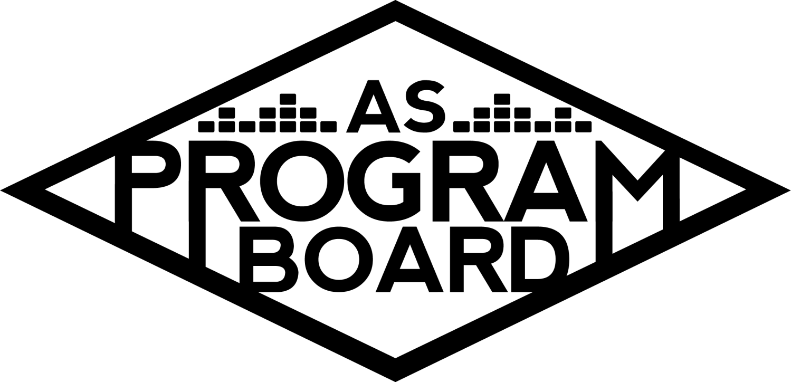
Program Board Agenda

Associated Students
April 27, 2020
Remote

CALL TO ORDER: 5:05PM by Kiyomi Morrison
A. MEETING BUSINESS
- Roll Call
Name | Vote:  absent (excused/not excused)  arrived late (time)  departed early (time)  proxy (full name) | Name | Note:  absent (excused/not excused)  arrived late (time)  departed early (time)  proxy (full name)
Adam Salton
Alexis Xa |  | Kathryn Quinones
Bethel Tammerat | Late Arrival | Kiyomi Morrison
Brenna Collins |  | Lucas Jackson
Brett Friedman |  | Mikio Sacramento | Absent
Carlos Aviles-Sullivan |  | Mitchell Lewis | Absent
Conner Jones |  | Nathaly Pacheco
Enaiya Judkins |  | Sarah Danielzadeh
Erica Ko |  | Benjamin Chocron
Esteban Alvarado
Gabriel Reyes

Acceptance of excused absences, absences, early departure and proxies
Motion by Nathaly, second by Carlos. Consent with 15 present.

B. PUBLIC FORUM

C. ACCEPTANCE of AGENDA/CHANGES to AGENDA
Motion by Gabe, second by Conner. Consent with 15 present .

D.ACCEPTANCE of ACTION SUMMARY/MINUTES
Motion by Alexis, second by Gabe. Consent with 15 present.

E. ANNOUNCEMENTS
- Reaffirmation
  - WE PASSED!!!
    - YAY!!!!!
    - Thank you for all the work campaigning!
    - Passed with 77%
- ASPB Applications due May 1
  - If you’re reapplying make sure you still submit an application
- Mustache Themes
  - Thank you to the mustaches
  - New theme each week

F. WEEK IN REVIEW
- Noon Storke Show - 4/23
  - Went pretty well- announced the morning of and hope to announce earlier next time
  - ~150 total viewers
  - Simple to set up, and had no internet connection issues

G. PREVIEW OF THE WEEK
- Binging with Babish LIVE - 4/28
  - All set to go- 7PM through Zoom
  - Deadline for questions was today, may be able to incorporate some live Q&A but we will find out tomorrow
- Storke Show - 4/30
  - Delta Dagger will be playing
  - Waiting on contract and graphic but hoping to get those soon
  - Would be good to also do FB event for Storke shows
- Eric Andre Live Stream - 4/30
  - Confirmed but waiting to hear back from the agent for some documents
  - Board members will be moderators- will send question sheet out
  - Need to figure out how to allow multiple people to speak at once to ask questions
  - Announcing with press photo since event is soon
  - Want to moderate live questions

H. OLD BUSINESS
- Youtube Channel
  - Editing coffee video and will be posting soon
  - Have videos lined up for the next 2 weeks- MW every week- hoping to have first video out Wednesday
  - Videos are on the drive
  - If you have ideas for videos, let us know
- Playlists
  - Started posting last week
  - Supposed to be updating weekly
  - Not everyone may have access to account
  - Missing one graphic
- Films
  - Have been in contact with on campus films agent
  - More info on how it works
    - Cloud style, they ad 15-20 new titles each month and it refreshes every month too
  - Trying to contact Swank
- ASPB Applications
  - Due Friday May 1 at 5PM
  - Working with hiring committee and receptionists to schedule interviews
  - Haven’t gotten as many as we want, need new ways to advertise
    - Compilation video- Nathaly can start working on it soon and Enaiya and Conner can help edit
      - Doesn’t exactly show the work that was put in
    - Pub announcements before Storke shows
    - Short video from everyone saying why they love ASPB and their favorite experiences
      - Since we already have event videos, start on that first and can include personal statements at the end- can ask specific people so we aren’t waiting on everyone
      - Don’t have to make a compilation, can post them individually and on a rolling basis to make it easier
    - UCSB announcement emails?
    - Mailing list- not actively growing but have a decent base
      - Can write an email to send out to our list by tomorrow
      - Volunteer emails are on Shoreline
    - Newsletter- add Storke shows- let Conner know if things need to be added
    - Classroom announcements
    - Facebook ads/instagram ads?
    - Slack channels- general
      - Ask senators to share it on their pages
    - Free and For Sale
    - Daily nexus slide as other half of noon storke show screen?
    - Making posts in previous events- it alerts people that were going or interested
- Live & On The Rise
  - Moving Artist A to 5/13
  - Going to try to get Artist B next week 5/6
  - Artist C on 5/21
  - Need to get in touch with graphics
  - In general, need to update pub more on status of events
    - Could hold weekly Wednesday pub meetings or hold individual meetings
      - Added people to pub Slack, may not need to meet
- Artist D - 5/5
  - Update
    - Sent updated offer today- expires tomorrow
    - Looking like it’ll happen and graphic is already done
- Artist E - 5/8
  - Moving to 5/8
    - Gives enough time to dedicate pub to events this week
    - Seemed super excited and looking like they will confirm
    - Also going to take questions from students
    - If anyone has ideas on how show should be run, let Nathaly know
- Artist F - 5/15
  - Moving to 5/15 & Need to discuss budget
    - Will be on Instagram instead of Zoom- will also help bring people to Instagram page
    - Sent out new budget- ending offer at $35k
      - If we are spending this much should it be exclusively for students?
        - We can make Zoom students only
        - More people will tune in to Instagram and get new followers
        - Could find a way to only allow UCSB students to submit questions?
        - Private Instagram?
          - Will limit participation
        - Most of our other events are on Zoom anyway
    - Instagram takeover throughout the day with Q&A
    - Can only do 30 minute set but we can make event an hour
    - Moderating?
      - Nathaly will be on and others can help
    - Not closed to UCSB students
    - Special shoutout to one of our followers?- increase our followers
      - Live streams need to be unique to universities- finding ways to personalize events so they may be down to do this
    - Action vote for Zoom vs Instagram
- Artist G - 5/17
  - Discussion on moving date to 5/17 (would’ve been X)
  - Live set and Q&A
  - Date?
    - Would have been X so it could be a meaningful time to have him
  - His team is down, we need to figure out the details
- Artist H - 5/29
  - Update budget title and date passed in the phone vote last week
  - Last event of the quarter
  - Workout/fun twerk class and possibly performance
  - Already passed budget, just want to set date
- Mailing List
  - Should keep collecting email addresses

I. NEW BUSINESS
- Artist I - 5/26
  - Moderated Q&A
  - Wanted to work with Queer Commission for pride month
  - Have one of the members be a moderator with us and can ask them for questions
    - Can see how involved they want to be
  - Does board need to collaborate on events like this?
    - Can have some value to collaborate with other groups but these events are things we should be putting on anyway
    - May seem like we only do these events with other groups
    - Good to consult with campus groups
    - Time of unity and may reach more people
  - Agent seems excited about this event

J. ACTION ITEMS
- Artist E
  - Set Date
    - Motion to change the date for the Painting with Artist E back to May 8 2020 at 7PM.
      - Motion by Nathaly, second by Brett. Consent with 16 present.
- Artist H
  - Set Date
    - Motion to amend the budget that was passed in the phone votes for May 29 2020.
      - Motion by Nathaly, second by Conner. Consent with 16 present.
- Artist G
  - Set Date
    - Motion to change the date for the Artist G livestream to May 17 2020
      - Motion by Nathaly, second by Erica. Consent with 16 present.
- Artist F Livestream Medium
  - Vote between Instagram (open to everyone) and Zoom (UCSB exclusive).
    - Instagram: 15; Zoom: 1. Instagram wins.
- Live and The Rise
  - Motion to change the date of Artist A from May 6 to May 13.
    - Motion by Brett, second by Conner. Consent with 16 present.

K. FINANCIAL ACTION ITEMS
- Reaffirm Email Votes
  - Motion to reaffirm to move Artist D to May 5.
    - Motion by Nathaly, second by Brett. Consent with 16 present.
  - Motion to have Painting w/ Artist E on 5/1 and Artist G on 5/8
    - Motion by Nathaly, second by Erica. Consent with 16 present.
  - Motion to pass $55,750 for a live stream/takeover featuring Artist H or Artist F starting at $30k ending at $55k with a tbd date in mid to late May.
    - Motion by Nathaly, second by Brett. Consent with 16 present.
  - Motion to pass Artist B as the next artist for Artist on the Rise for May 6th starting at $5,000 and ending at $7,000 with Artist J as contingency starting at $5,000 and ending at $5,000.
    - Motion by Brett, second by Erica. Consent with 16 present.
  - Motion to change the date for Livestream Comedy with Eric Andre from 4/23/2020 to 4/30/2020
    - Motion by Gabe, second by Conner. Consent with 16 present.
- Friday Night Vibes
  - Artist F
    - Motion to pass $35100 for Artist F instagram takeover starting at $20k and ending at $35k on May 15 2020.
      - Motion by Nathaly, second by Esteban. Consent with 16 present.
- Artist I
  - Motion to pass $20,000 for Artist I on May 26 2020 starting at $15k and ending at $20k.
    - Motion by Gabe, second by Enaiya. Consent with 16 present.
L. REPORT
Facebook Factory / Tuesday Slide / Thursday Ad
- Free & For Sale post
Kudos
Kiyomi for getting Binging with Babish happening. Kiyomi for helping organize everything and for being a great (the best) commissioner. MD for helping schedule everything. Alexis for being sweet and kind- second by Erica. EVERYONE for continuing to work this hard during this time!! MD for filling out a survey for Brett. Pub for helping with Binging and Conner for the website. Mitchell for the NGHTMRE graphic. Kris/Kiyomi for help with video recording.

The Marilyn Report
Looking forward to the event tomorrow. Still a lot going on generally in AS and got a letter that they are calling for a hiring freeze. Replacing the advisor is on pause until it’s lifted or we get an exception.

The Kris Report.
Appreciate production checking in and looking forward to events.

Commissioner's Report .
Thank you to everyone who wore mustaches. Interviews starting this week!

Deputy Commissioner’s Report .
Send shower songs! Excited for interviews

Coordinators’ Reports
Adam- Having weekly production meetings. Looking into livestream services.
Brett- Excited for nice weather and upcoming events.
Carlos- Excited to get artists we’ve been talking about for a while.
Conner- Welcoming website feedback.
Erica- Let her know when you need things posted.
Esteban- Thank you for the bday wishes. Excited for hiring and upcoming events and hoping to get films going.
Gabriel- Figuring out Eric Andre stuff and working on planning another event.
Mitchell-
Nathaly- Working on events we passed today and getting offers out.

Assistants’ Reports
Alexis- Exciting to see everything coming together. And noon storke shows!
Brenna- Excited for tomorrow- friends were excited for binging.
Enaiya- Learned how to pronounce Babish. Bab-ish vs Babeesh
Kathryn- People have been commenting on Babish. Excited to be a moderator for Eric Andre. Found a way to record switch screen for 30 seconds that's free.
Lucas- Feeling the buzz cut. Excited for tomorrow- people are commenting about us having events
Mikio-

Senator’s Reports
Benjy- Excited for events.
Sarah- Congrats on reaffirmation. Let them both know if you need help.

ADJOURNMENT: 7:00PM by Kiyomi Morrison.

Artists mentioned: Channel Tres, Gus Dapperton, Doja Cat, Still Woozy, Sad Girl, NGHTMRE, Lil Yachty, Megan Thee Stallion, Steve Aoki, Billy Porter

