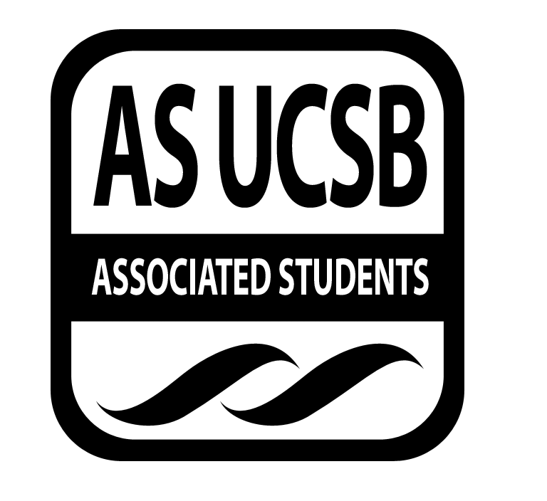
AS Food Bank Committee

Associated Students
January 26th, 2017;
EAB Lounge
CALL TO ORDER by Bre Jones, Chair at 6:11pm

A. MEETING BUSINESS
- Roll Call (Pre-entered Names)

Name | Note:  absent (excused/not excused)  arrived late (time)  departed early (time)  proxy (full name) | Name | Note:  absent (excused/not excused)  arrived late (time)  departed early (time)  proxy (full name)
Breanna Jones | Present | Priyanka Bist | Present
Gary Huynh | Present | Maggie Ma | Arrived Late
Yanira “Jenny” Flores | Present | Thao Phan | Arrived Late
Kathy Lee | Present | Miho Yamamoto | Present
Nathalie Recendez | Present | Sue Encarnacion | Present
Steven Marquardt | Present | Khalil Kochiyama | Absent
Wen Ying Liu | Arrived Late | Patrick Dohoney | Excused
Eileen Lui | Excused | Bianca Fernandez | Present
Teniola Adedeji | Present | Maria Hoang | Present
Nicolas Pascal | Departed Early | Matthew Norton | Excused

- Acceptance of Excused Absences
MOTION/SECOND: Jones/Flores
ACTION: Passed by Consent
B. PUBLIC FORUM
a. AGENDA SUMMARY
b. CHECK INS / INTRODUCTIONS

- REPORTS
  - CHAIR:
    - ECOalition Town Hall (1/24)
    - 2017 - 2018 ASFB budget meeting with Matt (1/24)
    - Meeting with Food Security Coordinator Melissa Fontaine (1/20)
    - Expansion project update.
  - VICE CHAIR:
    - UCSB First
      - Yearly Video Update
    - UCSB Health and Wellness
      - Collaboration update
        - Sent information to ASFB internal co-coordinators
    - UC Regent Governance is hiring/in search for of UC representative
      - Due February 26th
      - All expense paid/tuition
  - INTERNAL AFFAIRS COORDINATOR(S):
    - STEVEN:
      - IV Co-Op will sponsor the ASFB donation walk
        - Circle K signed up to volunteer
        - CAB meeting next wednesday for volunteers
      - ASFB tabling went well today (1/24)
      - Food for Freedom Fair update
    - WEN: none
  - EXTERNAL AFFAIRS COORDINATOR:
    - John L (manages UC dining)
      - Draft of UCSB food recovery and donation program
    - Food Basic Nutrition Skills Workshop update
    - Launch of Financial Crisis Team (Similar to UCLA’s program)
    - CHEFS and CHESC will be merged this year
      - June 24-26th CHEFS
      - June 26th-29th CHESC
  - PUBLICITY COORDINATOR:
    - Greek Fest update/ meeting with Juli Nguyen: ASFB Vice-Chair 2015-2016
    - Judy-Ann (AS Web Developer)
      - ASFB website update
  - TREASURER:
    - TGIF grant
    - SB printers (UCen)
      - ASFB food tote bags update
  - SENATE LIAISON(S): none
  - OTHER MEMBERS: none

- ACCEPTANCE of AGENDA/CHANGES to AGENDA
MOTION/SECOND: Jones/Recendez
ACTION: Passed by Consent

- ACTION ITEMS
F-2 New Business
ACCEPTANCE of Nathalie Recendez’s Funding request for $30 snacks for tabling on 2/2
MOTION/SECOND: Recendez/Jones
ACTION: Passed by hand vote (9 to 1)

- DISCUSSION ITEMS
a. CO-OP TOUR:
Currently scheduling with Marissa (the co-op outreach manager)
Great opportunity to foster stronger relationship with co-op.
EARLY MARCH
How many interested & available: 8
At what time are we scheduling: 3:30pm on FRIDAY

b. FNBS WORKSHOP:
Proposals due Feb. 3rd!
Past workshops include dinner & a movie and garden tours.
Great way to build a sense of community connected to Food Bank.
Possible ideas:
Lead(s): Thao! And Maggie To meet with Bre.

c. WEBSITE & SOCIAL MEDIA (NATHALIE):
Newsletter tab and calendar of events.
Update on info and dates.
Including tab on committee!

d. CAMPUS & COMMUNITY EXPANSION (NICO): Nico left early

ADJOURNMENT
MOTION/SECOND: Jones/Phan
Motion to adjourn at 7:02pm
ACTION: Passed by Consent

