ZERO WASTE COMMITTEE MINUTES

Associated Students
DATE: Monday, 1/31/22
LOCATION: Zoom / AS Main Office (UCEN 1523)
Minutes/Actions recorded by: Charu Garapaty

CALL TO ORDER: 5:06 PM by Alyssa Young, Co-Chair

A. MEETING BUSINESS

- Roll Call

Name | Note:  absent (excused/not excused)  arrived late (time)  departed early (time)  proxy (full name) | Name | Note:  absent (excused/not excused)  arrived late (time)  departed early (time)  proxy (full name)
Alyssa Young  Co-Chair | Present | Adam Jahnke  Advisor | Present
Charu Garapaty  Co-Chair | Present | Christopher Perez  Admin Coordinator | Absent (excused)
David Gjerde  Treasurer / Senate Liaison | Present | Vacant  Outreach Coordinator | N/A
Marie Levisay  Compost Coordinator | Absent (excused) | Vacant  Outreach Coordinator | N/A
Emma Burke  Compost Coordinator | Present | Gracie Young  Festival Coordinator | Absent (excused)
Sophia Vargas  Athletics Coordinator | Absent (excused) | Jordan LeGrys  Festival Coordinator | Present
Vacant  Athletics Coordinator | N/A | Taylor Hitchan  Activities Coordinator | Present
Vacant  Pearman Fellow | N/A | Ava Gordon  Activities Coordinator | Present
Teresa Gonzalez  Voting Member | Absent | Tuan Le  Voting Member | Absent
Emily Duong  Voting Member | Absent | Sonnet Richmond  Member | Absent
Benise Limon  Member | Absent | Avery Gunderson  Member | Absent
Anabel Willy  Member | Absent

- Acceptance of Excused Absences

MOTION/SECOND: Burke/Legrys
Motion Language: motion to bundle and approve all excused absences
ACTION: Vote: Consent to APPROVE
Motion Passes

- Acceptance of Proxies
N/A

- Land Acknowledgement

Before we begin, we wish to acknowledge the traditional custodians of the place and all land upon which the University is located. We pay our respects to the Chumash elders, past, present, and future who call this land their home.

B. PUBLIC FORUM

- Landry Guillen (she/her) - EAB Volunteer Chair
  - Hi all! I hope you are all doing well and staying safe. I wanted to reach out and let all of you know about the upcoming Block Clean Up event EAB is hosting this Friday (2/4) from 2:30-4:30pm. If possible, I'd really appreciate if you could share this information with your organizations and networks of students. I will attach the flier below. Thank you so much for all of your continued work! Here is also the link to register on shoreline: https://cglink.me/2dD/r1473376
  - 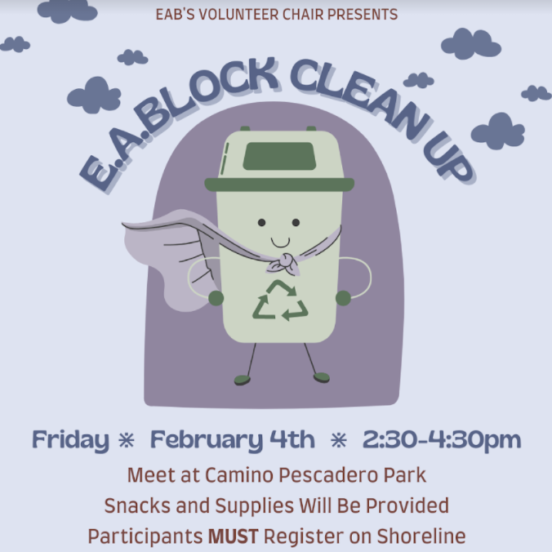

- EXTERNAL REPORTS

- Advisor’s Report (Adam Jahnke)
  - Password reset: Emma, Chris, Charu
    - Stay after the meeting

- Executive Officer’s Report(s)

  - Co-Chair Report (Alyssa Young)
    - ZWC and AS Emails
      - Poll: How much do people use their emails?
      - auto-forward email to the account you use
      - some using personal emails
      - Changing things to make things easier, setting emails and people not using them
      - streamlining, centralizing committee communication
      - old conversations from previous years on emails
      - Ava: Something my sorority does is officer transition documents that outline what they did, what they wish they would’ve done better/had known, etc., and then we also had transition meetings where the former officer would meet with the new officer to essentially hand over their role
    - Retroactive Honoraria
      - LAST REMINDER: Applications due on February 1st at 11:59 PM. : Retroactive Honoraria – Associated Students Senate (ucsb.edu)
    - Open Positions
      - AS Committee on Committees (CoC) offered to help with recruiting new officers: 2021-2022 AS Positions Needed
      - Public Outreach Coordinator (2)
      - Zero Waste Athletics Coordinator
        - Taylor will reach out to a SAAC member to share the ZWAC position.
          - Update: Will share at the next SAAC meeting (in Feb)
      - Activities Coordinator?
        - Taylor is planning to graduate at the end of Winter Quarter
    - “Office Hours” for Winter
      - See ZWC Google Calendar for updated OHs and events.
      - Appointments with Alyssa: Feel free to use email alyssayoung@ucsb.edu to check availability on Google Calendar.
      - Charu updated her Google Calendar to her schedule.
        - new office hours: Fridays 1-3pm
    - Tabling Supplies
      - ASR found them and will have it in their office for me to pick-up!
      - Update: Have not picked this up yet.
    - Canva Pro Subscription Renewal
      - Will request $120 to renew subscription for another year.
  - Activities Coordinator Report (Taylor Hitchan & Ava Gordon)
    - Event: I Am Greta Documentary Screening
      - Ava: bought 2 $25 gift cards from IV Coop
      - will be working on reimbursement with David
    - Event: Study Jam This Sat, 11 am
      - buying donuts
    - Winter Retreat
      - End of week 6 or 7, weekend morning
      - Outdoor activities and eating together in person
      - Santa Barbara animal center: check out a dog for a day
        - vests that say adopt me to get people’s attention
    - Finals Study Jam TBD
  - Administrative Coordinator Report (Christopher Perez)
    - Officer Bios & Photos for Website
      - Make sure to send your bio and photos if you haven’t already.
  - Treasurer Report (David Gjerde)
    - 2022-23 Budget Request
    - Mostly a prediction, usually same as last year
    - DUE: Wedn. Feb 2, Noon
  - Public Outreach Coordinator Report (Vacant)
    - N/A
  - Compost Coordinators Report (Marie Levisay & Emma Burke)
    - Bigbelly Bins by HSSB
      - contacted EAB
      - found alternative for Big Bellies for $2000
      - no composting Big Bellies, quote from big belly about how much the single one would cost
  - Zero Waste Festival Coordinators Report (Gracie Young & Jordan LeGrys)
    - Date: Friday, April 15th, 2022 (booked for all day)
      - Any preferences on what time?
      - thinking of 12-2pm
      - don’t know schedules for spring quarter
      - will need committee members to help set up, especially the day of
    - Venue: Storke Plaza
      - amplified sound/noise is only allowed from 12-1pm in Storke Plaza if we want to have music
    - Company Outreach
      - No updates
    - ZWF Committee Applications
      - thinking of making a committee
  - Zero Waste Athletics Coordinators Report (Sophie Vargas)
    - Single-use Gatorade Cups at Practices and Games
      - Idea: Each player has a designated cup that the trainers bring
        - Not sure how they would be washed or maintained
        - Coming up with different ideas of either compostable cups or reusable cups.
      - No update
    - Strictly online tickets for events
      - No update
    - Replace pamphlets and rosters with QR codes
      - No update
    - Food at the snack shacks (UCSB Concessions) changed to locally-sourced food
      - No update
    - Tortillas at events
      - No update
  - Senate Liaison Report (David Gjerde)
    - N/A

- Group Project/Member Report(s)
  - Reusable Menstrual Products (Alyssa, Taylor & Emma)
    - MHE Coalition Updates
      - Menstrual Equity Kit Tabling Schedule
        - Need volunteers!
    - RMP Meeting
      - Scheduling soon.

- ACCEPTANCE of AGENDA/CHANGES to AGENDA

- CONSENT ITEMS

- Approval of our Action Summary/Minutes from: 01/24/22
MOTION/SECOND: Gordon/Legrys
Motion Language: motion to approve last meeting’s minutes.
ACTION: Vote: Consent to APPROVE

- ACTION ITEMS

- Old Business
  - [Action item]
    - [details]
MOTION/SECOND:
Motion Language:
ACTION: Vote:X-X-X to APPROVE/DENY

- New Business

  - Canva Pro Subscription
    - We purchased Canva Pro last year, and it has been our main method of creating communications with students (through flyers, social media posts, etc.)
    - The requested amount of $120 will extend our Canva Pro subscription for another year.
MOTION/SECOND: Young/Hitchan
Motion Language: Motion to allocate $120 for Canva Pro Subscription.
ACTION: Vote:X-X-X to APPROVE/DENY
ACTION: Vote: Consent to APPROVE

  - [Action item]
    - [details]
MOTION/SECOND:
Motion Language:
ACTION: Vote:X-X-X to APPROVE/DENY

- DISCUSSION ITEMS

- 2021-2022 ZWC Project Ideas
  - Charu: update website w/ photos!
- ZWC Reusable Utensils
  - 300 reusable utensils would be $5,000 and that would be used the whole year. We don’t necessarily need them but they are very popular and would have our logo on them.
    - Cyan: it could help with tabling.
    - Alyssa: some past hesitations it might be hard to distribute them and there may be other options that may be more sustainable. This vendor would create a carbon footprint because they are coming from china.
    - Emma: Is there better local options?
    - Alyssa: last time I checked we couldn’t find them so maybe.
    - Cyan: they may not have to be customizable so that may open up some options.
    - Alyssa: If they aren’t customized it would be better.
    - Emma: It could work to not customize them because we would be handing them out.
    - Taylor: says If you follow our instagram then you could get a free silverware set.
    - Cyan: if we are still online for a while we could ship to people
- Winter Retreat
  - Charu can bring a camera for us to take pictures for the website.
    - before we take
- Valentine’s Day event: Feb 14: 2-5pm
  - making body butters
  - picking a location: email the MCC, SRB multipurpose room
  - budget: $150-200

- REMARKS

- N/A

- Adjournment

MOTION/SECOND: Legrys/Garapaty
Motion Language: motion to adjourn the meeting at 5:49 pm.
ACTION: Vote: Consent to APPROVE

