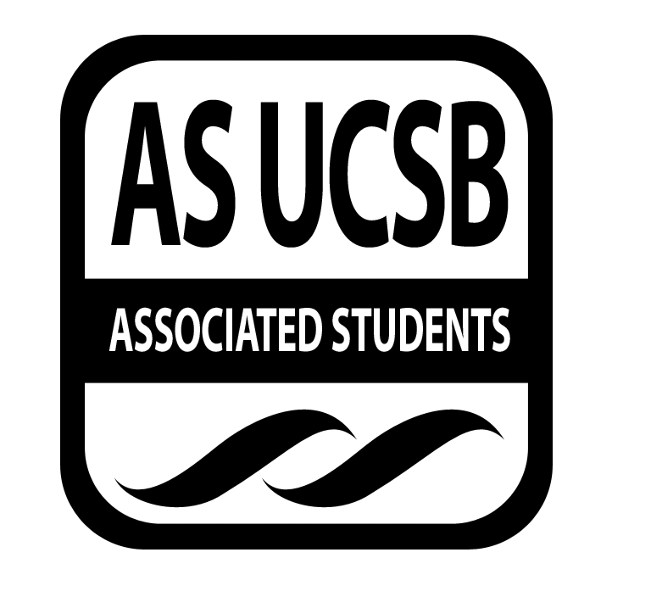AS SIRRC Agenda

Associated Students
January 29,2015 6:00 pm
AS Annex Minutes recorded by: Eric Rubio
CALL TO ORDER 6:05 by Cairo Briceño

A. MEETING BUSINESS
- Roll Call

Name | Note:  absent (excused/not excused)  arrived late (time)  departed early (time)  proxy (full name) | Name | Note:  absent (excused/not excused)  arrived late (time)  departed early (time)  proxy (full name)
Mariana Cruz-Garcia | Present | Cairo Briceño | Present
Oscar Gutierrez | Present | Josh Hudson | Present
Carmen Mares | Present | Ariana Munoz | Present
Joselyne Matamoros | Present | Janette Ruano | Present
José Javier Mendoza Magana | Present | Eric Rubio | Present
 |  | Nelson Monge | Present

B. PUBLIC FORUM
  - Announcements/Information/Introductions/ Ice Breaker
  - Testimony for items on today’s agenda (out of order)
    - Ice Breaker
    - Break-out Groups
    - Announcements
    - Voting
  - Appreciations/Concerns
  - Request to have item added to today’s agenda

- REPORTS
- Recruitment Report
- Fafsa Workshop is scheduled and going as planned
- CAMP is still a work in progress, more updates next week
- Retention Report
- GSO- It will take place at Anacapa.
- On Friday, The movie social for the mentees (13) The movie will be 22 jump street
- Got a new mentor for the middle school mentorship. Still looking for new mentors, sign up sheet will be passed throughout the meeting.

- ACTION ITEMS

D-1. New Business:
- National Society of Black Engineers (NSBE): Funding Request
The NSBE would like to request funding in order to be able to send its members to the National Engineering Conference in Anaheim, CA. There will be resume building workshops and networking offered to the members of NSBE who attend the convention. Also internships will be available through the career fair. Anyone who meets the minimum requirements will be able to attend. It will take place on March 25th- March 29th. They have requested funding from other AS organizations. Total cost of sending 10 engineering students to the National Convention is approximately $4892. They are requesting $350 of support from SIRRC.
Josh discussed that we wanted to raise funding to $200. Cairo argued that we don’t have much money to allocate to all our new programs.We are on a tight budget.
MOTION/SECOND: Nelson/Cynthia
Mariana motions to fund the NSBE $150 for their National conference
Josh calls to question. Carmen calls consent.
There is no objection to consent. Motion passes.
Additional approval required: YES Senate

- DISCUSSION ITEMS
- Mariana, SIRRC Co-Chair: Winter Retreat - This Saturday at 9:00am. Will go over budget and future events
- AS Olympics- Februray 8th from 1:00 to 4:00
- Jose- Valentines themed gift exchange. $10 limit for the gift.
- Publicity- Fliers done for the Study jam. Is asking the freshman to take some flyers to ask RA’s if they can post them and leave at front desk of their residence halls. Also tabling will start next week. If you want to sign up, please visit the AS SIRRC FB page to access the Doodle.
- Hiro- Will send me a bill regarding a revision on the senate voting power. We will provide feedback.
- Oscar- Will pass out a sign up sheet for the conference for high school from 8:30 to 5:45.
ADJOURNMENT

MOTION/SECOND to ADJOURN: Cynthia/Ricardo
ACTION: Vote: Consent
Vote Taken: 7:04

