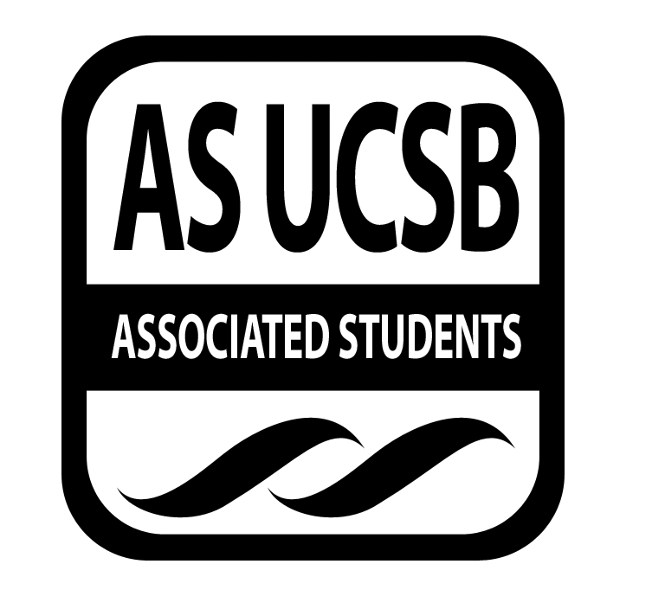AS SIRRC Agenda

Associated Students
January 22, 6:00 pm
AS Annex Minutes recorded by: Eric Rubio
CALL TO ORDER 6:03 by Cairo Briceño

A. MEETING BUSINESS
- Roll Call

Name | Note:  absent (excused/not excused)  arrived late (time)  departed early (time)  proxy (full name) | Name | Note:  absent (excused/not excused)  arrived late (time)  departed early (time)  proxy (full name)
Mariana Cruz-Garcia | Present | Cairo Briceño | Present
Oscar Gutierrez | Present | Josh Hudson | Present
Carmen Mares | Present | Ariana Munoz | Present
Joselyne Matamoros | Proxy (Kimberly Garcia) | Janette Ruano | Present
Jose Javier Mendoza Magana | Present | Eric Rubio | Present
 |  | Nelson Monge | Present

B. PUBLIC FORUM
  - Announcements/Information/Introductions/ Ice Breaker
  - Testimony for items on today’s agenda (out of order)
    - Ice Breaker- Human Knot
    - Break-out Groups
    - Announcements
    - Voting
  - Appreciations/Concerns
  - Request to have item added to today’s agenda

- REPORTS
- Recruitment Report

SIRRC will be hosting a financial aid workshop on February 5th at la Caza de la Raza. We are also planning CAMP (College Anticipation Mentorship Program), an overnight stay for San Marcos GUIDES mentees. They are considering changing the CAMP event to a one-day program. We are currently looking for mentors to help 7th grade students who read at a 4th grade level on Fridays from 10:28 to 11:16

- Retention Report

We went over the budget for PAGE-plus, which is $1335. Oscar is looking for a keynote speaker. The SRB is reserved on the April 18th. The venue is to be changed at LPC. They are in the process of planning a movie night for the GSO students; there will also be a study session before the movie. The movie that is going to be shown will be “22 Jump Street”. It will take place either at the Annex or the Santa Catalina movie room.

- ACTION ITEMS

D-1. New Business:
- Vote to have Kimberly Garcia as a proxy for Joselyne Matamoros

MOTION/SECOND: /Janette Ruano/ Carmen Mares
Ariana calls to question. Josh calls consent.
There is no objection to consent. Motion passes.
Additional approval required: YES Senate

- REMARKS
- Cairo, SIRRC Co-Chair: No funding Requests today.
The Success Factor: This event is going to be hosted by Hermanos Unidos featuring the guest speaker Ramsey Jay Jr. It will be at the MCC Auditorium this Saturday January 24th at 10:00am. Lunch will be provided by SB Menus and other networking lunches. There will be academic workshops and professional services offered as well.
Community Builder position now open: On week 5 we will have new elections for the Community Builder position. If interested, please let us know and fill out the application. You do not have to be a voting member to apply.
- Mariana, SIRRC Co-Chair: A.S. SIRRC Retreat- To bond together as SIRRC and determine the budget for next year. It will be on 1/31/2015 Saturday at 9am. Sign ups will be passed around during the meeting.
AS Olympics- A.S. committees will play team building games and other sport events in the Thunder dome. It is taking place Sunday February 8th. Must RSVP by January 30th. Food will be provided. Sign ups passed around during the meeting.
ADJOURNMENT

MOTION/SECOND to ADJOURN: Carmen/Arianna
ACTION: Vote: 18-0 to APPROVE
Vote Taken: 7:00

