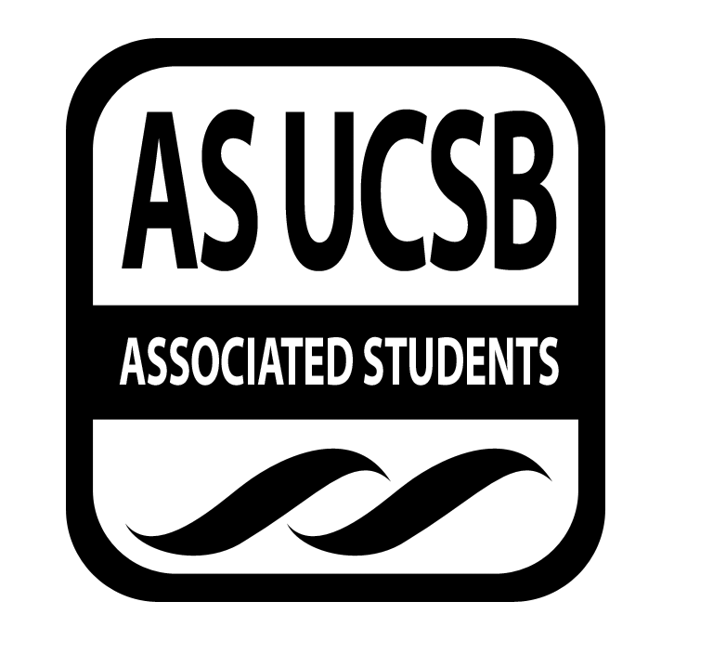
A.S. SIRRC Minutes

Associated Students
November 10, 2016 @ 6:00 pm
AS Annex Minutes Recorded By: James Fonseca

CALL TO ORDER at 6:10 by Josh Hudson

A. MEETING BUSINESS
- Roll Call

Name | Note:  absent (excused/not excused)  arrived late (time)  departed early (time)  proxy (full name) | Name | Note:  absent (excused/not excused)  arrived late (time)  departed early (time)  proxy (full name)
Lorena Alvarez | Present | Bryan Garcia | Present
Josh Hudson | Present | Mara Tinajero | Present
Michelle Martinez | Present | James Fonseca | Present
Ernesto Jimenez | Present | Renata Rodriguez | Present
Julia Hsueh | Present | Stella Au | Present
Joseph Rico | Present | Lesly Silva | Excused
Anthony Lai | Proxy | Jonathan Lopez | Present
Carmen Garcia | Proxy

A-2. Acceptance of Excused Absences
Additional approval required: YES Senate
Motion to make Jhan proxy for Carmen. Mara/Renata. Jorge calls to question. Julia calls consent. No objections to consent; motion passses
Motion to make Brenda as proxy for Anthony .Lorena/Daniel. Derick calls to question. Andrea calls consent. No objections to consent; motion passes
B. PUBLIC FORUM
  - Announcements/Information/Introductions/ Ice Breaker
  - Testimony for items on today’s agenda (out of order)
    - Ice Breaker- “Bang”
    - Break-out Groups
    - Announcements
    - Voting
  - Appreciations/Concerns
  - Request to have item added to today’s agenda
- REPORT ITEMS
D-1. Retention-
Page Plus: will go more into depth next meeting

Gift Exchange: Secret Snowflake
- Sign-up sheet available if you want to join

D-2. Recruitment-
Workshop: Next Wednesday at 5:30 at Casa de la Raza
-Asking for volunteers to help students with personal
- Action Items

- New Business
Cash Advance for Julia for $1,215 for Joshua Hudson. for Christina Ellen Mitine. And for Jenson Wang for beong RA for GSO and GTSO. Perry/Andrea. Jorge calls to question. Mara calls consent.No objections to consent; motion passes

Additional approval required: YES Senate

- REMARKS
-IDEAS is having a
-There are spaces available for students who need to process the recent events
-Study Jam next Thursday from 8-12am at El Centro
-Chican@ Workshop next Wednesday Nov.16 from 12-1pm
-Against Trump Protest at De La Guerra Plaza Saturday at 12pm
-There will be speaker on Nov.16 that will discuss how communicate in a nonviolent way
-Hermanos Unidos Club Party Nov.19. Tickets cost $25 and 18 and up with a valid ID
-Monday night Nov.14th 6-8pm is the talk and 8-10pm is the art show
ADJOURNMENT
MOTION/SECOND to ADJORN: Joseph/Jhan
ACTION: Vote: 13-0 to APPROVE
Vote Taken: 7:07 pm

